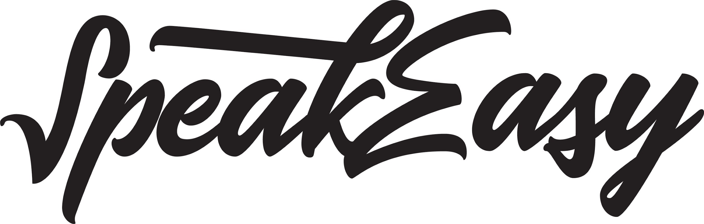

SPEAKEASY UPDATES ON STATUS OF FILING ITS INTERIM CONSOLIDATED
FINANCIAL STATEMENTS AND MD&A
VANCOUVER, BC – March 30, 2020 — SpeakEasy Cannabis Club Ltd. (CSE: EASY) (Frankfurt: 39H) (the “Company” or “SpeakEasy”), a holder of a federal licence to cultivate, process and sell cannabis under the Cannabis Act is providing an update on the status of the filing of its interim financial statements and accompanying management’s discussion and analysis and related CEO and CFO certificates for the financial period ended January 31, 2020 (collectively, the “Quarterly Filings”) which are required to be filed by on March 31, 2020 under National Instrument 51-102 – Continuous Disclosure Obligations.

On March 18, 2020, the Canadian Securities Administrators (CSA) announced that they will provide issuers with a 45-day filing extension for filings required on or before June 1, 2020 to allow issuers the time needed to focus on the many other business and financial reporting implications of COVID-19. The Company will rely on this exemption with respect to the Quarterly Filings in accordance with BC Instrument 51-515 - Temporary Exemption from Certain Corporate Finance Requirements.

The Company is continuing to work diligently and expeditiously to file the Quarterly Filings and currently expects to have them filed on or prior to the extended timeline. In the interim, management and other insiders of the Company are subject to a trading black-out policy that reflects the principles in section 9 of National Policy 11-207 Failure to-File Cease Trade Orders and Revocations in Multiple Jurisdictions.

The Company confirms that since the filing of its condensed interim consolidated financial statements for the three months ended October 31, 2019 there have been no material business developments other than those that have been publicly disclosed as required under applicable securities laws.

About SpeakEasy Cannabis Club Ltd.:

SpeakEasy Cannabis Club Ltd. holds a cultivation, processing and sales licence issued by Health Canada under the Cannabis Act. SpeakEasy owns 290 acres of land in Rock Creek, British Columbia, and leverages three generations of farming experience in B.C. as well as its favourable location to grow and process high-quality cannabis products at low cost. SpeakEasy cultivates small batch, high quality craft cannabis in its 10,000 square foot indoor facility and has recently completed the development of its 60-acre outdoor field. The Company’s intention, upon receipt of an amendment to its current licence to include the outdoor cultivation area, is to produce approximately 70,000kg of outdoor, sun grown cannabis in 2020.

For more information about SpeakEasy, visit speakeasygrowers.com.

For further information:

Bin Huang
investor@speakeasygrowers.com
1-778-668-4339

This news release contains statements that constitute "forward-looking statements." Such forward looking statements involve known and unknown risks, uncertainties and other factors that may cause SpeakEasy’s actual results, performance or achievements, or developments in the industry to differ materially from the anticipated results, performance or achievements expressed or implied by such forward-looking statements. Forward looking statements are statements that are not historical facts and are generally, but not always, identified by the words "expects," "plans," "anticipates," "believes," "intends," "estimates," "projects," "potential" and similar expressions, or that events or conditions "will," "would," "may," "could" or "should" occur.

Forward-looking statements in this document include statements concerning SpeakEasy’s intention to file the Quarterly Filings on or prior to the extended timeline, its intent to produce and sell high quality craft cannabis, its expected production output upon receipt of an amendment to its current licence and the timeframe associated with such production output, and all other statements that are not statements of historical fact.

Although SpeakEasy believes the forward-looking information contained in this news release is reasonable based on information available on the date hereof, by their nature forward-looking statements involve known and unknown risks, uncertainties and other factors which may cause our actual results, performance or achievements, or other future events, to be materially different from any future results, performance or achievements expressed or implied by such forward-looking statements. By their nature, these statements involve a variety of assumptions, known and unknown risks and uncertainties and other factors, which may cause actual results, levels of activity and achievements to differ materially from those expressed or implied by such statements.

Examples of such assumptions, risks and uncertainties include, without limitation, assumptions, risks and uncertainties associated with the global Covid-19 pandemic, including the risk that the Company be deemed a non-essential business and asked to temporarily cease operations general economic conditions; adverse industry events; future legislative and regulatory developments involving cannabis; the Company’s ability to access sufficient capital from internal and external sources, and/or inability to access sufficient capital on favorable terms; the cannabis and hemp industries and markets in Canada and generally; the demand for CBD distillate, cannabis and cannabis related products, the ability of SpeakEasy to implement its business strategies; competition; the ability of SpeakEasy to obtain and retain all applicable licences under the Cannabis Act and other assumptions, risks and uncertainties.

THE FORWARD-LOOKING INFORMATION CONTAINED IN THIS NEWS RELEASE REPRESENTS THE EXPECTATIONS OF THE COMPANY AS OF THE DATE OF THIS NEWS RELEASE AND, ACCORDINGLY, IS SUBJECT TO CHANGE AFTER SUCH DATE. READERS SHOULD NOT PLACE UNDUE IMPORTANCE ON FORWARD-LOOKING INFORMATION AND SHOULD NOT RELY UPON THIS INFORMATION AS OF ANY OTHER DATE. WHILE THE COMPANY MAY ELECT TO, IT DOES NOT UNDERTAKE TO UPDATE THIS INFORMATION AT ANY PARTICULAR TIME EXCEPT AS REQUIRED IN ACCORDANCE WITH APPLICABLE LAWS.
The Canadian Securities Exchange has not approved nor disapproved the contents of this news release.

