GOLDREA’S 3DIP Survey Identifies Second Porphyry Copper Target at Cannonball Property
November 2, 2021 - Vancouver, British Columbia
Goldrea Resources Corp. (CSE:GOR, Frankfurt:GOJ, OTC-US;GORAF) (“Goldrea” or the “Company”) has received preliminary results from a 3DIP Survey that was completed on the Cannonball Property during the 2021 field season. The survey defined a chargeability anomaly that is coincident with the recently discovered malachite (copper) stained andesitic volcanic rocks referred to as the “Juice Box Zone.” This anomaly represents a second, highly prospective porphyry copper target on Goldrea’s Golden Triangle Property. The Company’s August 16, 2021 press release gives additional information regarding the Juice Box.
Field work was completed during 2020 at the Cannonball Target which is located 4 kilometers south of the Juice Box Zone, and has confirmed geological similarities to Seabridge Gold’s Quartz Rise porphyry copper target. The Quartz Rise is located 10 kilometers south of the Cannonball Target and has been Seabridge’s focus of extensive exploration work since 2018. Additional information on the Cannonball Target is in Goldrea’s October 21, 2020 press release at www.goldrea.com.
A total of 18 line kilometers were surveyed and covered the Juice Box Zone as well as a series of north-east trending gold bearing quartz-pyrite-chalcopyrite veins, referred to as the “Adrian vein system,” that were discovered in the late 1980s. According to BC Minfile records, the Adrian vein system has been traced over an area approximately 1,000 meters by 300 meters and nine grab samples collected in 1988 returned grades ranging from 2.7 g/t to 30.0 g/t. Goldrea completed verification sampling along the Adrian vein system as part of its 2021 field program and is waiting for the assay results. It is important to note that the historic grab sample results reported in BC Minfile records are selected samples that are not necessarily representative of the mineralization on the Property.
SJ Geophysics Ltd, completed a Volterra 3D inducted polarization (IP) survey consisting of 9 survey lines, 2000m in length, and spaced 150m apart. The data was acquired with a modified pole-dipole configuration utilizing 5 lines simultaneously. Each set of five lines consisted of 3 current and 2 receiver lines in an alternating pattern. Current injections were acquired every 100m along each current line. Along the receiver lines, dipoles were arranged in a diamond array. Each diamond consisted of four dipoles, with a dipole length of 112m. A total of 80 active dipoles were deployed for each current injection.
By operating on 5 lines simultaneously, data is acquired in a 3D configuration with active dipoles ahead, behind, and to the side of the current injections. This provides a multi-azimuth data set suitable for identifying geophysical anomalies resulting from real world 3D geological distributions. The Volterra-3DIP data set was inverted and modelled in 3D for interpretation and comparison with geological information.
The chargeability anomaly associated with the Juice Box Zone ranges from 500 to 900 meters in width on surface and is open to the south along the southernmost line of the survey grid. Plate 1 shows the surface chargeability response, the areas where copper staining was observed in outcrop and the locations of rock samples that were collected during the 2021 program. The attached 3DIP section (Plate 2) shows that the chargeability response extends to a depth of more than 500 meters along the southern boundary of the 3DIP survey. Although assay results from the 2021 sampling program are still pending, the Company’s independent geological consultants have confirmed that the observed malachite staining is directly related to pyrite and chalcopyrite mineralization. Plate 3 is a photograph of one of the malachite stained outcrops of andesitic volcanic rocks and includes a zoomed view of the staining. The survey grid will be extended as part of the 2022 program to fully delineate the extent of the Juicebox Zone chargeability anomaly. The plates and additional graphics can also be viewed on the Company’s website.
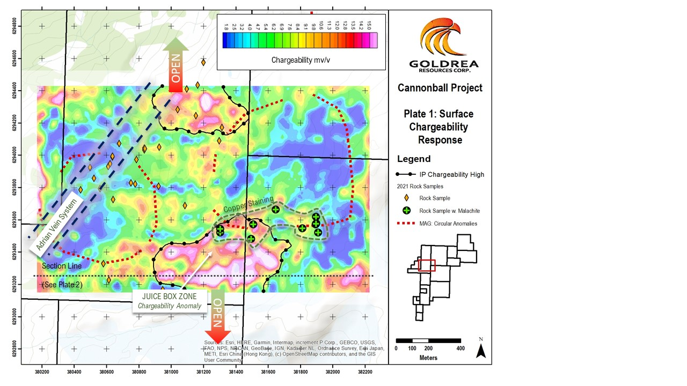
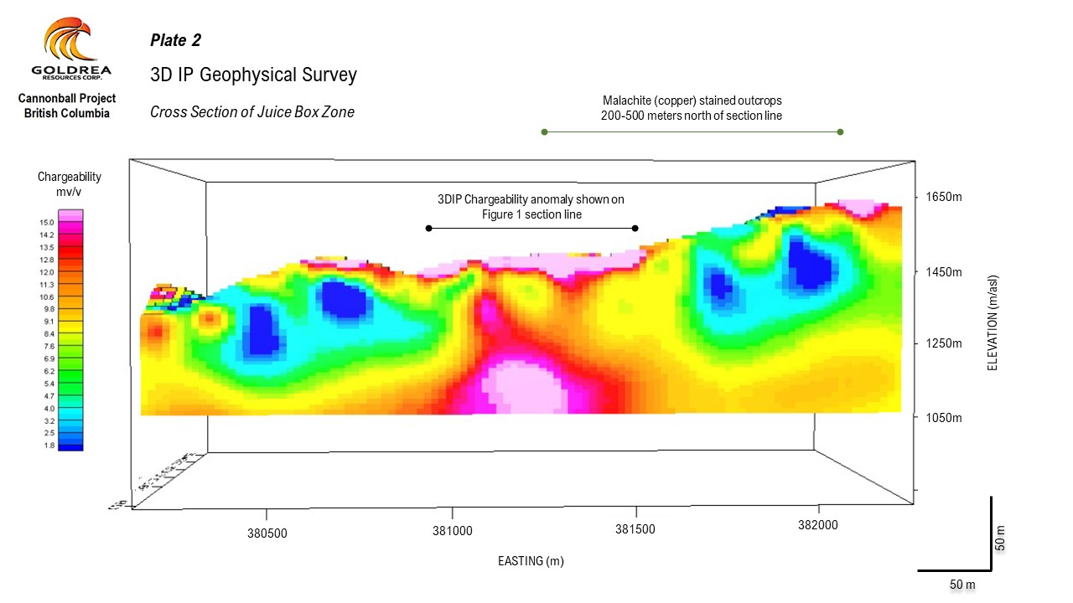
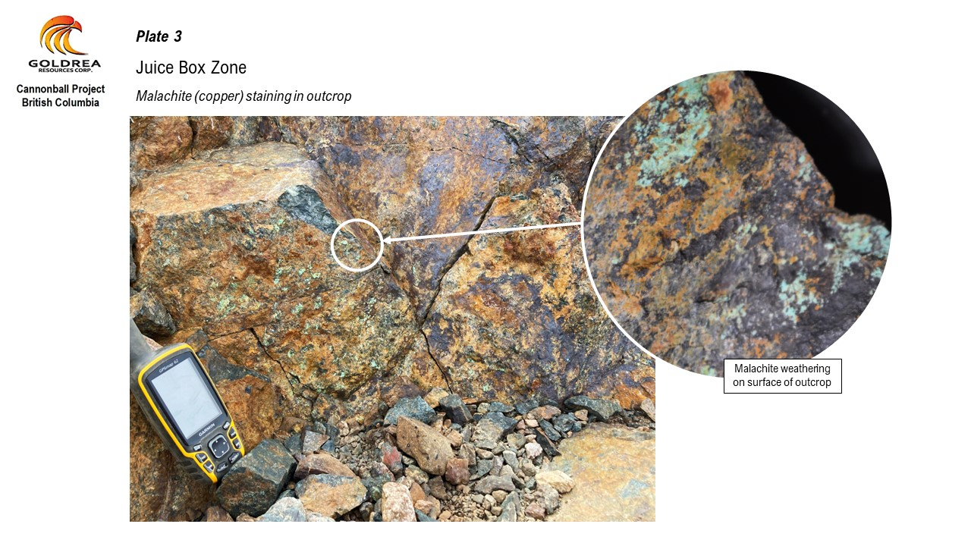
In addition to the chargeability response associated with the Juice Box target, the 3DIP survey also identified a chargeability response in the north central part of the survey grid which appears to be related to the quartz-pyrite-chalcopyrite mineralization associated with the Adrian vein system. This anomaly appears to be open for expansion to the north and represents another significant target for 2022. Additional interpretive work on the 3DIP survey data and planning for the 2022 field program is in progress. The 2021 sampling program assay results are expected in November and will be incorporated into a 43-101 compliant technical report to be filed on SEDAR.

Jim Elbert, Goldrea’s President and CEO, comments, “The discovery of the Juice Box target during the 2021 field program and the results of our recent 3DIP survey is a game changer for Goldrea shareholders. The decision to re-focus on copper potential here has massively increased our expectations. This discovery, combined with the up to 400g/t gold values we encountered during our 2020 fieldwork on the Cannonball target, clearly show that Goldrea’s claims have incredible potential. Goldrea now has three highly prospective targets on the Cannonball Property with arguably the premier location in B.C.’s Golden Triangle.”

Carl von Einsiedel (P.Geo.) is a non-independent Qualified Person within the meaning of National Instrument 43-101 Standards, and has prepared, reviewed and approved the scientific and technical information in this press release.

For more information, please contact:
James Elbert, President and CEO
Telephone: (604) 559-7230
Email: jelbert@goldrea.com

The CSE has not reviewed and does not accept responsibility for the adequacy or accuracy of this release.
This news release may contain "forward-looking statements", which are statements about the future based on current expectations or beliefs. For this purpose, statements of historical fact may be deemed to be forward-looking statements. Forward-looking statements by their nature involve risks and uncertainties, and there can be no assurance that such statements will prove to be accurate or true. Investors should not place undue reliance on forward-looking statements. The Company does not undertake any obligation to update forward-looking statements except as required by law.

