INVESTOR UPDATE
Progress Report on Waverley-Tangier /Brazil Program

July 25, 2011

Dear Investor:

I visited the Waverley-Tangier gold/silver/zinc property approximately 50 kms north of Revelstoke, BC 2 weeks ago. I was accompanied by Al Little a local contractor, to determine whether the recent, ongoing wet weather throughout the province was going to have a further detrimental effect on our availability to access to the property via road.

Last fall, we purchased two bridges to assist in road access to various locations including access to the Tangier dump. Due to the large amount of snowfall last year and a snowpack that is still melting, portions of the road are still too wet to commence repair. In addition, a spring snow slide – not unexpected in this part of the province – has added to our workload. It was apparent that the repairs needed are more extensive than we first believed. However, with a few days of good dry weather, we will have the opportunity to move forward which will allow us access to the Tangier ore tailings. Once there, we will move the material into an area where we can crush and take to the mill for processing.

The drill program at Waverley is schedule to take place this year but due to these conditions, we are now slightly behind schedule; however, the drill company is now just awaiting our go-ahead and we have mobilized a work camp which can accommodate up to 12 people.

Preliminary assessment work with regard to the Amazonia property in Brazil is taking longer than anticipated simply because of the size of the property and its potential for silver, gold, iron ore, manganese and diamonds. Our geological team is assessing preliminary data in preparation for a closer look at one or more locations; in addition, joint venture potential is being weighed. A work program is in the works on a couple of areas and once finalized, we will advise our shareholders.

We have updated our NI 43-101 report on the Amazon basin projects and this has been posted on our website in the Projects section.

- More -

Lastly, I have included some photos of my recent trip at the bottom of this report so you can see what sort of weather we have had to contend with this summer!

Again, I thank all of your for your patience and support as we move the Company forward. I also continue to welcome your calls and emails and please, do feel free to contact us if you would like additional information.

On behalf of the Board,
‘Les Kjosness’
President & CEO

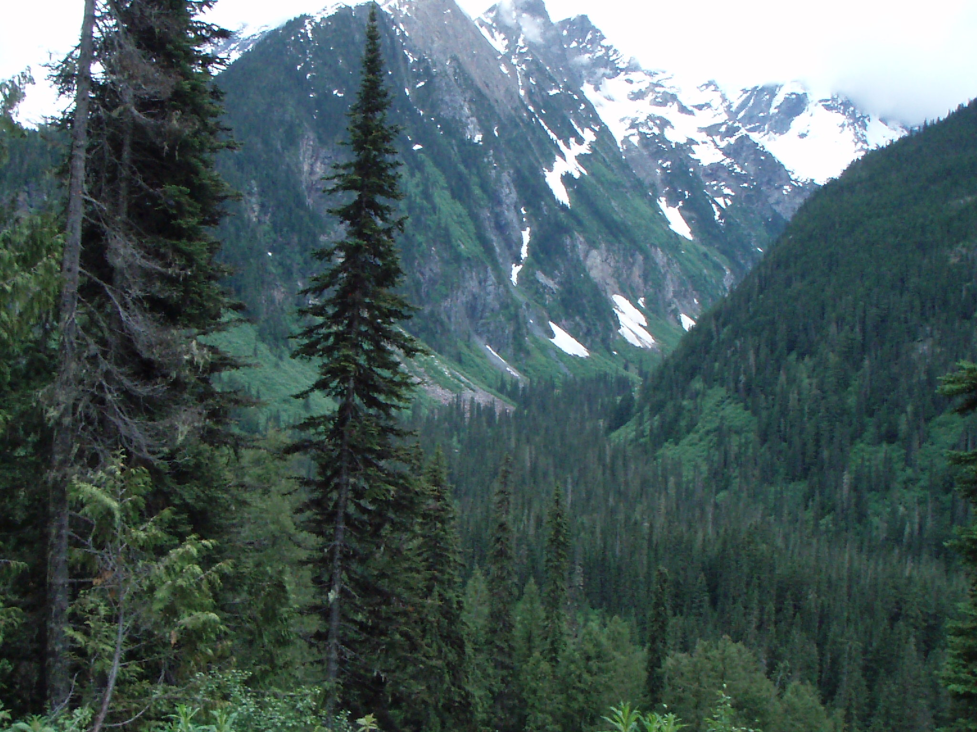
Property location
- More -

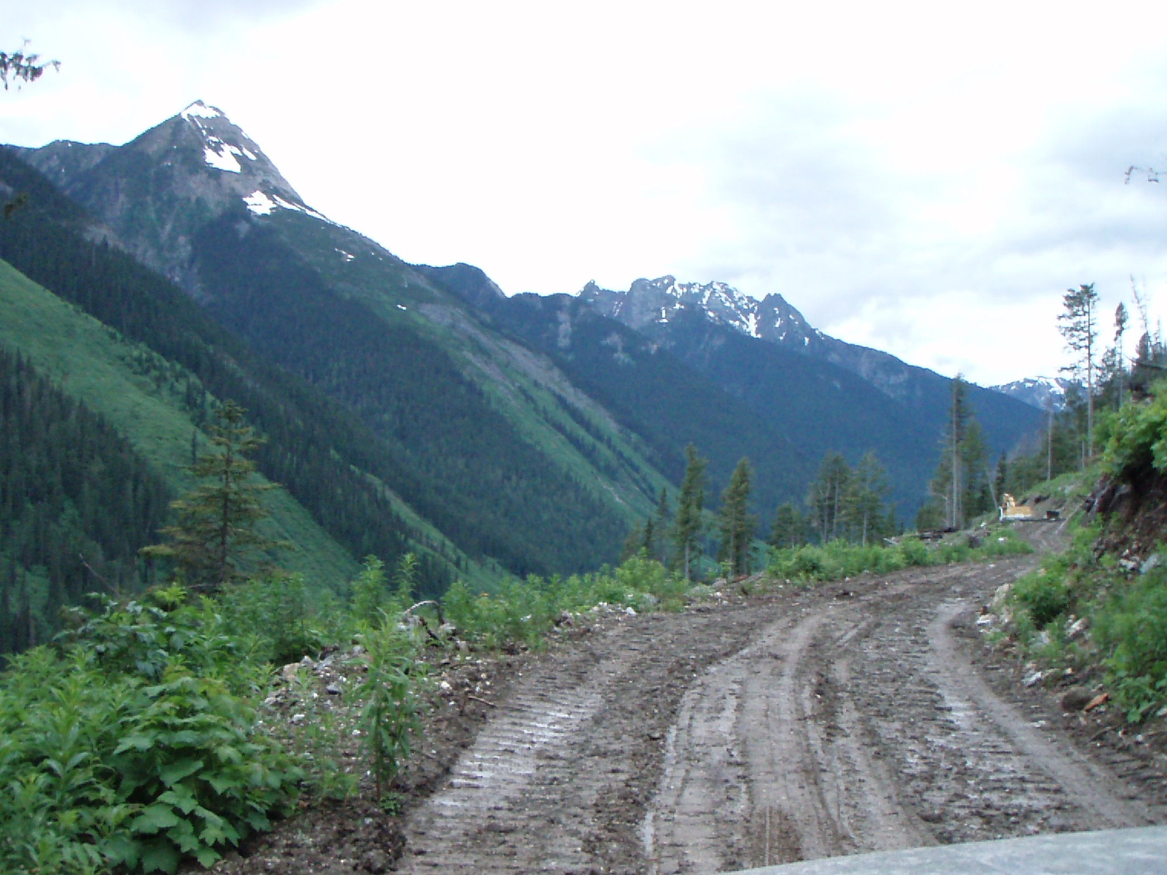

Road to the Waverley-Tangier

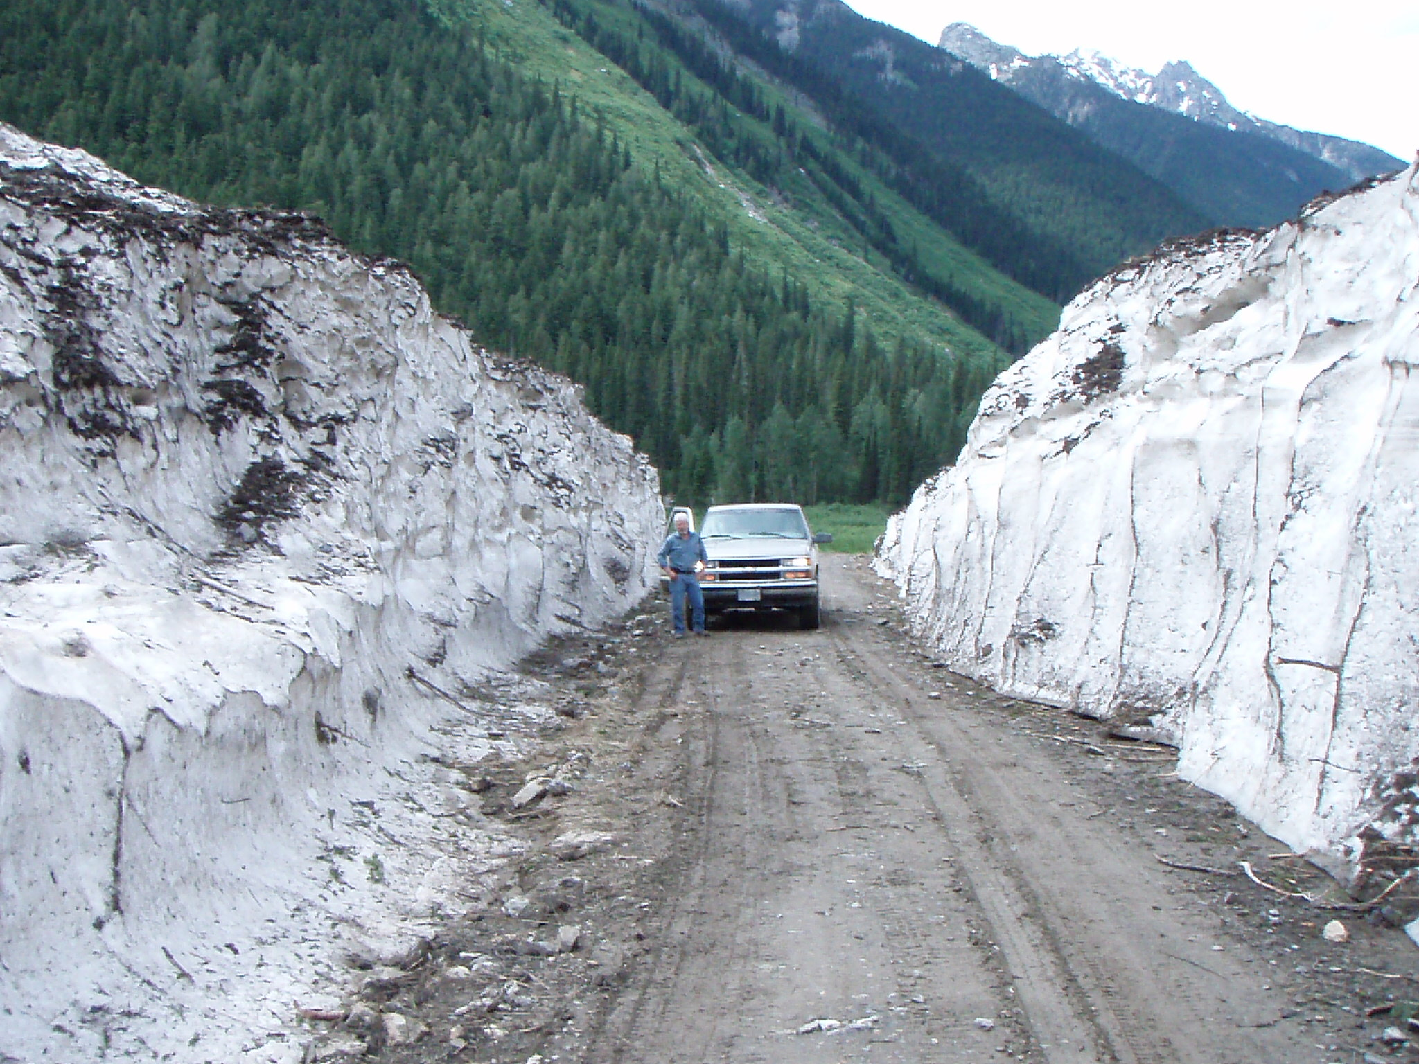

President Les Kjosness at slide area

