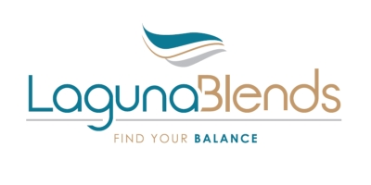
NEWS RELEASE
Laguna Blends Inc. Files Amended and Restated Interim Financial Statements

KELOWNA, BC – February 29, 2016 – Laguna Blends Inc. (CSE: LAG) (Frankfurt LB6.F) (GNRSF OTC) (the “Company” or “Laguna”) wishes to advise that it has filed the following amendments, which documents are publicly available on the SEDAR website at www.sedar.com:
- Amended and Restated Management Discussion and Analysis for the six months ended September 30, 2015;
- Amended and Restated financial statements for the six months ended September 30, 2015; and
- Form 52-109F2R Certifications by the CEO and CFO of Interim Filings Venture Issuer Basic certificates.

The Company has amended its quarterly filing for the six months ended September 30, 2015 to include an increase in Stock Based Compensation expense of $158,506 and an offsetting increase in Reserves. As a result, the Condensed Consolidated Interim Statements of Financial Position, Loss and comprehensive Loss and Cash Flows have been amended to reflect the increase in Stock Based Compensation costs and the corresponding increase in the Reserves account. The statements have also been restated to change the reported period of nine months ended September 30, 2014 to Period from Incorporation on June 24, 2014 to September 30, 2014. Our Management Discussion and Analysis has also been revised accordingly.

About Laguna Blends Inc.
The Company's business is focused on the nutritional health benefits derived from hemp. Laguna is a network marketing company that intends to generate retail sales through independent affiliates. Affiliates utilize tools and technology that enable them to build an international business from their own home or while travelling. The first products to be launched are functional beverage products that provide high levels of protein and/or nutrition.

Laguna’s products are made from high quality hemp protein. Some of the current products are, “Caffe” an instant, “just add water” hot coffee beverage that contains both whey and hemp protein. In addition, the Company plans to market a product called Pro369. This unique single serving "on-the-go" hemp protein is served cold and comes in 4 delicious flavors. Pro369 is water soluble and can be directly mixed in water or added to milk, almond milk or coconut milk. Pro369 can be blended in a shake or smoothie. The Company intends to sell its products through its independent affiliates in the USA and Canada and anticipates launching its business in early 2016.
ON BEHALF OF THE BOARD
“Stuart Gray”
President, Chief Executive Officer,
Chief Financial Officer and Director
FOR INVESTOR RELATIONS INFORMATION PLEASE CONTACT:
Glenn Shand and Associates, LLC
Glenn Shand – Consultant
1-602-284-3840
ir@lagunablends.com
www.lagunablends.com

