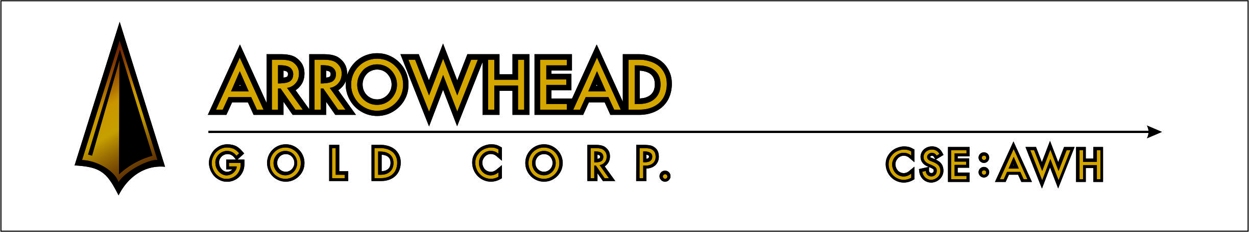

ARROWHEAD GOLD SIGNS DEFINITVE AGREEMENT TO ACQUIRE NUVO ENERGY GRID INC.

Vancouver, B.C., December 15, 2015 - Arrowhead Gold Corp. (the “Company”) (CSE: AWH) is pleased to announce that it has signed a formal Share Exchange Agreement to acquire 100% of the outstanding shares of Nuvo Energy Grid Inc. (“Nuvo”), a private company, with its headquarters in Toronto, Ontario.
Pursuant to the Share Exchange Agreement, Arrowhead will acquire all shares of Nuvo from the Nuvo shareholders in exchange for 13.25 million post consolidated common shares of Arrowhead. Nuvo has sufficient working capital to implement its business plan, and as such, no concurrent financing will be undertaken.
Refer to the Company’s news release of October 16, 2015 for further details concerning the acquisition. Arrowhead will be holding an Annual and Special General Meeting to seek shareholder approval of the proposed transaction. The transaction is also subject to regulatory approval.
Nuvo Energy Grid Inc.
Nuvo is a Private Canadian Company based in Toronto, Ontario; focused on acquiring companies in the Energy Efficiency and Technology sectors.

On Behalf of the Board of Arrowhead Gold Corp.,
“Steve Smith”
President
Neither the Canadian Securities Exchange nor its Market Regulator (as that term is defined in the policies of the Canadian Securities Exchange) accepts responsibility for the adequacy or accuracy of this release.
This news release may contain forward-looking statements based on assumptions and judgments of management regarding future events or results. Such statements are subject to a variety of risks and uncertainties which could cause actual events or results to differ materially from those reflected in the forward-looking statements. There is no assurance the private placement referred to above will close on the terms as stated, or at all. The Company disclaims any intention or obligation to revise or update such statements.

