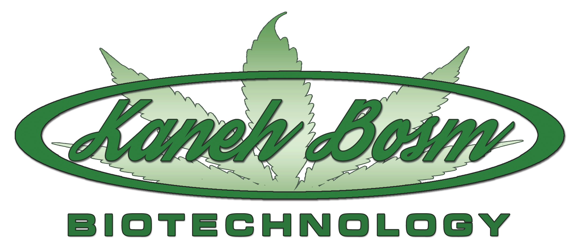
Kaneh Bosm BioTechnology Inc.
810 – 675 West Hastings Street
Vancouver, BC V6B 1N2
Tel: 604.782.4191 Fax: 604.637.9614

NOT FOR DISTRIBUTION TO U.S. NEWS WIRE SERVICES OR DISSEMINATION IN THE UNITED STATES

Kaneh Bosm (KBB:CSE) ANNOUNCES SHARES FOR DEBT & OPTION ISSUANCES

September 9th, 2015
CSE Trading Symbol: KBB

Vancouver, British Columbia
Kaneh Bosm BioTechnology Inc. (“Kaneh Bosm” or the "Company") announces that Kaneh Bosm has entered into an agreement to settle $7,000 of outstanding debt by issuance of 100,000 common shares at a deemed price of $0.07 per share.
The Company has also granted incentive stock options to its Consultants to acquire 300,000 common shares at a price of $0.07 per common share (the "Options").
All securities issued in connection with the shares for debt settlement will be subject to a statutory hold period of four months plus a day from the date of issuance in accordance with applicable securities law. The offering is subject to a number of conditions, including receipt of all necessary corporate and regulatory approvals, including approval of the CSE.
On behalf of the Board of Directors of Kaneh Bosm Inc.

“Michael Martinz”

Michael Martinz
President, Director

“Rudy de Jonge”

Rudy de Jonge
CEO, Director

For further information, contact the company at 604-782-4191 or via email at info@kanehbosmbiotech.com.

THE CSE HAS NOT REVIEWED AND DOES NOT ACCEPT RESPONSIBILITY FOR THE ACCURACY OR ADEQUACY OF THIS RELEASE.

This news release includes certain statements that may be deemed “forward-looking statements”. The use of any of the words “anticipate”, “continue”, “estimate”, “expect”, “may”, “will”, “would”, “project”, “should”, “believe” and similar expressions are intended to identify forward-looking statements. Although the Company believes that the expectations and assumptions on which the forward-looking statements are based are reasonable, undue reliance should not be placed on the forward-looking statements because the Company can give no assurance that they will prove to be correct. Since forward-looking statements address future events and conditions, by their very nature they involve inherent risks and uncertainties. These statements speak only as of the date of this News Release. Actual results could differ materially from those currently anticipated due to a number of factors and risks including various risk factors discussed in the Company’s disclosure documents which can be found under the Company’s profile on www.sedar.com.

