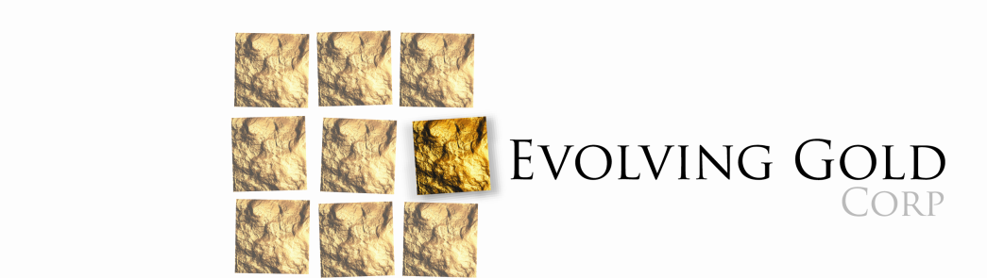

Evolving Gold Restates Year End Financial Statements

August 28th, 2015, Vancouver, British Columbia: Evolving Gold Corp. (CSE: EVG) (FSE: EV7) (OTCB: EVOGF) (the “Company”) announces that subsequent to the release of its financial statements for the year ending March 31st, 2015, management discovered that during the audit process, one of its vendors provided incorrect information with respect to balances owing from the Company. Accordingly, the Company has had to amend and restate its March 31st, 2015 financial statements to include US$107,020 (C$135,314) which had previously been written off based on the incorrect information. For more information about Evolving Gold Corp. please visit: www.evolvinggold.com.
On Behalf of the Board of Directors
EVOLVING GOLD CORP.
“R. Bruce Duncan”
President, CEO and Director
FOR MORE INFORMATION, PLEASE CONTACT:
Investor Relations:
Tel: 604.685.6375
Fax: 604.909.1163
info@evolvinggold.com
Neither the Canada Securities Exchange nor the Market Regulator (as defined in the policies of the Canadian Securities Exchange) accepts responsibility for the adequacy or accuracy of this release.

FORWARD LOOKING STATEMENTS: This news release contains forward-looking statements, which relate to future events or future performance and reflect management’s current expectations and assumptions. Such forward-looking statements reflect management’s current beliefs and are based on assumptions made by and information currently available to the Company. Investors are cautioned that these forward looking statements are neither promises nor guarantees, and are subject to risks and uncertainties that may cause future results to differ materially from those expected. These forward-looking statements are made as of the date hereof and, except as required under applicable securities legislation, the Company does not assume any obligation to update or revise them to reflect new events or circumstances. All of the forward-looking statements made in this press release are qualified by these cautionary statements and by those made in our filings with SEDAR in Canada (available at www.sedar.com).

