FORM 6
CERTIFICATE OF COMPLIANCE
TO: CANADIAN SECURITIES EXCHANGE (“CSE”)
Cascadia Consumer Electronics Corp. (the “Listed Issuer”) hereby certifies to CSE that the Issuer is in compliance with the requirements of applicable securities legislation (as such term is defined in National Instrument 14-101) and all Exchange Requirements (as defined in Policy 1).

Date: March 17, 2015

Signed: 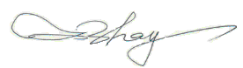
(Signature)
Jing Zhang
(Print Name)
President and Chief Executive Officer
(Print Office)

