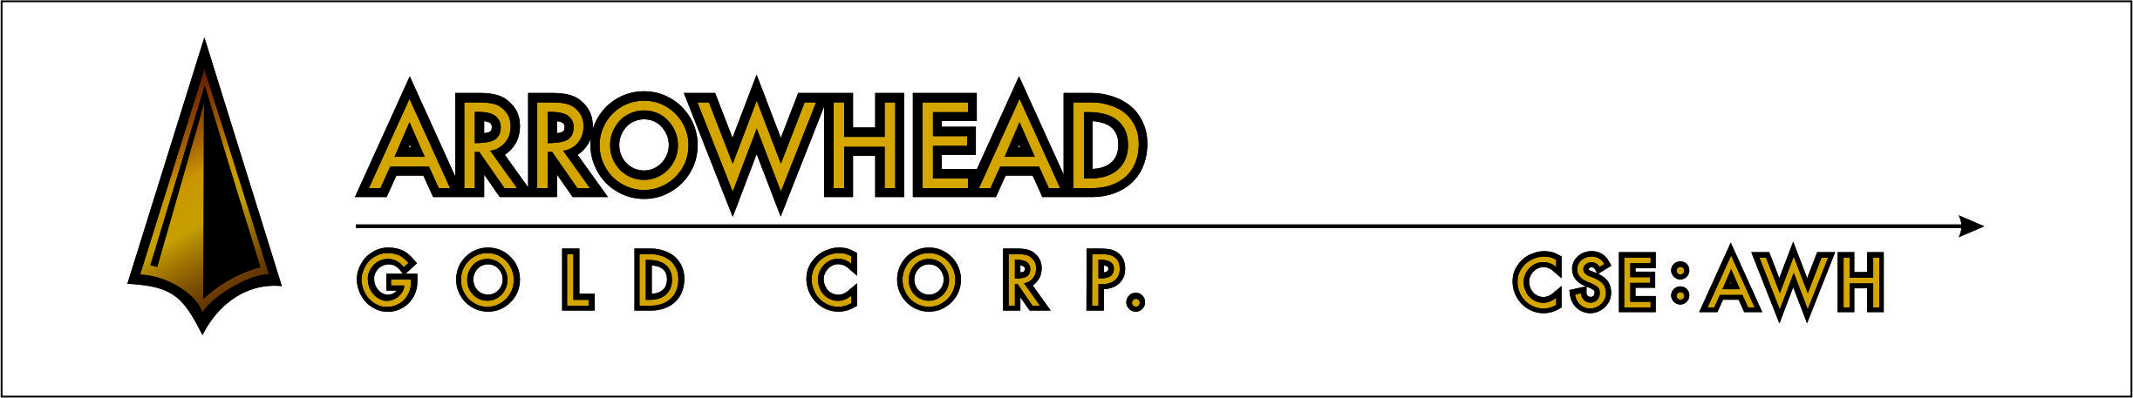

ARROWHEAD CLOSES FIRST TRANCHE OF PRIVATE PLACEMENT

For Immediate Release:

Vancouver, B.C., December 3, 2014 – Arrowhead Gold Corp. (“Arrowhead” or the “Company”) (CSE: AWH) – is pleased to announce that further to its news release dated October 29, 2014, the Company has closed the first tranche of its private placement. The Company has raised an aggregate $101,500 through issuance of 1,268,750 units at a price of $0.08 per unit (“Unit”) in the first tranche closing.

Each Unit consists of one common share and one non-transferrable share purchase warrant (“Warrant”), each Warrant entitling the holder to purchase one common share for the price of $0.20 per share for a period of 24 months following the date of issuance.

No Finder’s fees were paid in connection with the first tranche closing of the private placement.

The securities issued in relation to the first tranche closing are subject to a regulatory four-month hold period expiring April 4, 2015.
The proceeds from the private placement will be used for acquisitions, investments and general working capital to advance the Company's initiatives in the agriculture, pharmaceutical, medical technology, and resources industries.
On Behalf of the Board of Arrowhead Gold Corp.,
“Steve Smith”
President
Neither the Canadian Securities Exchange nor its Market Regulator (as that term is defined in the policies of the Canadian Securities Exchange) accepts responsibility for the adequacy or accuracy of this release.

This news release may contain forward-looking statements based on assumptions and judgments of management regarding future events or results. Such statements are subject to a variety of risks and uncertainties which could cause actual events or results to differ materially from those reflected in the forward-looking statements. There is no assurance the private placement referred to above will close on the terms as stated, or at all. The Company disclaims any intention or obligation to revise or update such statements.

