PRESS RELEASE

RENFORTH RESOURCES INC.

65 Front Street East, Suite 304, Toronto, Ontario, M5E 1B5

Renforth Channel Sampling cuts 22.1 g/t Au over 0.3 m on its Nixon-Bartleman Property

Toronto – September 9, 2014 – Renforth Resources Inc. (CSE: RFR) (“Renforth” or the “Company”) is pleased to report that it has completed a reconnaissance mapping and channel sampling program on its Nixon-Bartleman gold property, in Keefer and Hillary Townships, west of Timmins, Ontario (see acquisition press release Aug. 5, 2014). The property straddles the Porcupine-Destor Fault Zone (“PDFZ”), which has produced over 110 million ounces of gold since the early 1900’s.

Several historic trenches were located on the property within the previously stripped mineralized zone and were sampled to validate the historic assay results. The most significant channel sample assay interval within the stripped area returned 9.4 g/t Au. Interestingly, Renforth obtained a channel sample outside of the historically stripped area which returned 22.1 g/t gold over 0.3 metres. This interval comprises part of a larger interval, which averaged 13g/t gold over 0.6 metres.

The results of this program have validated the historic assays and have increased the size of the historic gold bearing zone, from a previous length of 200 metres to a length which is now over 450 metres.

The results of this program are present on the following figure;
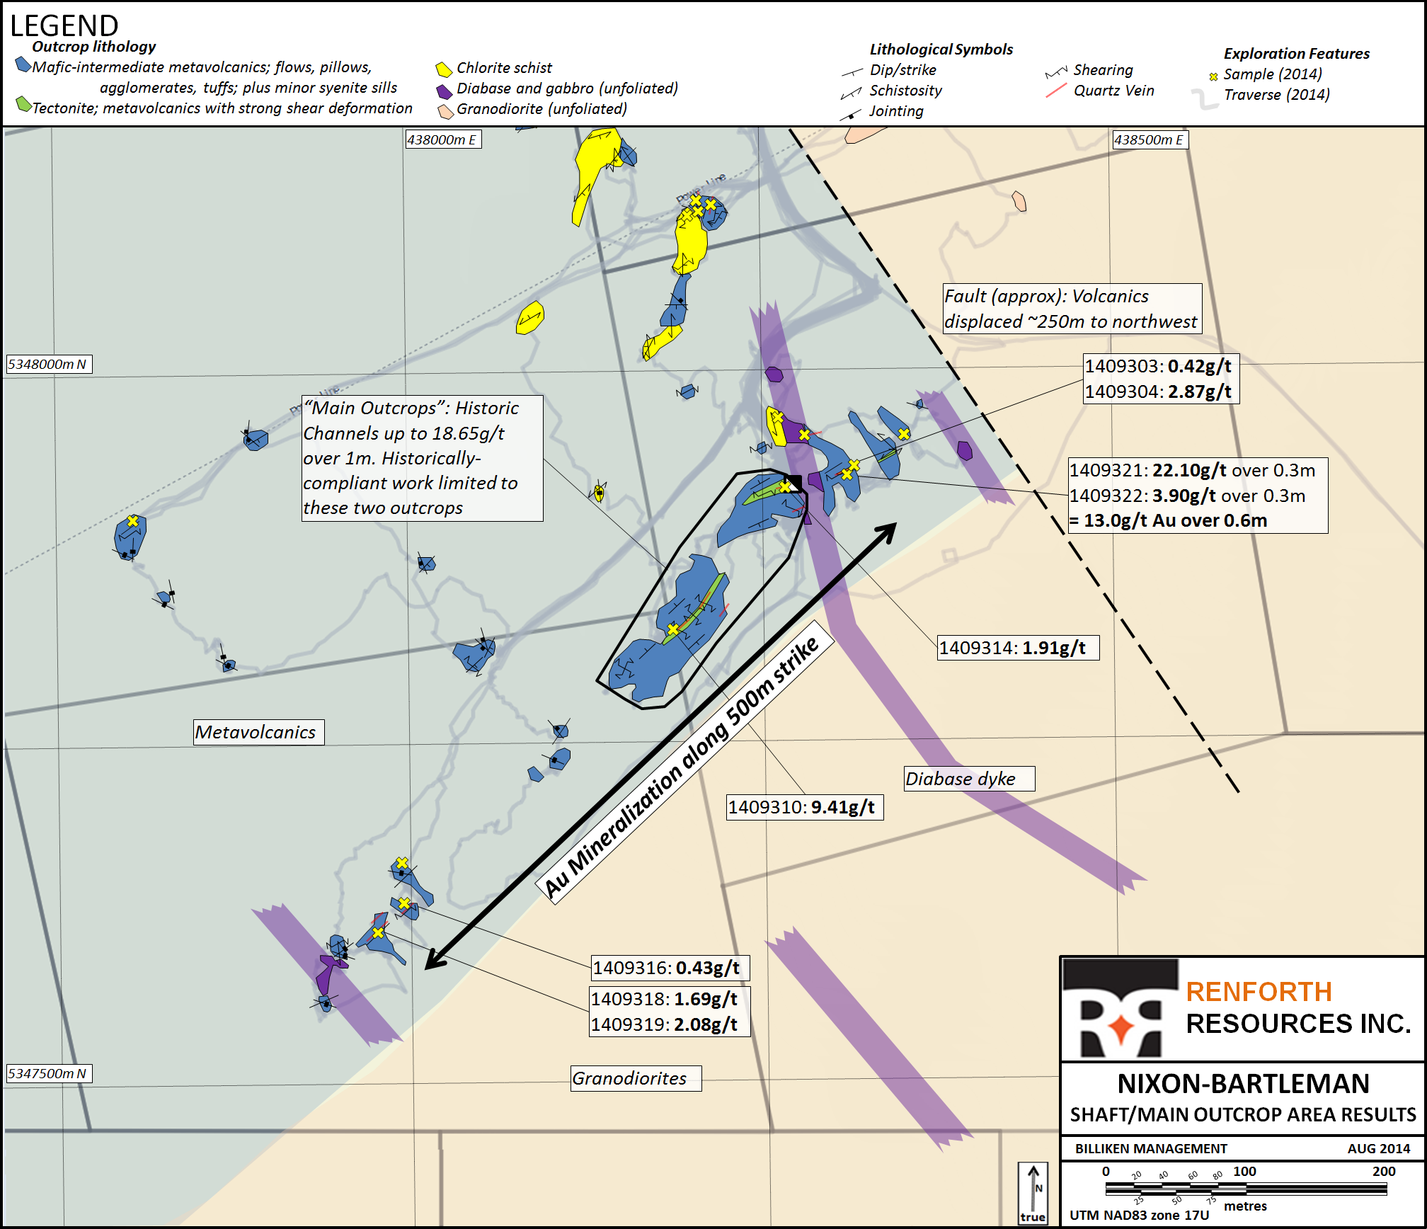

“The Nixon-Bartleman Property hosts classic structurally controlled gold mineralization, the full extent of which has been largely ignored. We are quite optimistic that there is much more to learn at this property as the full potential of this property, given its setting within such a prolific structure, has not been defined. Additional exploration will be undertaken as funding permits in order to better define the structural setting of the main showing and explore known mineralized structures elsewhere on the property. We will focus on the formulation of a structural interpretation conscious of the gold-bearing nature of the cross-cutting features. This structural setting has proven fruitful in this camp and has not been examined on this property as yet.” states Nicole Brewster, President and CEO of Renforth.

Renforth has commenced a compilation of all historic information, both publicly filed and in private hands, which can be located on this property. With the large volume of accessible information available Renforth is confident that the results of this compilation will be helpful in future exploration on the property.

Samples referred to in this press release were obtained in the field by, or under the supervision of, Brian H. Newton P.Geo, a “qualified person” pursuant to the guidelines set out in National Instrument 43-101. Once obtained the samples were bagged and tagged and personally delivered to Agat Laboratories in Sudbury where they underwent analysis procedure 202-052 to fire assay for gold, a gravimetric finish was used for overlimits. Mr. Brian H. Newton P.Geo has reviewed and approved the technical contents of this press release.

ABOUT RENFORTH

Renforth Resources Inc. is a Toronto-based gold exploration company with interests in two of Canada’s gold exploration camps, the New Alger project located on the Cadillac Break outside of Rouyn, Quebec and the Nixon-Bartleman project, located on the Porcupine-Destor fault in the West Timmins Mining area.
For further information please contact:

Renforth Resources Inc.

Nicole Brewster

President and Chief Executive Officer
T: (416) 368.5049
E: nicole@renforthresources.com

No securities regulatory authority has approved or disapproved of the contents of this news release.

Forward Looking Statements

This news release contains forward-looking statements and information under applicable securities laws. All statements, other than statements of historical fact, are forward looking. Forward-looking statements are frequently identified by such words as ‘may’, ‘will’, ‘plan’, ‘expect’, ‘believe’, ‘anticipate’, ‘estimate’, ‘intend’ and similar words referring to future events and results. Such statements and information are based on the current opinions and expectations of management. All forward-looking information is inherently uncertain and subject to a variety of assumptions, risks and uncertainties, including the speculative nature of mineral exploration and development, fluctuating commodity prices, the risks of obtaining necessary approvals, licenses and permits and the availability of financing, as described in more detail in the Company’s securities filings available at www.sedar.com. Actual events or results may differ materially from those projected in the forward-looking statements and the reader is cautioned against placing undue reliance thereon. Forward-looking information speaks only as of the date on which it is provided and the Company assumes no obligation to revise or update these forward-looking statements except as required by applicable law.

