October 19, 2020

Canadian Securities Exchange
First Canadian Place
100 King Street West, Suite 7210
Toronto, Ontario M5X 1E1

Dear Sirs/Mesdames:
Re: Private Placements of Units at $0.09 per Unit
With respect to the non-brokered private placement of units (the “Units”) of Winston Gold Corp. (the “Company”) at a price of $0.09 per Unit (the “Private Placement”) closed on October 16, 2020, we hereby confirm receipt of gross subscription proceeds of $2,413,351 for the issuance of 26,815,013 Units.

Yours very truly,

WINSTON GOLD CORP.

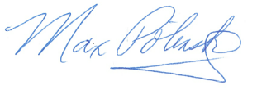
Max Polinsky
Chief Financial Officer

