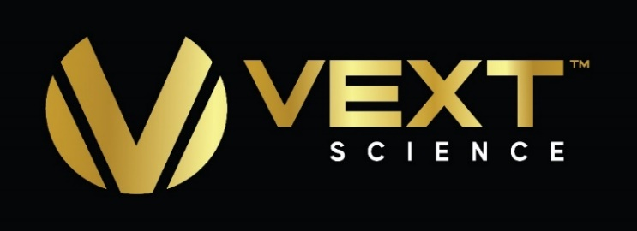
VEXT ANNOUNCES STOCK OPTION GRANT

VANCOUVER, November 27, 2020 /CNW/ - Vext Science, Inc. ("VEXT" or the "Company") (CSE: VEXT; OTCQX: VEXTF) a cannabinoid brand leader based in Arizona, leveraging its core expertise in extraction, manufacturing, cultivation and marketing to build a profitable multi-state footprint, announced today that it has granted 375,000 stock options to certain employees and consultants of the Company. All of the options are exercisable at a price of CAD$0.75, are fully vested and have a 10-year term.
About VEXT Science, Inc.

Vext Science, Inc. is a US-based Cannabis THC and Hemp cannabinoid products company manufacturing THC cartridges, concentrates, edibles and accessories under the Vapen™ Brand, and Hemp based products under the Pure Touch Botanicals brand as well as the Vapen CBD brand. Based in Arizona, Vext Science, Inc. has one of the leading THC concentrates, edibles, and distillate cartridge brands sold in most of the state's 100+ dispensaries. Herbal Wellness Center is one of Arizona's leading dispensaries and we execute all aspects of the cultivation, extraction, edibles infusion and manufacturing processes which insures a product of the highest quality and purity. Product quality and purity are core to our marketing strategy. Vext Science, Inc. is executing its business growth by leveraging experience and expertise in extractions, product manufacturing, and marketing to expand in the U.S. and internationally through revenue and profit-sharing joint venture partnerships. For more information visit our website at www.VextScience.com.

For more details on the Vapen brand:
Vapen website: VapenBrands.com
Instagram: @vapen
Facebook: @vapenclear

COVID-19 Risk Factor
VEXT may be impacted by business interruptions resulting from pandemics and public health emergencies, including those related to COVID-19. An outbreak of infectious disease, a pandemic, or a similar public health threat, such as the recent outbreak of COVID-19, or a fear of any of the foregoing, could adversely impact VEXT by causing operating, manufacturing, supply chain, and project development delays and disruptions, labor shortages, travel, and shipping disruption and shutdowns (including as a result of government regulation and prevention measures). It is unknown whether and how VEXT may be affected if such a pandemic persists for an extended period of time, including as a result of the waiver of regulatory requirements or the implementation of emergency regulations to which VEXT is subject. Although VEXT has been deemed essential and/or has been permitted to continue operating its facilities in the states in which it operates during the pendency of the COVID-19 pandemic, there is no assurance that the Company’s operations will continue to be deemed essential and/or will continue to be permitted to operate. VEXT may incur expenses or delays relating to such events outside of its control, which could have a material adverse impact on its business, operating results, financial condition and the trading price of the Company’s Common Shares.
Forward Looking Statements
Statements in this news release that are forward-looking statements are subject to various risks and uncertainties concerning the specific factors disclosed here and elsewhere in VEXT's periodic filings with Canadian securities regulators. When used in this news release, words such as "will, could, plan, estimate, expect, intend, may, potential, believe, should," and similar expressions, are forward- looking statements.
Forward-looking statements may include, without limitation, statements related COVID-19, to future developments and the business and operations of VEXT, the proposed operational timeline for the joint venture with Texoma and the Processing Facility, and revenue and profit contribution for VEXT’s operations.
Although VEXT has attempted to identify important factors that could cause actual results, performance or achievements to differ materially from those contained in the forward-looking statements, there can be other factors that cause results, performance or achievements not to be as anticipated, estimated or intended, including, but not limited to: dependence on obtaining regulatory approvals; being engaged in activities currently considered illegal under U.S. Federal laws; change in laws; reliance on management; requirements for additional financing; competition; hindered market growth and state adoption due to inconsistent public opinion and perception of the medical-use and adult-use marijuana industry and; regulatory or political change.
There can be no assurance that such information will prove to be accurate or that management's expectations or estimates of future developments, circumstances or results will materialize. Because of these risks and uncertainties, the results or events predicted in these forward-looking statements may differ materially from actual results or events.
Accordingly, readers should not place undue reliance on forward-looking statements. The forward- looking statements in this news release are made as of the date of this release. VEXT disclaims any intention or obligation to update or revise such information, except as required by applicable law, and VEXT does not assume any liability for disclosure relating to any other company mentioned herein.
The Canadian Securities Exchange has not reviewed, approved or disapproved the content of this news release.
Eric Offenberger
Chief Executive Officer

For further information:
Jonathan Ross, VEXT Investor Relations
jon.ross@loderockadvisors.com
416-244-9851

