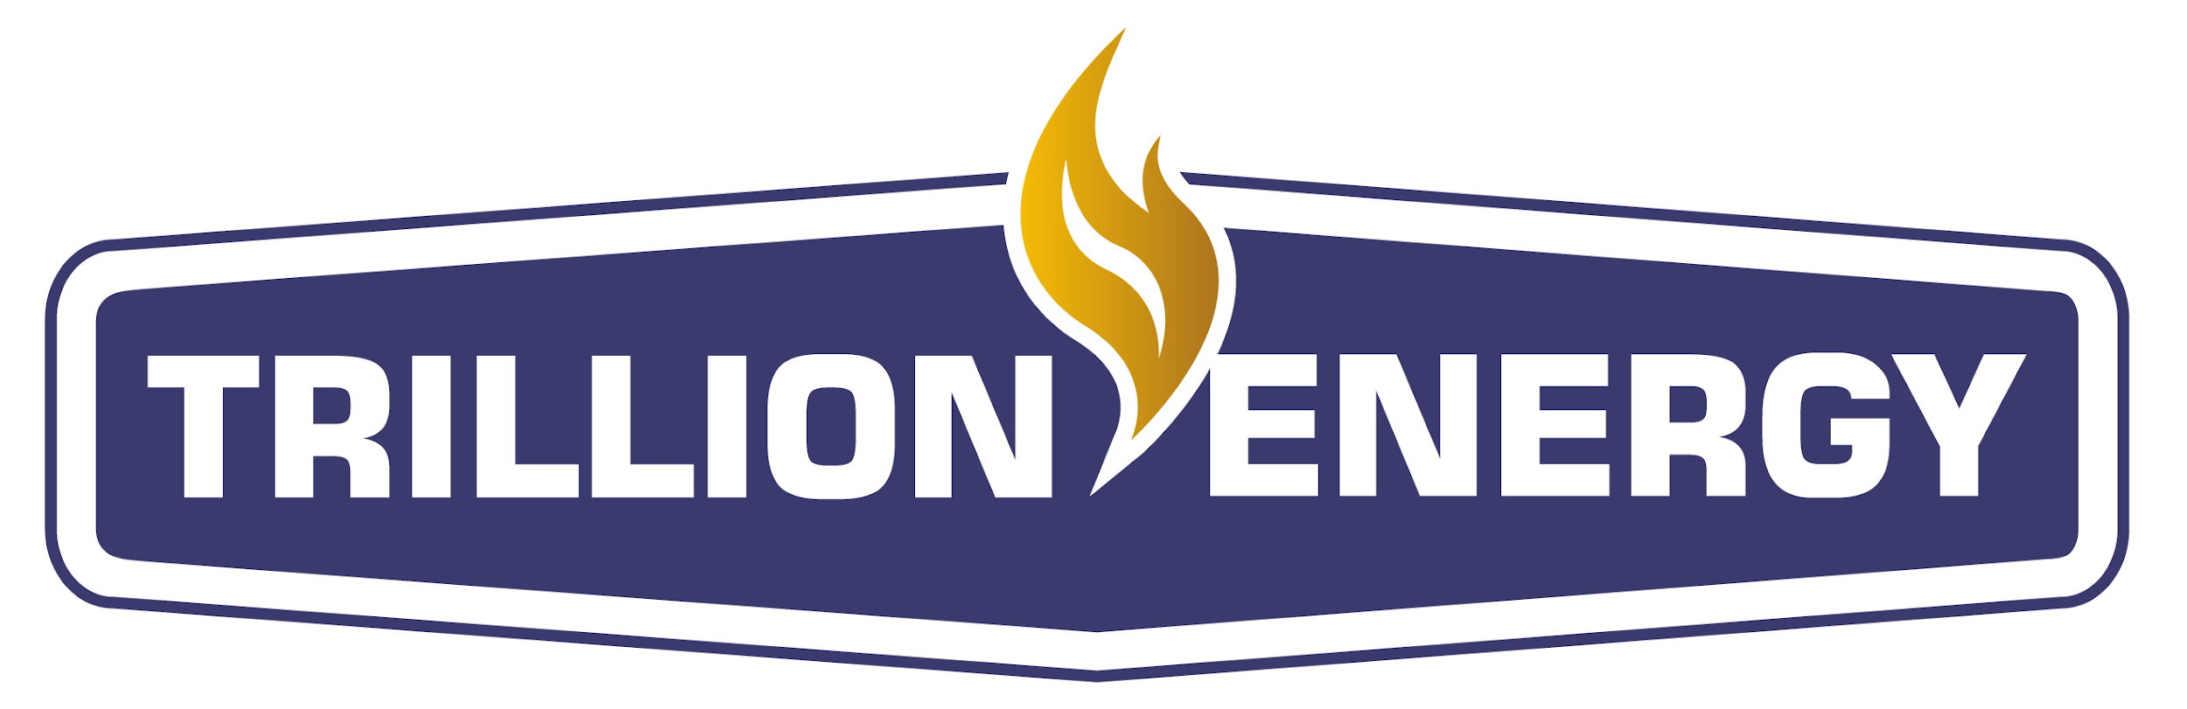

Trillion Energy Announces Debenture Settlement Agreement

March 27, 2026 - Vancouver, B.C. - Trillion Energy International Inc. (“Trillion” or the “Company”) (CSE: TCF) (OTCQB: TRLEF) (Frankfurt: Z62) announces that further to the convertible debenture indenture entered into between the Company and debentureholders dated April 20, 2023 and as supplemented from time to time thereafter for aggregate principal amount of $15,000,000 at 12.0% interest for convertible debentures of the Company (the "Convertible Debentures"), holders (the "Debenture Holders") representing at least 66-2/3% of the principal amount of the Convertible Debentures have signed an extraordinary resolution dated March 20, 2026, authorizing the Company and the debenture trustee Odyssey Trust, to enter into a fourth supplemental debenture indenture (the "Fourth Supplemental Indenture") to amended various terms of the Indenture as described below.

As of March 20, 2026, the Company owes principal and interest to the Debenture Holders, all of which is currently due in the amount of CAD$16,379,828.49 as of January 31, 2026 (principal amount of CAD$14,999,000 plus interest of CAD$1,380,828.49) plus interest accrued to March 20, 2026 (the "Amount Due").

The Company intends to use its best efforts to raise new equity capital for cash consideration through a brokered prospectus offering to investors for an amount not less than CAD$10,000,000 (the “Financing Amount”) to conclude at or before September 30, 2026 (the “Financing”).

The Company and the Debenture Holders entered into the Fourth Supplemental Indenture dated March 20, 2026 and, provided the Company completes the Financing for aggregate proceeds of not less than the Financing Amount, the Amounts Due shall be settled and satisfied in the manner set out in the Fourth Supplemental Indenture (collectively, the “Amendments”).

Subject to and conditional upon the Company completing the Financing for aggregate proceeds of not less than the Financing Amount:

  - The Debenture Holders shall convert $11,000,000 of the Amount Due (the “Converted Amount”) to common shares of the Company at the same price and terms of the Financing completed by the Company. In the event that the Company completes the Financing in one or more separate tranches or offerings, the Debenture Holders shall only be obligated to convert the Convertible Debentures hereunder when the cumulative total raised from the Financing meets or exceeds the Financing Amount; and

  - The remaining portion of the Amount Due (approximately $5.37 million) shall be written off and fully forgiven by the Debenture Holders (the “Forgiven Amount”).

In the event the Financing is completed in more than one tranche or offering at different offering prices, the Debenture Holder’s conversion price shall be equal to the lowest price at which equity capital is issued under the Financing.

In the event the Company does not complete the Financing for aggregate proceeds of not less than the Financing Amount Financing on or before September 30, 2026, this Fourth Supplemental Indenture shall terminate and be of no force and effect after such date, and the Amount Due owing under the Convertible Debentures shall immediately become due and payable, including for greater certainty the Forgiven Amount.

A copy of the Fourth Supplemental Indenture will be filed on SEDAR+ under the Company's profile at www.sedarplus.ca .

About the Company

Trillion Energy International Inc is focused on oil and natural gas production for Europe and Türkiye with natural gas assets in Türkiye. The Company is 49% owner of the SASB natural gas field, a Black Sea natural gas development and a 19.6% (except three wells with 9.8%) interest in the Cendere oil field. More information may be found on www.sedarplus.ca, and our website.
Contact
Sean Stofer, Chairman
Brian Park, VP of Finance
1-778-819-1585
E-mail: info@trillionenergy.com
Website: www.trillionenergy.com

