CRESCO LABS EXPANDS SUNNYSIDE IN FLORIDA’S GULF COAST WITH NEW CLEARWATER DISPENSARY
New Clearwater store expands the Company’s retail presence to 14 locations in one of the largest U.S. medical markets

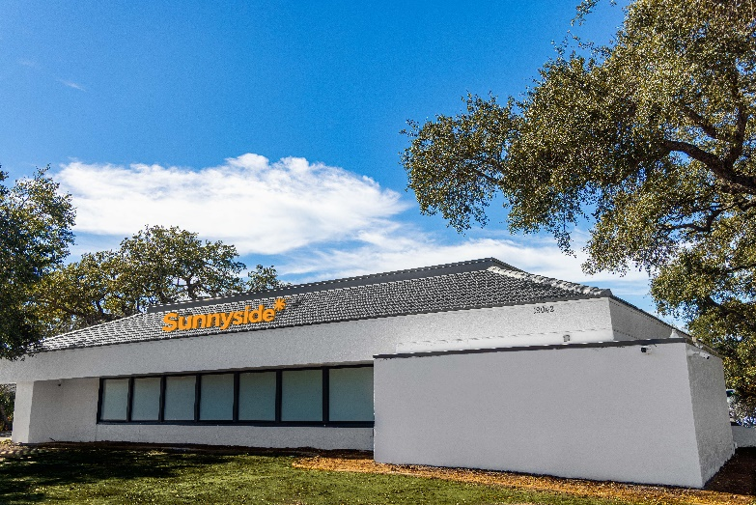
Photo Caption: Cresco Labs opened a new Clearwater, Florida store, its 48th dispensary in the U.S.

Clearwater, Fla. – January 27, 2022 — Cresco Labs (CSE:CL) (OTCQX:CRLBF) (“the Company”), a vertically integrated multistate operator and the number one U.S. wholesaler of branded cannabis products, continues to grow its retail footprint in Florida with today’s opening of Sunnyside Clearwater at 19042 US Hwy 19 N. The new Clearwater store is the Company’s sixth new store opening in Florida and marks its 48th dispensary nationwide. Cresco Labs expects to open a new Sunnyside in N. Miami (505 NE 125th St.) by the end of February, pending city approval.

“Since entering Florida in April 2021, we’ve expanded patient access across Florida. It has been great seeing the reception to our Sunnyside dispensaries and we look forward to launching Cresco Labs’ portfolio of products shortly,” said Charlie Bachtell, CEO & Co-founder at Cresco Labs. “Over the course of 2022, we look forward to bringing Sunnyside to more patients throughout the state.”

Sunnyside Clearwater is a prime retail location on US Hwy 19 N. Patients of the new store will have access one of the largest selections of cannabis products and accessories, including One Plant’s top selling, premium, hand-trimmed flower and solventless live rosin concentrates, as well as pre-rolls, vape cartridges, tinctures, lighters, rolling papers and more.

In addition to the Clearwater store opening, Cresco Labs serves patients through its Sunnyside dispensaries in Avon Park, Boyton Beach, Orlando (Fern Park), Jacksonville Beach, Ocala, Port St. Lucie, St. Petersburg, Bonita Springs, Fort Lauderdale, Oakland Park, Tallahassee, Pensacola and Sarasota.

For more information about Sunnyside and to place online orders, visit www.Sunnyside.shop.

About Cresco Labs
Cresco Labs is one of the largest vertically integrated multistate cannabis operators in the United States, with a mission to normalize and professionalize the cannabis industry. Employing a consumer-packaged goods (“CPG”) approach, Cresco Labs is the largest wholesaler of branded cannabis products in the U.S. Its brands are designed to meet the needs of all consumer segments and comprised of some of the most recognized and trusted national brands including Cresco, High Supply, Mindy's Edibles, Good News, Remedi, Wonder Wellness Co. and FloraCal Farms. Sunnyside, Cresco Labs’ national dispensary brand, is a wellness-focused retailer created to build trust, education and convenience for both existing and new cannabis consumers. Recognizing that the cannabis industry is poised to become one of the leading job creators in the country, Cresco Labs operates the industry’s largest Social Equity and Educational Development initiative, SEED, which was established to ensure that all members of society have the skills, knowledge and opportunity to work and own businesses in the cannabis industry. Learn more about Cresco Labs at www.crescolabs.com.

About Sunnyside
Sunnyside is where cannabis meets wellness. The nationwide cannabis retailer aims to educate today’s diverse users on cannabis’ many positive benefits and provides one of the widest ranges of cannabis brands. A more sophisticated and familiar shopping destination that combines high-end design from healthcare, retail and hospitality, Sunnyside elevates the value dispensaries can add to a community with a bright, welcoming aesthetic and convenient shopping whether in store, online or delivery. Visit Sunnyside.shop to learn more.

###

