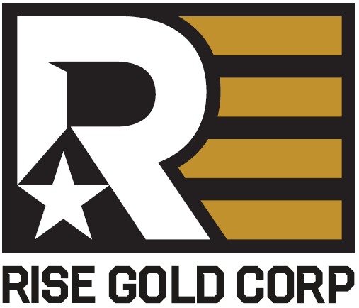.

Rise Gold Closes US$1.0 M in Debt Financing

September 3, 2019 – Vancouver, British Columbia – Rise Gold Corp. (CSE: RISE, OTCQB: RYES) (the “Company”) announces that it has closed the US$1 M debt financing with Eridanus Capital LLC previously announced in its August 20th, 2019 news release. Eridanus Capital LLC is an affiliate of Myrmikan Capital, LLC, which operates in the gold and silver junior mining sector.

The Loan Principal of US$1,000,000 may be used for engineering, permitting, and working capital at the Idaho-Maryland Gold Project and is secured against the assets of the Company.
The Loan has a term of 2 years. Interest will be accrued at an annual interest rate of 10% and be paid along with the Principal on the Maturity Date. The total repayment at the Maturity Date will be US$1,200,000.

The Lender will be issued 11,500,000 share purchase warrants as consideration for advancing the Loan. Each warrant entitles the holder to acquire one Share of the Company at an exercise price of C$0.10 for a period of three years from the date of issuance. The warrants and any securities issued upon exercise of the warrants are subject to statutory hold periods in accordance with applicable United States and Canadian securities laws.

The Company has the option, at its sole discretion, to extend the repayment of the loan up to an additional 2 years past the Maturity Date. If the Company exercise its rights to extend repayment, the annual interest rate would increase to 20% in year 3 and 25% in year 4. The Company also has the option, at its sole discretion, to repay the loan before the 2-year Maturity Date. If the Company exercises its right of early repayment, the minimum interest charge will be US$200,000.

The Company announces it will not proceed with the final C$500,000 tranche of the Equity Financing previously announced on August 20th, 2019. The Company previously closed a total of C$3,933,619, which has fully closed with all funds received, in two tranches of the Equity Financing as announced on August 20th and July 11th, 2019.
The securities offered have not been registered under the United States Securities Act of 1933, as amended (the “U.S. Securities Act”), or any state securities laws and may not be offered or sold absent registration or compliance with an applicable exemption from the registration requirements of the U.S. Securities Act and applicable state securities laws.

About Rise Gold Corp.
Rise Gold is an exploration-stage mining company. The Company’s principal asset is the historic Idaho-Maryland Gold Mine located in Nevada County, California, USA. The Idaho-Maryland Gold Mine is a past-producing gold mine with total past production of 2,414,000 oz of gold at an average mill head grade of 17 gpt gold from 1866-1955. Historic production at the Idaho-Maryland Mine is disclosed in the Technical Report on the Idaho-Maryland Project dated June 1st, 2017 and available on www.sedar.com. Rise Gold is incorporated in Nevada, USA and maintains its head office in Vancouver, British Columbia, Canada.

On behalf of the Board of Directors:

Benjamin Mossman
President, CEO and Director
Rise Gold Corp.

For further information, please contact:
RISE GOLD CORP.
Suite 650, 669 Howe Street
Vancouver, BC V6C 0B4
T: 604.260.4577
info@risegoldcorp.com
www.risegoldcorp.com

The CSE has not reviewed, approved or disapproved the contents of this news release.

Forward-Looking Statements

This press release contains certain forward-looking statements within the meaning of applicable securities laws. Forward-looking statements are frequently characterized by words such as “plan”, “expect”, “project”, “intend”, “believe”, “anticipate”, “estimate” and other similar words or statements that certain events or conditions “may” or “will” occur.

Although the Company believes that the expectations reflected in the forward-looking statements are reasonable, there can be no assurance that such expectations will prove to be correct. Such forward-looking statements are subject to risks, uncertainties and assumptions related to certain factors including, without limitation, obtaining all necessary approvals, meeting expenditure and financing requirements, compliance with environmental regulations, title matters, operating hazards, metal prices, political and economic factors, competitive factors, general economic conditions, relationships with vendors and strategic partners, governmental regulation and supervision, seasonality, technological change, industry practices, and one-time events that may cause actual results, performance or developments to differ materially from those contained in the forward-looking statements. Accordingly, readers should not place undue reliance on forward-looking statements and information contained in this release. Rise undertakes no obligation to update forward-looking statements or information except as required by law.

