Relay Medical and Fio Corporation Announce the Signing of MOU Agreement to Collaborate on a Rapid Diagnostic Testing Platform
May 15, 2020 – Relay Medical Corp. (“Relay” or the “Company”) (CSE: RELA, OTC: RYMDF, Frankfurt: EIY2), and Fio Corporation (“Fio”) are pleased to announce the signing of a memorandum of understanding (“MOU” or the “Agreement”) to define a mutually beneficial collaboration to accelerate the enhancement of Fio’s Data-Device Platform as a COVID-19 testing, data collection and reporting platform.
Under the terms of the agreement Relay will provide expertise in medical technology development and commercialization as well as the integration of compatible and complementary assets from its portfolio including HemoPalm Corp. and Pharmatrac technologies to enhance Fio’s data-device platform for COVID-19 testing regimes using third-party rapid diagnostic tests (RDT). Fio’s technology has been proven for community-based RDT testing, triage, and tracking to manage outbreaks of high-consequence infectious diseases, such as malaria, HIV, dengue, and others.
The objective of the MOU is for the companies to jointly form a plan and partnership for the rapid expansion of Fio’s platform to encompass multiple emerging COVID-19 tests. The companies will assess and establish a collective infrastructure for the advancement and pursuit of commercial opportunities related to the project with the intent to execute a definitive agreement within 60 days from signing.
During the MOU period both companies will allocate resources to the project and Relay will provide development resources including its extensive expertise in medical device development, regulatory strategy, diagnostics, software and artificial intelligence, project management and its lab, workshop, and office space to support the growing operational requirements of the partnership.
"The COVID-19 situation will evolve - new and more tests, new triage procedures, new treatments, and ups and downs in threat patterns. In this time, a safe return to social and economic life can be accomplished only by new, rapid, and flexible technological responses. This requires companies to combine capabilities for a common purpose, which is what Relay and Fio are doing." said Dr. Michael Greenberg, CEO of Fio Corporation.
“It is clear that COVID-19 will continue to present multiple healthcare challenges before we move into the next phase of recovery and we are very excited to participate in the delivery of a meaningful technological solution to potentially give individuals, families and governments the confidence required to return to day-to-day life, and do so safely as we continue to fight the pandemic.” said Yoav Raiter, CEO, Relay Medical Corp.
"Fio's data-device platform, Fionet, offers an elegant and powerful way to solve many COVID-19 testing problems, from the administration of efficient serological surveys that enable public health decision making, to the practical assurance of biosecurity at work, public, and educational facilities. Relay's HemoPalm team looks forward to working with Fio to create optimized solutions for these challenges." said Paul Glavina, VP In Vitro Diagnostics, Relay Medical Corp.
On April 29, 2020 Fio Corporation, with Relay as a joint-venture partner, filed a proposal to Innovative Solutions Canada through the COVID-19 Testing Stream Call for Proposals for a grant to test a jointly developed COVID-19 antibody testing platform with a federal government organization.
Need for distributed COVID-19 testing using RDTs
Rapid diagnostic tests are being developed for active infections targeting antigens of the COVID-19 virus and for detecting past infections and immune response by detecting the presence of specific antibodies. These tests are typically lateral flow rapid diagnostic strips, similar to an over-the-counter pregnancy test, and offer low-cost and simple operation and can be manufactured at high volumes. However, such tests suffer from several issues including lack of automation and a requirement for visual human interpretation to determine the outcome. In a mass testing regime, manual interpretation can have significantly high error rates, and documenting and communicating the results is not streamlined and is subject to transcription errors. Given the importance of the data, tools which can help reduce error rates, automate interpretation, and collate results are needed to facilitate safe and effective mass testing of the population for disease presence and exposure.
Details of Fionet Platform
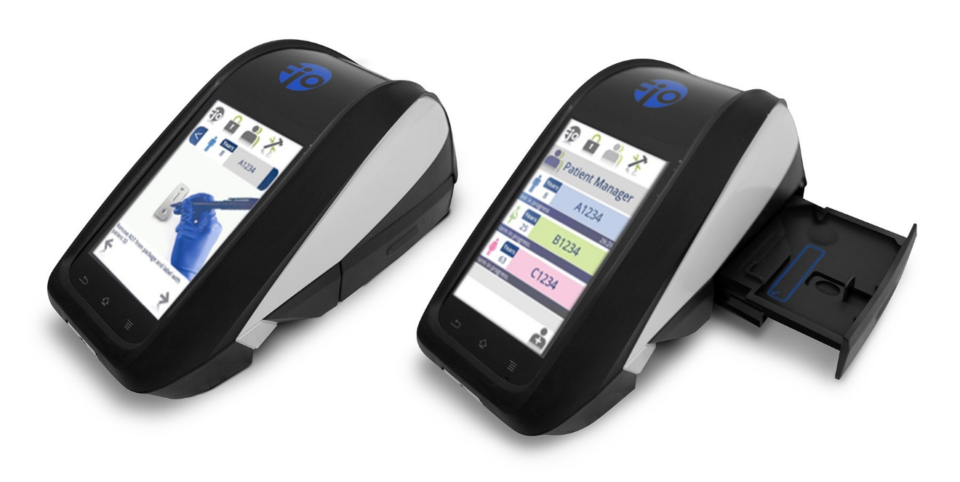
Fio Deki Device as part of the Fionet diagnostic solution platform

Fio’s platform enables distributed testing and automated aggregation of diagnostic data from multiple diagnostic devices that can support public health decisions with accurate, real-time data. Its components are:
• Fio Deki Mobile Device
o A rugged mobile RDT reader that improves diagnostic quality and testing accuracy
o Includes procedures and protocols for running approved RDT tests
o Machine interpretation of RDT tests
o Compatible with third-party diagnostic tests, devices, and laboratory instruments.
o Real-time data capture and geotagging
• Fionet Cloud
o Device connectivity even in areas with poor connectivity
o Seamless data exchange with 3rd party health databases
o Secure, encrypted storage of private health data
o Remote updating of protocols and software to Fio Mobile devices
• Fionet Online Portal
o Oversight of testing results and protocol adherence
o Intervention planning with real-time, anonymous epidemiological data
o Track and evaluate resource allocation and efficiency

The Company’s platform has been deployed in 12 countries where frontline healthcare workers have benefitted 1 million patients for testing, triage, and management of diseases such as Malaria and HIV. The information collected from these health visits resulted in over 50 million data points that were available in near real-time for Public Health managers. With Fionet, public health authorities were able to reduce diagnostic errors, ensure correct testing and clinical procedures, monitor performance, capture data and support supply chain management¹.

COVID-19 Pandemic Adaptation
Fio and Relay’s collective aim is to offer a system that is automated and ready to perform mass distributed testing, triage, and tracking for COVID-19 organized by public health agencies and private sector companies. This will require efforts to customize the Fio platform for specific COVID-19 approved third-party RTDs and ensure that the device is compliant with FDA, Health Canada, and other medical device standards. Innovations are envisioned to expand the software’s security, workflow, throughput, and data capture for mass serological surveillance programs.
**The Companies are not making any express or implied claims that its product has the ability to eliminate, cure or contain the COVID-19 (or SARS-2 Coronavirus) at this time.
¹Adah, P., Maduka, O., Obasi, O. et al. The role of the Deki Reader™ in malaria diagnosis, treatment and reporting: findings from an Africare pilot project in Nigeria. Malar J 17, 221 (2018). https://doi.org/10.1186/s12936-018-2356-8
About Fio Corp.
Fio Corporation, privately held and headquartered in Toronto, developed and markets the world’s first integrated guidance & tracking IT platform for decentralized healthcare settings, a new category of solution that raises healthcare quality and lowers healthcare costs. The platform enables average healthcare workers in clinics to deliver a new level of quality-controlled diagnostic testing and case management. Simultaneously, as an automated by-product of its clinical use, the platform captures and provides unprecedented frontline data to remote supervisors and stakeholders, enabling real-time remote tracking, insight distribution, and intervention. Fio operates globally in partnership with local distribution, service, and support organizations and also partners with other companies that license its technologies.
Website: www.fio.com
About Relay Medical Corp.
Relay Medical is a MedTech innovation Company headquartered in Toronto, Canada focused on the development of novel technologies in the diagnostics and AI data science sectors.
Website: www.relaymedical.com
Contact:
W. Clark Kent
President
Relay Medical Corp.
Office. 647-872-9982 ext. 2
TF. 1-844-247-6633 ext. 2
investor.relations@relaymedical.com
Bernhard Langer
EU Investor Relations
Office. +49 (0) 177 774 2314
Email: blanger@relaymedical.com
Forward-looking Information Cautionary Statement
Except for statements of historic fact, this news release contains certain "forward-looking information" within the meaning of applicable securities law. Forward-looking information is frequently characterized by words such as "plan", "expect", "project", "intend", "believe", "anticipate", "estimate" and other similar words, or statements that certain events or conditions "may" or "will" occur. Forward-looking statements are based on the opinions and estimates at the date the statements are made, and are subject to a variety of risks and uncertainties and other factors that could cause actual events or results to differ materially from those anticipated in the forward-looking statements including, but not limited to delays or uncertainties with regulatory approvals, including that of the CSE. There are uncertainties inherent in forward-looking information, including factors beyond the Company’s control. There are no assurances that the commercialization plans for HemoPalm Corp. described in this news release will come into effect on the terms or time frame described herein. The Company undertakes no obligation to update forward-looking information if circumstances or management's estimates or opinions should change except as required by law. The reader is cautioned not to place undue reliance on forward-looking statements. Additional information identifying risks and uncertainties that could affect financial results is contained in the Company’s filings with Canadian securities regulators, which filings are available at www.sedar.com

