Phyto Extractions™ (Adastra Labs) Launches New Shatter Product Line to Canadian Retail Market in Time for 420
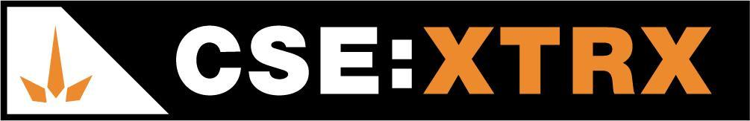
Langley, BC / Accesswire / April 9, 2021 – Phyto Extractions Inc. (formerly, Adastra Labs Holdings Ltd.) (CSE: XTRX) (Frankfurt: D2EP) (“Phyto Extractions™” or the “Company) is proud to announce the launch of three new Shatter Products, adding to its product line in the burgeoning cannabis extracts market.

About Shatter Products

A favourite among Cannabis enthusiasts, Phyto Extractions’™ shatter product line launches with three of the most popular cannabis strain extracts on the market through its one-gram offerings; Pink Kush, Blueberry Gorilla and Death Bubba.

Phyto Extractions’™ current increasing market share in the disposable vape, vape cartridge and live resin markets, strengthens the brands launch of its new flagship shatter product line. With relatively few players in the shatter product space in Canada, this expansion represents a significant opportunity given the forecasted growth of the Cannabis extract market.
Staying true to the corporate mission of being: “...a cannabis brand grown from its legacy roots as the first real name in extracts to deliver the experience of quality and value through all of our product offerings.” Phyto Extractions will be pricing its products to strive to be the lowest priced in every market served in the specific formats offered.

“Our goal is not only to serve existing cannabis enthusiasts with the quality and value they demand,” said David Kolby, VP of Marketing. “Our strategy is to send a signal to black market consumers as well, that there are legal market players that want their business and are willing to do what it takes to attract them to the legal market with safe and competitive product offerings.”

The Shatter products will be launched in British Columbia, Alberta, Saskatchewan, Manitoba, and Ontario with the rest of Canada to follow soon thereafter, in addition to new shatter products that are in development.

About Phyto Extractions™
Phyto Extractions™ is an agricultural-scale cannabis extraction, distillation and product manufacturer located in Langley, BC at its co-located Health Canada Licensed Standard Processing (extraction, no cultivation), Sales (extracts, topicals, and edibles) through Adastra Labs Inc. and Analytical Testing Laboratory through Chemia Analytics Inc. Adastra Labs also has a pending Health Canada R&D license amendment.

ON BEHALF OF THE BOARD
ADASTRA LABS HOLDINGS LTD.
Contact: J. Scott Munro, President, CEO & Director (Chairman)
Phone: (778) 715-5011
Email: scott@adastralabs.ca

Forward-Looking Information:
This news release includes forward-looking information within the meaning of Canadian securities legislation, concerning the business of the Company. Forward-looking information is based on certain key expectations and assumptions made by the management of the Company. Although the Company believes that the expectations and assumptions on which such forward-looking information is based are reasonable, undue reliance should not be placed on the forward-looking information because the Company can give no assurance that they will prove to be correct. Forward-looking information in this news release includes statements with respect of the proposed name change, proposed consolidation, the closing of the private placement and the use of proceeds thereof. There are numerous risks and uncertainties that could cause actual results and the Company’s plans and objectives to differ materially from those expressed in the forward-looking information, including: (i) adverse market conditions; (ii) risks inherent in the cannabis extraction sector in general; (iii) inability to close the private placement for any reason, or in the amounts expected by the Company; and (iv) other factors beyond the control of the Company. Actual results and future events could differ materially from those anticipated in such information. These and all subsequent written and oral forward-looking information are based on estimates and opinions of management on the dates they are made and are expressly qualified in their entirety by this notice. Except as required by law, the Company does not intend to update these forward-looking statements.
The CSE has not reviewed or approved of any contents of this news release.

