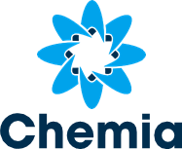

Adastra Labs Announces Update on Proposed
Name Change & Share Consolidation
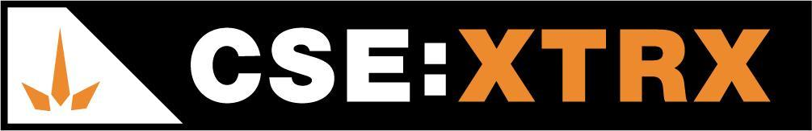
Langley, BC / Accesswire / April 8, 2021 - Adastra Labs Holdings Ltd. (CSE: XTRX) (Frankfurt: D2EP) (“Adastra Labs” or the “Company) announces that the Company’s proposed name change to “Phyto Extractions Inc.” and concurrent consolidation (on the basis of 1 post consolidated common share for every three pre-consolidation shares) will be effective market open on April 9, 2021, as per the bulletin posted by the Canadian Securities Exchange (“CSE”). There will be no change to the Company’s trading symbol.

Following the consolidation, the Company anticipates there will be 43,333,995 common shares issued and outstanding. The record date for the consolidation is April 12, 2021 with an effective date of April 9, 2021.

Shareholders will receive a letter of transmittal from the Company’s transfer agent with instructions on how to exchange their current share certificates with new share certificates or direct registration statements (also known as, DRSs) of the Company reflecting post-consolidation/post-name change shares. A copy of the letter of transmittal will also be posted on the Company’s SEDAR profile accessible at www.sedar.com. The Company’s new CUSIP and ISIN is 71945P103 and CA71945P1036, respectively.

Update on Financing

The Company continues to proceed with its previously announced private placement equity unit offering, with each unit consisting of one common share and one whole warrant priced at $1.10 per unit on a post-consolidation basis. The financing will be undertaken to raise working capital for expanded growth of business operations, Phyto Extraction™ product offerings (16+ new SKUs) (pending closing of the acquisition), marketing, and sales throughout Canada. The financing will be on a private placement or exempt basis to qualified investors, mainly accredited investors. Interested parties can contact the Company for more information and should consult their own independent financial and legal advisors with respect of their interest and potential investment into the Company.

About Adastra Labs
Adastra Labs is an agricultural-scale cannabis extraction, distillation and product manufacturer located in Langley, BC at its co-located Health Canada Licensed Standard Processing (extraction, no cultivation), Sales (extracts, topicals, and edibles) and Analytical Testing Laboratory (Chemia Analytics) facilities. Chemia Analytics is a wholly-owned subsidiary of the Company. Adastra Labs also has an R&D license amendment pending Health Canada approval.

ON BEHALF OF THE BOARD
ADASTRA LABS HOLDINGS LTD.
Contact: J. Scott Munro, President, CEO & Director (Chairman)
Phone: (778) 715-5011
Email: scott@adastralabs.ca

Forward-Looking Information:
This news release includes forward-looking information within the meaning of Canadian securities legislation, concerning the business of the Company. Forward-looking information is based on certain key expectations and assumptions made by the management of the Company. Although the Company believes that the expectations and assumptions on which such forward-looking information is based are reasonable, undue reliance should not be placed on the forward-looking information because the Company can give no assurance that they will prove to be correct. Forward-looking information in this news release includes statements with respect of the proposed name change, proposed consolidation, the closing of the private placement and the use of proceeds thereof. There are numerous risks and uncertainties that could cause actual results and the Company’s plans and objectives to differ materially from those expressed in the forward-looking information, including: (i) adverse market conditions; (ii) risks inherent in the cannabis extraction sector in general; (iii) inability to close the private placement for any reason, or in the amounts expected by the Company; and (iv) other factors beyond the control of the Company. Actual results and future events could differ materially from those anticipated in such information. These and all subsequent written and oral forward-looking information are based on estimates and opinions of management on the dates they are made and are expressly qualified in their entirety by this notice. Except as required by law, the Company does not intend to update these forward-looking statements.
The CSE has not reviewed or approved of any contents of this news release.

