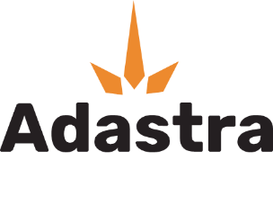
ADASTRA LABS PROVIDES CORPORATE UPDATE: MANAGEMENT CHANGE AND ACQUISITION
LANGLEY, BC / ISSUEWIRE / March 10, 2021 - Adastra Labs Holdings Ltd. (CSE: XTRX) (FRANKFURT: D2EP) (“Adastra” or the “Company) announces the appointment of J. Scott Munro as President, CEO and Director (Chairman) effective March 1, 2021 in conjunction with the resignation and retirement of Andy Hale from said positions. We wish Andy all the best as he pursues other life passions and ambitions.

J. Scott Munro is an experienced venture capitalist, accountant and entrepreneur who has led companies and served in a variety of senior executive roles including CEO, CFO and director in both Canadian and U.S. public and private companies for over 25 years. Over the past 10+ years, Scott has owned and operated private venture capital and consulting firms that provide M&A advisory, going-public transactions, reporting, and other services to private and public companies, including in the Life Sciences sector in which Adastra operates.

Summary Video: https://youtu.be/c9NopcSkd2o

“This is an exciting time for Adastra, its employees and shareholders as the Company is handed off to a strong management team led by Mr. Munro with a good footing to scale the business into the future. It’s been a great pleasure and rewarding endeavour in helping to build the Company from the ground up to this point in time, while working with its amazing employees and advisors while looking forward to bigger growth ahead,” Andy Hale expressed.

Acquisition Update for Phyto Extractions™ Brands (“Phyto Extractions”)
Adastra and 1204581 B.C. Ltd. (d/b/a Phyto Extractions™) have signed an extension to the letter of intent (LOI) announced via Accesswire and posted on SEDAR on December 23, 2020, extending the exclusivity period for entering into a transaction to on or before May 31, 2021, and are proceeding with negotiating the entry into a definitive agreement and then closing on the acquisition of a 51% controlling interest in Phyto Extractions™ Brands (the “Acquisition”) that includes a Right of First Refusal for the Company to acquire the remaining 49% interest. As a condition to close, the Company is awaiting receipt of final independent valuations on the respective companies along with a fairness opinion to determine the number of consideration shares to be issued for the Acquisition. In addition to any applicable regulatory holding requirements, the consideration shares will be escrowed and released over 24 months from the date of closing which would run concurrently with any regulatory hold periods.

Adastra and Phyto Extractions™ are under an agreed exclusivity and freeze period, pursuant to the LOI, until closing of the definitive acquisition agreement in the coming weeks that is also subject to any required securities exchange approvals.

In conjunction with the Acquisition of Phyto Extractions™ Brands, the Company is considering undergoing corporate re-branding and restructuring prior to closing. As a result, the Company is entering into voluntary trading halt on the Canadian Securities Exchange (CSE) until completing these actions in preparation to close on the definitive agreement for the Acquisition.

About Phyto Extractions™ Brands
Phyto Extractions™ products have been available in the regulated Canadian cannabis market since December 2019 when they launched 4 SKUs. Since that time, the brand has grown over four-fold to offer 18 SKUs including 0.3-gram disposable vaporizers (vapes) in four strains/flavours, 0.5-gram vaporizing cartridges in six strains/flavours with one kit, recently expanded to the 1.0-gram cartridge format in four strains/flavours, two strains of Live Resin and a unique High-Terpene Full Spectrum Extract (HTFSE) CO2 terp sauce SKU.

Phyto Extraction products are currently sold in the provinces of BC, AB, MB, SK and ON.

Figure 1 – Phyto Extractions Line Up of Concentrate Products and power cell.

About Adastra Labs
Adastra Labs is an agricultural-scale cannabis extraction, distillation and product manufacturer located in Langley, BC at its co-located Health Canada Licensed Standard Processing and Analytical Testing Laboratory (Chemia Analytics) facilities. Chemia Analytics is a wholly owned subsidiary of the Company. Adastra also has pending sales and R&D license applications amendments awaiting imminent Health Canada approval.

The Company produces cannabis extracts through its newly commissioned hydrocarbon extractor with capacity up to 450,000 kgs per year. The Company produces a variety of extracts, distillate, vape cartridges, live resin and terp sauce branded under Phyto Extractions™; with expanded cannabis product lines launching in 2021, subject to receipt of Health Canada sales license addendum(s), including: edibles, beverages, bulk distillate, hydrocarbon extracts (butter, diamond, live resin, shatter, terp sauce, and wax), flower (bags and pre-rolls) and topicals that will serve the Canadian medical and adult-use cannabis markets.

Hydrocarbon Extraction

Adastra has completed its final commissioning, certification and site upgrade approvals for its ExtractionTek Solutions MeP™ XT70 closed-loop hydrocarbon extractor. This extractor is rare in its Canadian certification with production capacity > 400kgs per day of cannabis biomass (hemp and weed) into a variety of hydrocarbon cannabis concentrate products with flexibility to run Propane, Butane, and blended solvents to afford the extractor the ability to produce a variety of cannabis concentrate products.

This includes high-THC shatter production capacity > 50kgs per day that well positions the Company to leverage the acquisition of Phyto Extractions™ and its strong grass-roots brand recognition for high-quality and good value cannabis concentrates.

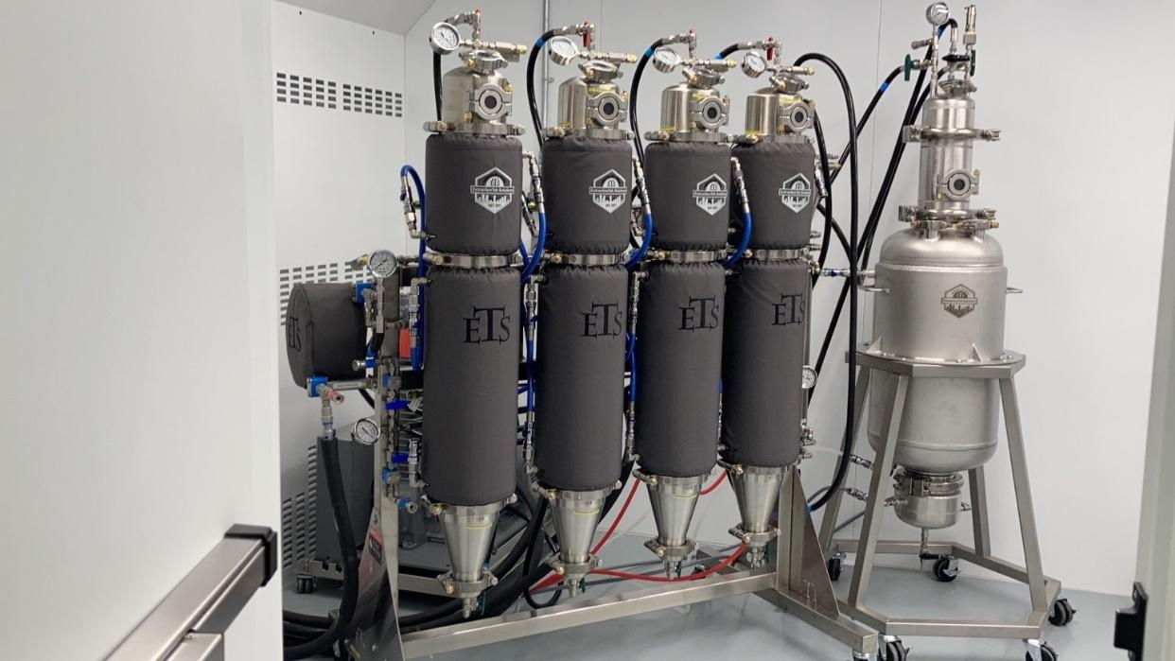
Figure 2 – ETS MeP™ XT70 Hydrocarbon Extractor assembly at Adastra Facility.

ON BEHALF OF THE BOARD
ADASTRA LABS HOLDINGS (2019) LTD.
Contact: J. Scott Munro, President, CEO & Director (Chairman)
Phone: (778) 715-5011
Email: scott@adastralabs.ca

Forward-Looking Information:
This press release may include forward-looking information within the meaning of Canadian securities legislation, concerning the business of the Company. Forward-looking information is based on certain key expectations and assumptions made by the management of the Company. Although the Company believes that the expectations and assumptions on which such forward-looking information is based are reasonable, undue reliance should not be placed on the forward-looking information because the Company can give no assurance that they will prove to be correct. Forward-looking information in this news release, including any linked video or other information accessible by such link, includes those with respect of the possible acquisition of Phyto Extractions and the development and future business opportunities of the Company as described in this press release; there is no guarantee whether the acquisition will occur or if it does, it will be on the terms currently disclosed, and there is no guarantee whether any such acquisition or other transaction will have a net positive effect for the Company’s business or finances. There is also to guarantee that the Company’s current business will perform as it has in the past. The Company’s pending sales and R&D license applications are subject to Health Canada approval, and although Company’s management believes that it will receive the approval, there is no guarantee that such approval would be granted or granted within the timeframes or terms currently expected. Information about Phyto Extractions was received by the Company from Phyto Extractions and to the Company’s management’s knowledge is believed to be true as of the date of this press release only. Forward-looking statements contained in this press release are made as of the date of this press release. The Company disclaims any intent or obligation to update publicly any forward-looking information or other information, whether as a result of new information, future events or results or otherwise, other than as required by applicable securities laws. The reader is cautioned that assumptions used in the preparation of any forward-looking information may prove to be incorrect. Events or circumstances may cause actual results to differ materially from those predicted, as a result of numerous known and unknown risks, uncertainties, and other factors, many of which are beyond the control of the Company, such as regulatory and business changes in the Company’s industry. The reader is cautioned not to place undue reliance on any forward-looking information contained in this news release. The CSE has not reviewed or approved of any contents of this news release.

