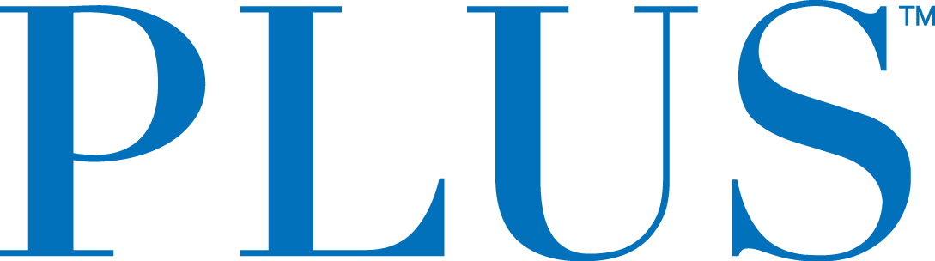

Plus Products Announces Listing of Debentures and Warrants on the CSE

NOT FOR DISTRIBUTION IN THE UNITED STATES OR OVER UNITED STATES NEWS WIRE SERVICES

San Mateo, California – June 28, 2019 – Plus Products Inc. (the “Company” or “PLUS”) (CSE:PLUS) (OTCQX:PLPRF), today announces that further to the Company’s news release of February 28, 2019, whereby the Company announced the closing of the brokered private placement of 25,000 units of the Company (the “Units”) at a price of C$1,000 per Unit for gross proceeds of C$25,000,000 (the “Offering”), where each Unit consisted of one unsecured convertible debenture having the principal amount of C$1,000 (each, a “Debenture”) and 77 subordinate voting share purchase warrants of the Company (each, a “Warrant”), the Company is pleased to announce that the Debentures and Warrants have been approved for listing on the Canadian Securities Exchange under the symbols PLUS.DB and PLUS.WT, respectively, and will begin trading at the open of market on July 2, 2019.

Each Debenture accrues interest at 8% per annum, payable semi-annually in arrears until maturity on February 28, 2021 and is convertible into subordinate voting shares (each, a “Conversion Share”) at a price of C$6.50 per Conversion Share commencing on September 28, 2019. The Debentures are unsecured obligations of the Company and rank pari passu in right of payment of principal and interest with all other Debentures issued under the Offering and all other unsecured indebtedness of the Company.

Each Warrant entitles the holder thereof to acquire one subordinate voting share (each, a “Warrant Share”) at an exercise price of C$8.00 per Warrant Share until February 28, 2024. If exercised during the first 12 months from February 28, 2019, the Warrant Shares shall be subject to a 365-day contractual hold from February 28, 2019.

About Plus Products
PLUS creates low dose and delicious cannabis food products that enhance the everyday lifestyle. PLUS’ mission is to use nature to bring balance to people’s lives - that starts with high-quality, precisely dosed products that deliver consistent experiences. PLUS’ food products, which include gummies and mints in a variety of delectable flavors, are manufactured at PLUS’ own factory in Adelanto, CA, where dosage is tested twice internally and then tested twice again by an independent lab. PLUS is headquartered in San Mateo, CA with 80 employees.

PLUS supports regulation in the cannabis industry and actively collaborates with regulators. The company recently rolled out child-resistant tins a year ahead of the California deadline, and it participates regularly in the National Cannabis Roundtable with John Boehner as honorary chairman.

For further information contact:
Investors:
Jessica Bornn
Director of Investor Relations
ir@plusproducts.com
Tel +1 650.223.5478

Media:
Heidi Groshelle
Ingrid Marketing
heidi@ingridmarketing.com

Maggie Squires
Moxie Communications Group
plus@moxiegrouppr.com

The CSE does not accept responsibility for the adequacy or accuracy of this release.

Forward-Looking Statements
This news also release includes statements containing certain “forward-looking information” within the meaning of applicable securities law (“forward-looking statements”). Forward-looking statements are frequently characterized by words such as “plan”, “continue”, “expect”, “project”, “intend”, “believe”, “anticipate”, “estimate”, “may”, “will”, “potential”, “proposed” and other similar words, or statements that certain events or conditions “may” or “will” occur and include, but are not limited to the execution of definitive agreements and the closing of the transaction.. These statements are only predictions. Various assumptions were used in drawing the conclusions or making the projections contained in the forward-looking statements throughout this news release. Forward-looking statements are based on the opinions and estimates of management at the date the statements are made and are subject to a variety of risks and uncertainties and other factors that could cause actual events or results to differ materially from those projected in the forward-looking statements. These risks include, but are not limited to, the ability to retain key personnel, the ability to continue investing in infrastructure to support growth, the ability to obtain financing on acceptable terms, the continued quality of our products, customer experience and retention, the continued development of adult-use sales channels, managements estimation of consumer demand in in jurisdictions where the Company exports, expectations of future results and expenses, the availability of additional capital to complete capital projects and facilities improvements, the ability to expand and maintain distribution capabilities, the impact of competition, and the possibility for changes in laws, rules, and regulations in the industry. The Company is under no obligation, and expressly disclaims any intention or obligation, to update or revise any forward-looking statements, whether as a result of new information, future events or otherwise, except as expressly required by applicable law.

