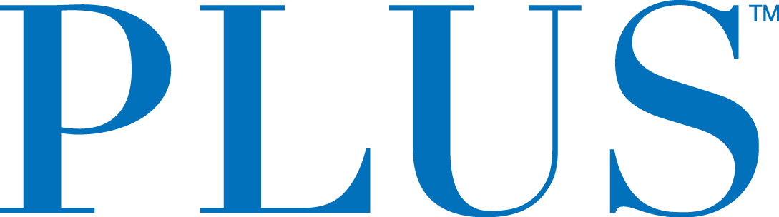
PLUS Products Launches Rebrand of its Cannabis Infused Edibles Line
New look designed to create greater clarity for consumers under three easy-to-understand banners – Uplift, Balance and Unwind
San Mateo, CA – July 17, 2019 – Plus Products Inc. (CSE: PLUS) (OTCQB: PLPRF) (the “Company” or “PLUS”) today announced a new look for its line of low dose cannabis infused edibles.
The rebrand was guided by market structure research from Henry J. Rak Associates and designed by Partners and Spade, an agency that has worked alongside brands including Peloton and Warby Parker.
PLUS has already seen success in California with the #1 and #2 best selling cannabis products over the last twelve months, both by number of units sold and dollars of retail sales according to BDS Analytics¹.
“Cannabis can be confusing. We hope our new system will help reduce some of that confusion,” said Jake Heimark, CEO and Co-founder. “We worked with experienced market researchers to find out why people use cannabis, then translated those findings into an easy-to-use system of cannabis. We are excited to help our customers Uplift their experiences, bring Balance to their everyday, and Unwind without getting unwound.”
The new packaging and product system goes beyond traditional use of Sativa, Hybrid and Indica and focuses on the science behind unique combinations of THC and CBD. The intention is to create the right mix of cannabinoids paired with a targeted flavor profile to give the consumer an amazing product experience.
“We believe this system will make PLUS even more accessible to new consumers, and we hope our investments in consistency and quality will keep them coming back,” said Mr. Heimark.
According to Headset², PLUS Gummies have the highest repeat purchase rate for the edibles category in California at 52%.
¹BDS Analytics GreenEdge^{tm} Platform
²Headset custom study commissioned by PLUS Products
Availability
PLUS cannabis infused edibles are available at over 300 licensed retailers across the state of California and the company has a pipeline of new product innovations that it will continue to rollout under the new streamlined and easy to understand design. PLUS edibles will also be available at licensed retailers in Nevada by the end of summer.
About PLUS
PLUS Products is a California edibles company focused on using nature to bring balance to consumers lives. PLUS’s mission is to make cannabis safe and approachable – that begins with high-quality products that deliver consistent consumer experiences. The PLUS Gummies and PLUS Mints are manufactured at PLUS’s own factory in Adelanto, CA, with strict internal and external testing to ensure accurate consistent dosage. PLUS is headquartered in San Mateo, CA with 80 employees.
For further information contact:
Jake Heimark, CEO & Co-founder
jake@plusproducts.com
Investors:
Jessica Bornn
Director of Investor Relations
ir@plusproducts.com
Tel +1 650.223.5478
Media:
Heidi Groshelle
Ingrid Marketing
Tel +1 415.307.1380
pr@plusproducts.com

The CSE does not accept responsibility for the adequacy or accuracy of this release.
Forward-Looking Statements
This news also release includes statements containing certain “forward-looking information” within the meaning of applicable securities law (“forward-looking statements”). Forward-looking statements are frequently characterized by words such as “plan”, “continue”, “expect”, “project”, “intend”, “believe”, “anticipate”, “estimate”, “may”, “will”, “potential”, “proposed” and other similar words, or statements that certain events or conditions “may” or “will” occur and include, but are not limited to, statements relating to the Company’s future products, the customer’s experience with the Company’s products and other such statements.
These statements are only predictions. Various assumptions were used in drawing the conclusions or making the projections contained in the forward-looking statements throughout this news release. Forward-looking statements are based on the opinions and estimates of management at the date the statements are made and are subject to a variety of risks and uncertainties and other factors that could cause actual events or results to differ materially from those projected in the forward-looking statements. These risks include, but are not limited to, the success of the rebranding, the ability to retain key personnel, the ability to continue investing in infrastructure to support growth, the ability to obtain financing on acceptable terms, the continued quality of our products, customer experience and retention, the continued development of adult-use sales channels, managements estimation of consumer demand in in jurisdictions where the Company exports, expectations of future results and expenses, the availability of additional capital to complete capital projects and facilities improvements, the ability to expand and maintain distribution capabilities, the impact of competition, and the possibility for changes in laws, rules, and regulations in the industry. The Company is under no obligation, and expressly disclaims any intention or obligation, to update or revise any forward-looking statements, whether as a result of new information, future events or otherwise, except as expressly required by applicable law

