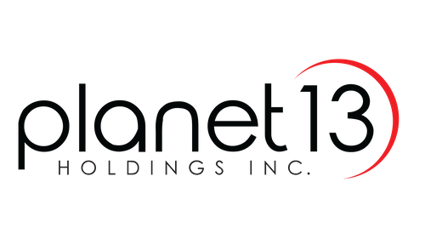
Planet 13 Expanding Las Vegas SuperStore

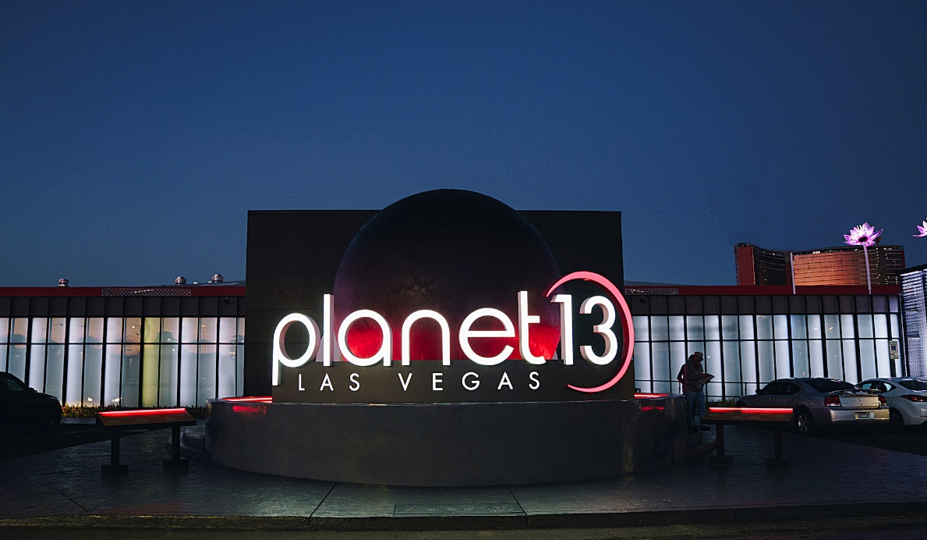
Planet 13 is expanding the largest dispensary in the world doubling the sales floor to service overwhelming customer demand and improve customer experience
Las Vegas, Nevada – October 19, 2020 – Planet 13 Holdings Inc. (CSE: PLTH) (OTCQX: PLNHF) (“Planet 13” or the “Company”), a leading vertically-integrated Nevada cannabis company, today announced it is expanding the Las Vegas SuperStore (the “SuperStore”) dispensary and adding new entertainment features. Planet 13 is doubling the sales floor and expanding the dispensary to ~23,000 sq. ft. The additional entertainment feature and lower wait times will improve on the already fantastic customer experience.

“Our focus on providing a safe, personalized shopping experience combined with overwhelming demand has led to longer wait times and lost customers during peak periods,” said Larry Scheffler Co-CEO of Planet 13. “We are expanding our sales floor, increasing cash registers, and adding new entertainment to capture lost sales and improve the shopping experience. Planet 13 has built its reputation on great customer service and unique entertainment. We are achieving record sales even with Las Vegas at ~50% tourist occupancy. As Las Vegas returns to normal and this industry continues to grow, we anticipate that this will be first of many expansions we will undertake to keep up with demand.”

The expansion adds 40 points of sale, an a 80-foot video wall. The expansion’s CAPEX cost is $1.5 - $2.5 million and is expected to be complete by the end of Q1 2021.

For further inquiries, please contact:
LodeRock Advisors Inc., Planet 13 Investor Relations
mark.kuindersma@loderockadvisors.com
(416) 519-2156 ext. 2230

Robert Groesbeck or Larry Scheffler
Co-Chief Executive Officers
ir@planet13lasvegas.com
# # #

About Planet 13
Planet 13 (www.planet13holdings.com) is a vertically integrated cannabis company based in Nevada, with award-winning cultivation, production and dispensary operations in Las Vegas - the entertainment capital of the world. Planet 13’s mission is to build a recognizable global brand known for world-class dispensary operations and a creator of innovative cannabis products. Planet 13’s shares trade on the Canadian Stock Exchange (CSE) under the symbol PLTH and OTCQX under the symbol PLNHF.

Cautionary Note Regarding Forward-Looking Information
This news release contains "forward-looking information" and "forward-looking statements" (collectively, "forward-looking statements") within the meaning of the applicable Canadian securities legislation. All statements, other than statements of historical fact, are forward-looking statements and are based on expectations, estimates and projections as at the date of this news release. Any statement that involves discussions with respect to predictions, expectations, beliefs, plans, projections, objectives, assumptions, future events or performance (often but not always using phrases such as "expects", or "does not expect", "is expected", "anticipates" or "does not anticipate", "plans", "budget", "scheduled", "forecasts", "estimates", "believes" or "intends" or variations of such words and phrases or stating that certain actions, events or results "may" or "could", "would", "might" or "will" be taken to occur or be achieved) are not statements of historical fact and may be forward-looking statements. In this news release, forward looking-statements relate to, among other things, Planet 13’s first California location and the timeline for opening of the Santa Ana dispensary.

These forward-looking statements are based on reasonable assumptions and estimates of management of the Company at the time such statements were made. Actual future results may differ materially as forward-looking statements involve known and unknown risks, uncertainties and other factors which may cause the actual results, performance or achievements of the Company to materially differ from any future results, performance or achievements expressed or implied by such forward-looking statements. Such factors, among other things, include: final regulatory and other approvals or consents; risks associated with COVID-19 and other infectious diseases presenting as major health issues; fluctuations in general macroeconomic conditions; fluctuations in securities markets; expectations regarding the size of the Nevada and California cannabis market and changing consumer habits; the ability of the Company to successfully achieve its business objectives; plans for expansion; political and social uncertainties; inability to obtain adequate insurance to cover risks and hazards; and the presence of laws and regulations that may impose restrictions on cultivation, production, distribution and sale of cannabis and cannabis related products in the State of Nevada and California; and employee relations. Although the forward-looking statements contained in this news release are based upon what management of the Company believes, or believed at the time, to be reasonable assumptions, the Company cannot assure shareholders that actual results will be consistent with such forward-looking statements, as there may be other factors that cause results not to be as anticipated, estimated or intended. Readers should not place undue reliance on the forward-looking statements and information contained in this news release. The Company assumes no obligation to update the forward-looking statements of beliefs, opinions, projections, or other factors, should they change, except as required by law.

The Company is indirectly involved in the manufacture, possession, use, sale and distribution of cannabis in the recreational and medicinal cannabis marketplace in the United States through licensed subsidiary entities in states that have legalized marijuana operations, however, these activities are currently illegal under United States federal law. Additional information regarding this and other risks and uncertainties relating to the Company's business, including COVID-19, are contained under the heading "Risk Factors" and elsewhere in the Company's annual information form dated April 13, 2020 filed on its issuer profile on SEDAR at www.sedar.com.

No stock exchange, securities commission or other regulatory authority has approved or disapproved the information contained herein.

