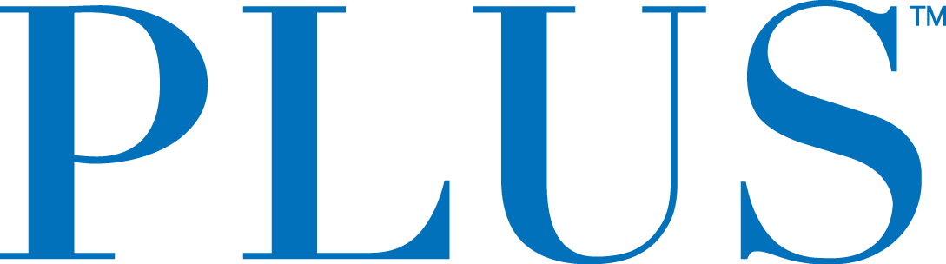

PLUS™ Launches Mango CBD Relief
New Mango Flavor Now Provides 90mg CBD and 10mg THC

San Mateo, CA – April 4, 2019 – Plus Products Inc. (CSE: PLUS) (OTCQB: PLPRF) (the “Company” or “PLUS”) today announced the launch of its newest product: “Mango CBD Relief,” which will contain 4.5MG of CBD and .5MG of THC in each gummy. The new product is already available at some of the more than 250 retailers in California who carry the PLUS product line.

The Company will retire its previous “CBD Relief” product, “Pineapple Coconut CBD Relief,” as part of a coordinated launch campaign with retailers. According to BDS Analytics, Pineapple Coconut CBD Relief was the top selling CBD edible in the California market in Q4 2018 as measured by units and dollars sold.

“Mango CBD Relief is a reimagining of what it means to deliver a high quality CBD experience. As one of the leading brands in California, the largest cannabis market in the world, PLUS is in a unique position to test products at scale,” said Jake Heimark, CEO of PLUS. “We leverage our brand position to work directly with customers who love our products and develop new products based on their feedback. With their help, we found that the inclusion of a small amount of THC and other balancing compounds in our CBD Relief product led to a consistently better consumer experience.”

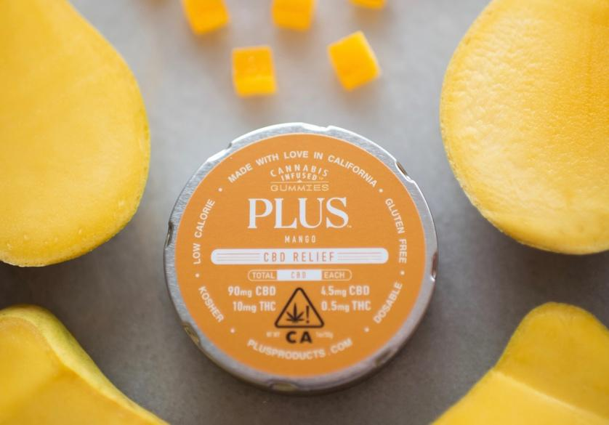
Mango CBD Relief

Listening to The People
PLUS regularly conducts customer research and takes the learnings back to its labs to enhance its products. Many PLUS customers indicate they feel greater therapeutic effects from using CBD when they pair it with a small amount of THC. The new CBD Relief formulation offers a deliberate, proprietary blend of cannabinoids, terpenes and flavonoids.

“California’s consumers have made PLUS a leading cannabis brand in the State. Direct feedback from consumers in California, which is the largest and most competitive cannabis market in the world, will enable brands like PLUS to have a significant product edge when launching products in other jurisdictions” said Jake Heimark. “If you win California, you can win the world.”

Customers also inspire PLUS to create limited editions of its market-leading infused gummies. Most recently, popular demand drove the limited release of “Pink Lemonade Refresh” this spring and “Cranberry Shortbread Bliss” for the holiday season.

About PLUS
PLUS Products creates safe and delicious cannabis food products. PLUS’s mission is to make
cannabis safe and approachable - that starts with high-quality products that deliver consistent
experiences. The gummies are manufactured at PLUS’s own factory in Adelanto, CA, where
dosage is tested twice internally and then tested twice again by an independent lab. PLUS is
headquartered in San Mateo, CA with 60 employees.

For further information contact:
Investors:
Jessica Bornn
Director of Investor Relations
ir@plusproducts.com
Tel +1 650.223.5478

Media:
Heidi Groshelle
Ingrid Marketing
Tel +1 415.307.1380
pr@plusproducts.com

Maggie Squires
Moxie Communications Group
plus@moxiegrouppr.com

The CSE does not accept responsibility for the adequacy or accuracy of this release.

Forward-Looking Statements

This news release contains statements and information that, to the extent that they are not historical fact, constitute "forward-looking information" within the meaning of applicable securities legislation. Forward-looking information is based on the reasonable assumptions, estimates, analysis and opinions of management made in light of its experience and its perception of trends, current conditions and expected developments, as well as other factors that management believes to be relevant and reasonable in the circumstances at the date that such statements are made, but which may prove to be incorrect.

Forward-looking information involves known and unknown risks, uncertainties and other factors that may cause the actual results, performance or achievements of the Company to differ materially from any future results, performance or achievements expressed or implied by the forward-looking information. Accordingly, readers should not place undue reliance on any such forward-looking information. Further, any forward-looking statement speaks only as of the date on which such statement is made. New factors emerge from time to time, and it is not possible for the Company's management to predict all of such factors and to assess in advance the impact of each such factor on the Company's business or the extent to which any factor, or combination of factors, may cause actual results to differ materially from those contained in any forward-looking statements. The Company does not undertake any obligation to update any forward-looking information to reflect information, events, results, circumstances or otherwise after the date hereof or to reflect the occurrence of unanticipated events, except as required by law including securities laws.

