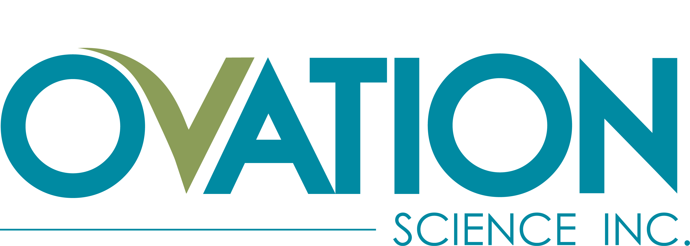

Ovation Science Announces Participation at MJ Unpacked Conference
Vancouver, BC, Las Vegas, NV – September 27th, 2022 (CSE: OVAT | OTCQB: OVATF) – Ovation Science Inc. (“Ovation” or the “Company”), a topical and transdermal cannabis product development company with a patented skin delivery technology Invisicare®, today announced it will be participating and be taking new licensee meetings at the MJ Unpacked conference being held at the MGM Hotel in Las Vegas from September 28 to 30th, 2022. Ovation will participate as an exhibitor (Booth 218) and management will be available for one-on-one meetings throughout the event. MJ Unpacked brings together cannabis retailers, buyers, brands and investors. Ovation will be highlighting its licensing opportunities for its topical / transdermal formulations.
“I am looking forward to meeting with potential licensees for our award-winning transdermal formulations,” said Terry Howlett, CEO of Ovation Science. “With Ovation’s recent announcements of our new patent protection to 2041 and our new licensee for Oklahoma, Missouri, New Mexico and Mississippi, we anticipate a great deal of interest from potential licensees for other states. This conference allows us to showcase our products and take advantage of the opportunity to meet with industry executives that may be seeking new product lines like ours.”
Ovation leverages its expertise in the pharmaceutical industry to develop highly effective, proprietary products. What makes Ovation’s products different from any other topical cannabis products on the market is its superior delivery of CBD / THC and other cannabinoids using its proprietary skin delivery technology Invisicare®. Invisicare has over twenty years of research and development in the pharmaceutical industry; specifically, dermatology. Ovation formulates two types of topicals; ones that remain on the skin to deal with “skin issues” and transdermal creams that allow the CBD (cannabidiol), and/or the THC (tetrahydrocannabinol) and other cannabinoids to be absorbed through the skin into the bloodstream. Studies show Ovation’s products have a 10 times greater release of CBD to the skin and over 5 times greater penetration compared to other products tested.
Ovation’s Updated Corporate Presentation: September 2022 is available on Ovation’s website and can be found under “Presentations” in the INVESTORS section: https://ovationscience.com/investors/

Statements have not been evaluated by the Food and Drug Administration. These products are not intended to diagnose, treat, cure, or prevent any disease.

#ovat #ovatf #cannabis #cannabisindustry #MJUnpacked #MJULV22 #cannainvestor #topicals

About Ovation Science Inc.
Ovation Science Inc. is a research and development company that develops topical and transdermal consumer products including its CBD/THC and other cannabinoid formulations which are licensed out and also distributed under Ovation’s own brands; ARLO CBD Beauty and InVibe® MD (“health & wellness” line); all made with its patented Invisicare® skin delivery technology. The Invisicare technology enhances the delivery of ingredients to and through the skin and is protected by patents and proprietary formulations which cannot be duplicated. With over twenty years of topical and transdermal drug delivery experience in the pharmaceutical market, Ovation’s management and science team have created a unique pipeline of over thirty proprietary medical / wellness topical and transdermal products along with a line of anti-aging / beauty formulas. Ovation earns revenues from royalties on licensees’ sales and the sale of Invisicare, along with revenue from its own product sales. Ovation has offices in Vancouver, BC Canada and Las Vegas, Nevada, USA.

Ovation trades on the CSE under the symbol OVAT and in the USA on OTC Markets under the symbol OVATF. Visit our website www.ovationscience.com for more information. Product Lines: HEALTH & WELLNESS: www.invibemd.com BEAUTY: www.arlocbdbeauty.com

Forward-Looking Statements
Information set forth in this news release contains forward-looking statements that are based on assumptions as of the date of this news release. These statements reflect management’s current estimates, beliefs, intentions and expectations and are subject to a number of risks and uncertainties that could cause actual results to differ materially from those described in the forward-looking statements. In particular there is no assurance of sales and acceptance of its products in any US states cited, continued sales in Nevada or expansion of distribution to other states or continued sales in dispensaries or in retail markets. There are no guarantees of future performance or changes to regulations. Ovation Science Inc. cautions that all forward looking statements are inherently uncertain and that actual results may be affected by a number of material factors, many of which are beyond Ovation Science Inc.'s control. Accordingly, readers should not place undue reliance on the forward-looking information. Ovation disclaims any obligation to revise or update any such forward-looking information to reflect future results, events or circumstances, except as required by law.
Neither the Canadian Securities Exchange, OTC Markets nor its Regulation Services Provider accepts responsibility for the adequacy or accuracy of this release.
Contact:
INVESTOR RELATIONS:
Kin Communications: ovat@kincommunications.com Phone: 604-684-6730 or Toll Free at 866-684-6730
FOR BUSINESS DEVELOPMENT & CORPORATE INQUIRIES:
Doreen McMorran: doreen@ovationscience.com Phone: 604-283-0903 ext. 4

