NOT FOR DISSEMINATION IN THE UNITED STATES OR FOR DISTRIBUTION TO U.S. NEWSWIRE SERVICES AND DOES NOT CONSTITUTE AN OFFER OF THE SECURITIES DESCRIBED HEREIN
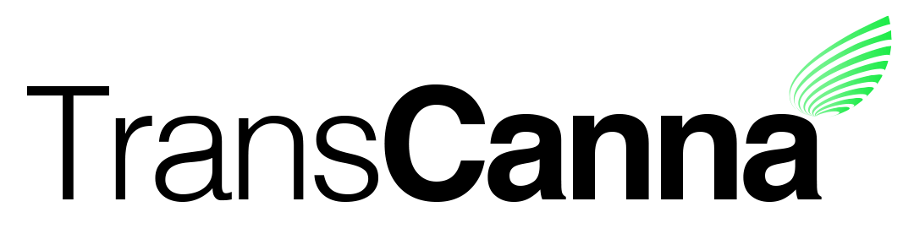
Suite 902, 1030 West Georgia Street
Vancouver, B.C. V6E 3M5

TransCanna Signs Binding Agreement with Lyfted Farms Inc

Canadian Securities Exchange: TCAN
Borse Frankfurt: TH8

Vancouver, BC, September 12th, 2019 - TransCanna Holdings Inc. (CSE:TCAN: XETR: TH8) (“TransCanna” or the “Company”) is pleased to announce it has signed a binding agreement to acquire all the outstanding shares of Lyfted Farms Inc., which updates the terms of the previously announced non-binding letter of intent.
Lyfted Farms brings over 2 decades of cultivation experience to the company and currently holds a Distribution License, Nursery License, and a Cultivation License at both the State and Local levels. Lyfted Farms has long been a recognized leader in complying with statewide regulations, the company was issued the 9th Cultivation License in the State of California.
“With this acquisition we are not only securing a high-quality brand but fulfilling a need in sourcing and stabilizing our upper supply chain which we see as a serious requirement in the California Cannabis marketplace” stated Steve Giblin, TransCanna President & CEO. “This acquisition represents a significant talent acquisition for the company moving forward.
The purchase price for the acquisition will be $6,300,000 USD comprised of $5,550,000 USD in cash and the issuance of 1,000,000 TransCanna Common Shares. $150,000 USD has already been advanced as a deposit and the remaining cash portion of the purchase price will be payable as to $400,000 USD on closing and the issuance by TransCanna of a non-interest bearing promissory note in favour of the vendors in the amount of $5,000,000 USD.
“This acquisition, once completed, allows our team to commit to the growth of the TransCanna business model. We see and believe in the vision of quality brands produced and distributed on scale and we can help with that execution” Commented Bob Blink, CEO and Founder of Lyfted Farms.
Under the TransCanna umbrella, Lyfted Farms is expanding their nursery and production capacity for a cost of $695,000 USD of which $105,000 USD has already been advanced. Completion of the expansion is expected within the next 90 days. This will pave the way for new staff to be onboarded and trained while the company looks to complete the process of licensing and building out the 196,000 square foot Daly facility.
Lyfted Farms is an award-winning trusted brand and has developed a very loyal following amongst cannabis consumers. As a leading brand, Lyfted Farms is continuously innovating, developing new strains and products and delivering them to the end consumer. Lyfted Farms and their products set and influence trends instead of following them. Shareholders or interested parties can follow the brand development on Instagram @lyftedfarms.

About TransCanna Holdings Inc.
TransCanna Holdings Inc. is a Canadian based company providing branding, transportation and distribution services, through its wholly-owned California subsidiaries, to a range of industries including the cannabis marketplace.

For further information, please visit the Company’s website at www.transcanna.com or email the Company at info@transcanna.com.

On behalf of the Board of Directors

The information in this news release includes certain information and statements about management's view of future events, expectations, plans and prospects that constitute forward looking statements. These statements are based upon assumptions that are subject to significant risks and uncertainties. Because of these risks and uncertainties and as a result of a variety of factors, the actual results, expectations, achievements or performance may differ materially from those anticipated and indicated by these forward looking statements. Forward-looking statements in this news release include, but are not limited to: timing of entering into the definitive agreement required to complete the acquisition, the ability to complete the acquisition on acceptable terms, and the expected benefits of Lyfted to the Company's business. Any number of factors could cause actual results to differ materially from these forward-looking statements as well as future results. Although the Company believes that the expectations reflected in forward looking statements are reasonable, it can give no assurances that the expectations of any forward looking statements will prove to be correct. Except as required by law, the Company disclaims any intention and assumes no obligation to update or revise any forward looking statements to reflect actual results, whether as a result of new information, future events, changes in assumptions, changes in factors affecting such forward looking statements or otherwise.

Neither the Canadian Securities Exchange nor its Regulation Services Provider (as that term is defined in the policies of the Canadian Securities Exchange) accepts responsibility for the adequacy or accuracy of this release.

