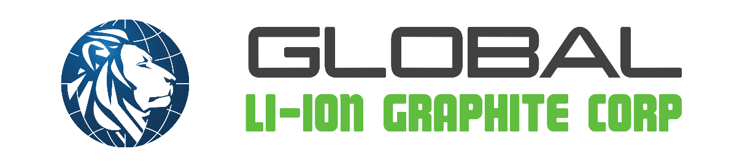

908 – 510 Burrard Street
Vancouver, B.C. V6C 3A8
NOT FOR DISSEMINATION IN THE UNITED STATES OR FOR DISTRIBUTION TO U.S. WIRE. SERVICES

Global Li-Ion Announces Debt Conversions and Settlement of Stock Bonuses

LION CSE GBBGF. OTCQB 0TD. F Vancouver, British Columbia, Canada (May 8th, 2026) – Global Li-Ion Graphite Corp. (“Global Li-Ion” or, the “Company”) (CSE: LION) is pleased to announce that it has settled $102,789.22 of indebtedness (the “Indebtedness”) owing to arm’s length creditors (the “Creditors”) through the issuance of an aggregate of 4,111,568 units of the Company at a price of $0.025 per Unit (the “Debt Conversion”). Each Unit is composed of one (1) common share in the capital of the Company (a “Share”) and one (1) common share purchase warrant (a “Warrant”). Each Warrant is exercisable into one (1) Share for two years from the date of issuance (the “Exercise Period”) at an exercise price $0.10 per Share for the first year of the Exercise Period and at an exercise price of $0.20 for the second year of the Exercise Period. The Indebtedness represents a portion of certain debts owing by the Company to the Creditors pursuant to a series of promissory notes (the “Notes”) executed by the Company in 2024 and 2025, such Notes having an aggregate principal amount of $269,420.50.

The Company further announces that, pursuant to the terms of the Notes, it has paid stock bonuses to the Creditors (the “Stock Bonuses”), in the aggregate amount of $27,101.08, through the issuance of an aggregate of 542,022 common shares of the Company at a deemed issue price of $0.05 per share. Following settlement of the Stock Bonuses, no further stock bonuses remain owing under the Notes.

All securities issued in connection with the Debt Conversion and the Stock Bonuses are subject to a four-month hold period from the date of issuance in accordance with applicable Canadian securities laws.

None of the securities referenced herein have been or will be registered under the United States Securities Act of 1933, as amended, and no such securities may be offered or sold in the United States absent registration or an applicable exemption from the registration requirements. This news release shall not constitute an offer to sell or the solicitation of an offer to buy nor shall there be any sale of the securities in the United States or any jurisdiction in which such offer, solicitation or sale would be unlawful.

For Further information about the Company, please contact:
Jason Walsh
Global Li-Ion Graphite Corp.
Telephone 604.608.6314
Email: info@liongraphite.com

Neither the Canadian Securities Exchange nor its regulation services provider have reviewed or accept responsibility for the adequacy or accuracy of this press release.

