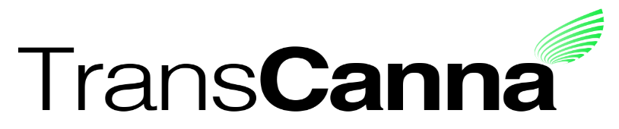
Suite 928, 1030 West Georgia Street
Vancouver, B.C. V6E 2Y3

TransCanna to Rely on Temporary Blanket Relief for Required Filings

Canadian Securities Exchange: TCAN
Borse Frankfurt: TH8

Vancouver, BC, April 3, 2020 - TransCanna Holdings Inc. (CSE: TCAN: XETR: TH8) ("TransCanna" or the "Company") today announces that it anticipates a delay in the filing of the financial statements required pursuant to Part 4 of National Instrument 51-102 Continuous Disclosure Obligations (the “Instrument”) as a result of the completion by the Company of the recent acquisitions of Tres Ojos Naturals LLC (dba Soldaze), and Lyfted Farms, Inc. in the Fall of 2019, both US corporations, as new subsidiaries of the Issuer.
The delay is due to the Company’s new management’s difficulties in coordinating with the auditor the collection of all of the required data and documentation to complete the audit on a consolidated basis. As well, certain key persons who are needed to complete the audit are being affected by the current COVID-19 pandemic due to self-isolation requirements.
The Instrument requires that the Company’s audited financial statements and MD&A for the fiscal year ended November 30, 2019 be filed by March 29, 2020 (“Original Filing Deadline”). The Company and its auditor are in the process of completing the required audit work to complete these audited financial statements and associated MD&A (collectively, the “Required Filings”). The Company expects that the Required Filings will be completed and filed on or before April 30, 2020.
In these circumstances, and considering the anticipated delay in making the Required Filings within the time period mandated by the Instrument, the Company intends to rely upon the temporary blanket relief afforded by Canadian securities regulators to extend the date for the filing of the Required Filings for up to 45 days from the date of the Original Filing Deadline.
During the period that the Required Filings remain outstanding, Transcanna’s management and other insiders are subject to a trading black-out policy that reflects the principles in section 9 of National Policy 11-207 Failure-to-File Cease Trade Orders and Revocations in Multiple Jurisdictions.
The Company confirms that there have been no other material business developments since August 31, 2019, the date of the Company’s last filed third quarter interim consolidated financial statements, other than the two business acquisitions described above.

About TransCanna Holdings Inc.
TransCanna Holdings Inc. is a California based, Canadian listed, company building Cannabis focused brands for the California lifestyle, through its wholly-owned California subsidiaries.

For further information, please visit the Company’s website at www.transcanna.com or email the Company at info@transcanna.com.

On behalf of the Board of Directors
Steve Giblin, President
604-207-5548

Neither the Canadian Securities Exchange nor its Regulation Services Provider (as that term is defined in the policies of the Canadian Securities Exchange) accepts responsibility for the adequacy or accuracy of this release.

