Stillcanna’s Nexus Facility Produces Pharmaceutical Grade CBD Isolate in Poland
Vancouver, British Columbia – (Accesswire) – Monday October 21, 2019 – Stillcanna Inc. (OTC:SCNNF) (CSE:STIL) (FRANKFURT:A2PEWA) ("STIL" or the "Company") is pleased to announce that its NEXUS extraction facility has produced bulk CBD isolate from hemp harvested by Olimax, the Company’s farming subsidiary in Poland.

With the use of Stillcanna’s proprietary operating procedures, CBD rich honey oil distillate is further purified into pharmaceutical grade CBD isolate. The successful manufacturing of the CBD isolate in the NEXUS facility is THC, pesticide and heavy metal free.

The Company is expected to begin shipping samples of its pharmaceutical grade CBD isolate to its current and potential customers as a part of its standard sales process this quarter. The Company is still on track for commercial production of CBD this quarter to begin fulfilling its contractual agreements.

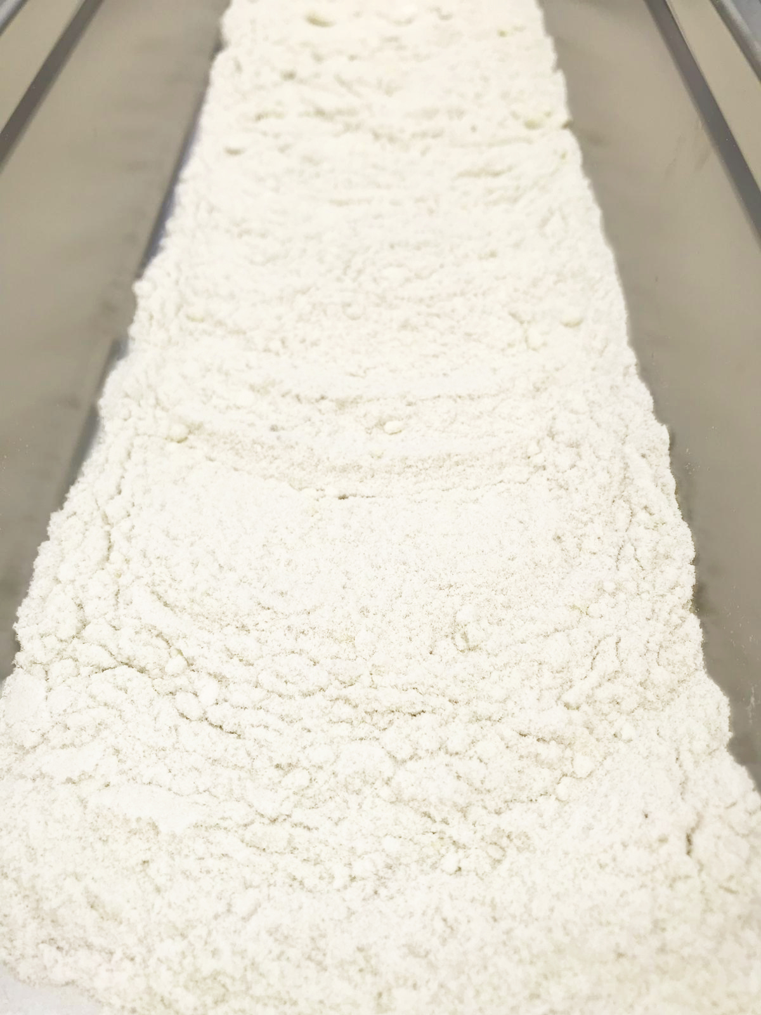

CBD Isolate Manufactured at NEXUS, Stillcanna’s Polish Extraction Facility

“The mandate of our Polish operations has always been seed to CBD, today we have achieved this goal”, stated Jason Dussault CEO of Stillcanna. “I have always been proud of our team who continues to deliver, and today is no exception. With pharmaceutical grade CBD isolate in hand we can move to the final phase of delivery and sales.”

About Stillcanna Inc.

Stillcanna Inc. (CSE: STIL) www.stillcanna.com is a Canadian early-stage life sciences company focused on the large scale manufacturing of CBD in Europe. The Company believes its proprietary intellectual property allows it to extract CBD at a lower cost. The Company has signed an initial extraction contract in Europe to be the exclusive extractor for Dragonfly Biosciences LLC, a United Kingdom-based supplier of CBD. The Company also recently completed the acquisition of Olimax NT SP. Z .O.O, a multi-generational hemp agricultural firm that is expected to increase the Company’s market share in the European CBD industry.

On Behalf of the Board
Jason Dussault, CEO

CONTACT:
Mauricio Inzunza
Mauricio@stillcanna.com
1(844)-442-STILL (7845)

Cautionary Note Regarding Forward Looking Statements: This release includes certain statements and information that constitute forward-looking information within the meaning of applicable Canadian securities laws, including that the Company should be in full commercial scale production this quarter and that the Company expects to begin shipping samples of its pharmaceutical grade CBD isolate to its current and potential customers as a part of its standard sales process. Generally, forward-looking statements and information can be identified by the use of forward-looking terminology such as "intends" or "anticipates", or variations of such words and phrases or statements that certain actions, events or results "may", "could", "should" or "would" occur. Forward-looking statements are based on certain material assumptions and analysis made by the Company and the opinions and estimates of management as of the date of this press release, including the Company will be in full commercial scale production this quarter and that the Company will begin shipping samples of its pharmaceutical grade CBD isolate to its current and potential customers as a part of its standard sales process. Although the Company considers these assumptions to be reasonable based on information currently available to it, they may prove to be incorrect, and the forward-looking statements in this release are subject to numerous risks, uncertainties and other factors that may cause future results to differ materially from those expressed or implied in such forward-looking statements. Such risk factors may include, among others, that the Company will not be in full commercial scale production this quarter or at all and that the Company will be unable to begin shipping samples of its pharmaceutical grade CBD isolate to its current and potential customers as a part of its standard sales process. Although management of the Company has attempted to identify important factors that could cause actual results to differ materially from those contained in forward-looking statements or forward-looking information, there may be other factors that cause results not to be as anticipated, estimated or intended. There can be no assurance that such statements will prove to be accurate, as actual results and future events could differ materially from those anticipated in such statements. Accordingly, readers should not place undue reliance on forward-looking statements and forward-looking information. Readers are cautioned that reliance on such information may not be appropriate for other purposes. The Company does not intend, and expressly disclaims any intention or obligation to, update or revise any forward-looking statements whether as a result of new information, future events or otherwise, except as required by law.
The CSE has not in any way passed upon the merits of and has neither approved nor
disapproved the contents of this news release.

