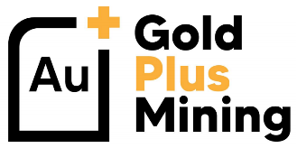
FOR IMMEDIATE RELEASE

GOLD PLUS MINING DISCOVERS EXTENSIVE MINERALIZATION ON ITS PLUTO PROPERTIES CONTIGUOUS TO KENORLAND MINERALS IN QUEBEC

VANCOUVER, BC, OCTOBER 19th, 2020 – Gold Plus Mining Inc. (“Gold Plus” or the “Company”) (CSE :GPMI) (OTC: GPMNF) (FSE: 1I3) is pleased to announce it has made extensive mineralization discoveries on the West and East blocks of its 100% owned Pluto Properties in the prolific Abitibi Greenstone Belt of Quebec.

These mineralized discoveries resulted from a recently completed sampling program (see Company news dated October 1st 2020) that identified new areas with exposed outcrops from forestry clear cutting and new logging roads that allowed Minroc field crews access to previously unexplored areas. Both West and East claim blocks were proven to host portions of mineralized regional structures that have now been extensively sampled.

Gold Plus considers these discoveries to be of significant interest and have sent samples to ALS Canada Ltd. for assaying. Sample results will be reported shortly once assay results are received back by the Company.

Discoveries on the West Block include a band of sheared and strongly chlorite and carbonate altered gabbro containing numerous pyritic zones and qz-ankerite veining within a logged area, with the most intense sulfide-mineralization in this unit occurring with very fine to coarse disseminations of pyrite, chalcopyrite and coarse sphalerite, and possibly even arsenopyrite. The most strongly mineralized sample taken contains 10-15% sulfide (pyrite + sphalerite) within the sheared gabbro (sample 19583). This band of shearing/deformation has an apparent thickness, as measured in the field, of about 30meters, although the strongest and most intense alteration and mineralization is contained within a 3-5m band and is in the approximate center of the zone. may represent part of the “Ventures Sill”. This is the same structure which hosts the Opémiska Cu-Au mine in Chapais and may also therefore be related to the much closer Dolomieu Ag-Cu mineralized occurrence, which lies about 1km east of the West Block. This area, with its large amount of outcrop, observed mineralization (including both Cu and Zn sulphides) and potential structural and strike relationship to a major local deposit, should be seen as a high priority for future exploration.

Discoveries on the East block include the presence of sphalerite amongst other sulphides in the southwest part of the East Block, this may suggest an environment favorable for volcanogenic massive sulphide (VMS) mineralization. This may be corroborated by findings from historic drilling in this approximate stratigraphic level, in the area between the two Pluto claim blocks. In addition to this, the East block hosts a corridor of veining prospective for the presence of gold, running east-west and consisting of several generations, or phases, of veining. The thickness of the quartz-chlorite to quartz-ankerite veining is approximately 10 meters but that is a very early approximation based on field observations. These features are approximately on strike of, and may be related to, the chloritic shear structure which hosts gold mineralization at the Lac Cavan gold occurrence, about 1km east of the property. The possible presence of lenses or sills of quartz feldspar porphyry may also be a favorable sign for gold mineralization; orogenic gold occurrences frequently have a close spatial relationship to both deformation zones and porphyry bodies.

Both of the Pluto properties are made up of a series of crustal scale deformation zones and highly prospective sedimentary-volcanic rock contacts. The properties are located approximately 40km west of the Chibougamau mining camp and 10km west of the Chapais mining camp (6.5 M oz Au; 2.7 B lbs Cu of historic production). The Chibougamau camp has historically been mined and explored for Cu-Au mineralization but the recent discovery of the Nelligan deposit (IAMGOLD – Vanstar Resources) highlights the regional potential for orogenic gold mineralization which has been overlooked in the past.

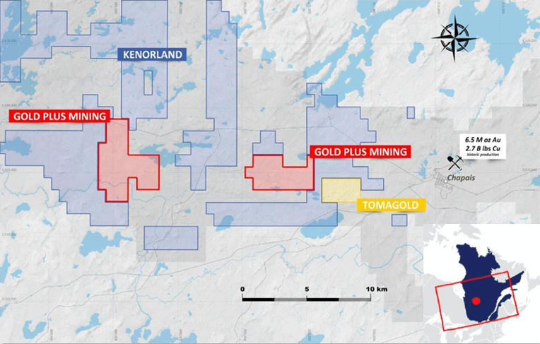

Gold Plus intends to leverage recent and historic work, both on the property and adjacent to the property, to identify high priority targets for a potential drill program.

Data sources available for the targeting program include geophysics, geochemical surveys and drill data. Collectively these demonstrate local mineralized trends, which may carry onto Pluto ground, including in previously unexplored areas, as well as mineralization present on the properties which requires follow up work. Management cautions that past results or discoveries on properties in proximity to Gold Plus may not be indicative to mineralization on the Company’s properties.

About the Pluto Properties - Chapais-Chibougamau Mining Camp, Quebec
The Pluto properties are located west of the town of Chibougamau, Quebec, which provides excellent infrastructure and an experienced local workforce for exploration and mining activities. The Pluto Properties have been under-explored for base and precious metals and historic assay results returned Cu-Zn-Au-Ag values. Some historic diamond drill holes returned visible sulfide mineralization and VMS showings (Dolomieu-Sud). Recent exploration work completed at Pluto resulted in anomalous gold and base metals values in till samples and three distinct anomalous zones were outlined.

The technical information in this press release has been reviewed and approved by Brian H. Newton P.Geo, a “qualified person” pursuant to NI 43-101.

About Gold Plus Mining Inc.
Gold Plus Mining is a publicly traded exploration company focused on the development of highly prospective, discovery-stage mineral properties located in some of Canada’s top mining jurisdictions. Our growing portfolio of mineral properties exhibit favorable geological characteristics in underexplored areas within the prolific “Golden Triangle” of British Columbia, the Mineral Rich “Red Lake” mining camp of Northwestern Ontario and the “Chapais-Chibougamau” mining camp, the second largest mining camp in Quebec, Canada.

Make sure to follow the company on twitter, Instagram and facebook as well as subscribe for company updates at www.goldplusmining.com

ON BEHALF OF THE BOARD
___Spencer Smyl___
CEO & Director

For more information on Gold Plus Mining, please contact:

Mr. Spencer Smyl – CEO & Director
Phone: 604-785-4229
E-mail: spencer@goldplusmining.com
Corporate e-mail: info@goldplusmining.com
Website: www.goldplusmining.com
Corporate Address: 303 – 570 Granville Street, Vancouver, BC, V6C 2P1

Neither Canadian Securities Exchange (CSE) nor its Regulation Services Provider (as that term is defined in the policies of the Canadian Securities Exchange) accepts responsibility for the adequacy or accuracy of this release.
Not for distribution to U.S. Newswire Services or for dissemination in the United States.

