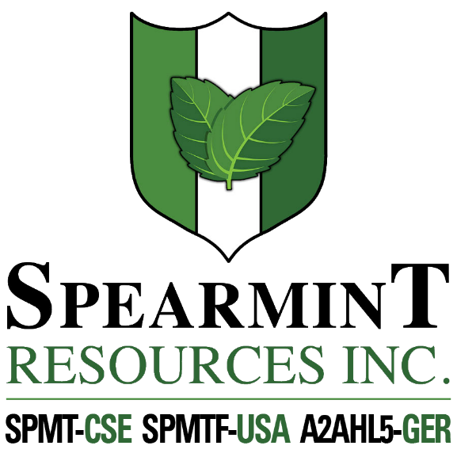

SPEARMINT RESOURCES INC.
1470 - 701 West Georgia St.
Vancouver BC V7Y 1C6

Spearmint Receives Drill Permit for Clayton Valley Lithium Project Drill Program in Nevada

September 14, 2020 - Spearmint Resources Inc. (CSE: SPMT) (OTC Pink: SPMTF) (FSE: A2AHL5) (the “Company”) wishes to announce that it has received a drill permit from the Bureau of Land Management (BLM) to carry out its planned phase-two drill program on its Clayton Valley Lithium Project. This next phase of drilling will be a multi-hole drill program to test the known claystone hosted lithium mineralization within Spearmint’s McGee lithium project. Spearmint has two lithium projects in Nevada consisting of the McGee property (Clay) and the Elon property (Brine) which cover an aggregate area of 1,160 acres. Previous drilling on the McGee project intersected lithium as high as 1,670 ppm Li (announced April 17, 2018).
James Nelson, President of Spearmint, stated "We are pleased to now have our drill permit in hand, and we plan to have drills turning as early as this week. We feel confident in Harrison’s ability to perform this drill program for us as they have many years of knowledge and experience drilling in the Clayton Valley. There are several areas of interest in the clay formation and our plan is to systematically work through these zones. Our first drill program generated some high-grade results, and we believe that a second series of drilling is the key to unlocking the potential of this project. This project lies within a known lithium claystone formation which we share with Cypress Development Corp. (CYP.v) who recently announced (August 11, 2020) a measured resource estimate which was increased to 574.1 million tonnes averaging 1,081 ppm Li or 3.3 million tonnes lithium carbonate equivalent (LCE) (see map). We are also actively formulating work programs for our projects in Quebec and Newfoundland and anticipate the next several weeks to be some of the most active in company history”

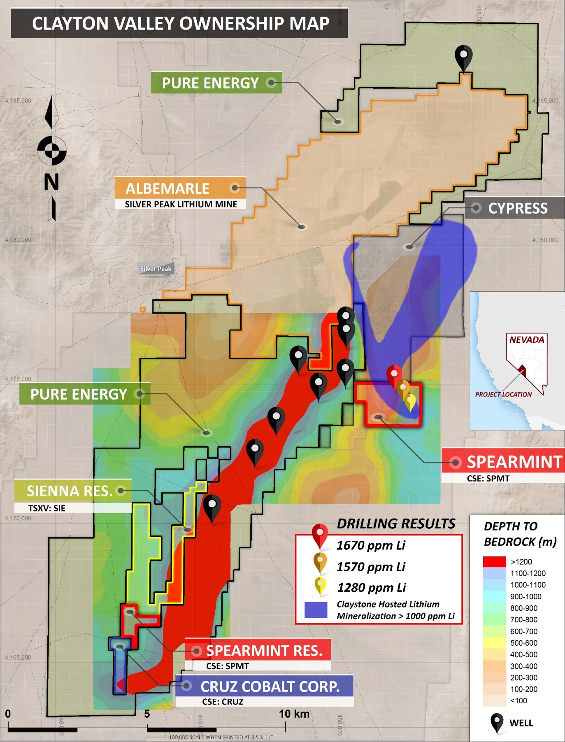

Management cautions that past results or discoveries on properties in proximity to Spearmint may not necessarily be indicative to the presence of mineralization on the Company’s properties. Mr. Greg Thomson, P.Geo., a director of Spearmint and a Qualified Person as defined by National Instrument 43-101 has reviewed and approved the scientific and technical disclosure contained within this news release.

About Spearmint Resources
Spearmint’s current projects include the ‘Goose’ Gold project consisting of 185 acres directly bordering New Found Gold Corp. (NFG.v) as well as the 'Clayton Valley Lithium Prospects' in Nevada comprising of two claim blocks totaling 1,160 acres bordering Pure Energy Minerals (PE.v) & Cypress Development Corp. (CYP.v) where Spearmint's drill results have intersected Lithium values as high as 1670 ppm Li; the ‘Escape Lake North’ PGM Project in Ontario consisting of ~4,000 contiguous acres directly bordering Clean Air Metals Inc. (AIR.v); the Case Lake South Cesium Project in Ontario consisting of ~7,300 acres directly bordering Power Metals Corp.’s (PWM.v) Case Lake Cesium Property; the River Valley East Platinum-Palladium Prospect in Ontario consisting of approximately 4,700 contiguous acres directly bordering New Age Metals (NAM:CSE) flagship River Valley Platinum Group Metals (PGM) project; the Carscallen West Gold Project in Ontario consisting of a ~2500 contiguous acres in the direct vicinity to Melkior Resources Inc. (MKR.v); the Perron-East Gold Prospects consisting of 5 mineral claim blocks covering 11,608 acres located in the Abitibi greenstone belt of northwestern Quebec in the direct vicinity of Amex Exploration Inc.’s (AMX.v) Perron property and past-producing Normetal mine; and the ‘Chibougamau Vanadium Prospect’ comprising of 15,493 contiguous acres directly bordering the vanadium deposit of BlackRock Metal’s (private) Ilmenite vanadium project.
Spearmint's current projects also include a portfolio of prospects in the Golden Triangle of British Columbia; the ‘Golden Triangle Gold Prospects’ comprising of five separate claims blocks totaling 8,265 acres bordering GT Gold Corp (GTT.v), the 6,805 acre ‘NEBA' Gold-Copper Prospects bordering Aben Resources Ltd (ABN.v), and the ‘EL North’ Nickel-Copper Prospect is a contiguous land package of 1,053 acres in the Eskay Creek Camp bordering Garibaldi Resources Corp (GGI.v), as well as the recent acquisition of the 4,980 acre ‘Prickle’ property bordering Brixton Metals Corp. (BBB.V).
Spearmint's other projects in British Columbia include the 'Safari' Copper-Gold Prospect consisting of 9,007 contiguous acres located in the northern Quesnel Trough in North-Central BC, and the ‘Hammernose’ Gold Prospect consisting of 8,685 acres directly bordering Westhaven Gold Corp.’s (WHN.v) Shovelnose Property in the Spences Bridge Gold Belt located in Southern British Columbia, Canada.
If you would like to be added to Spearmint's news distribution list, please send your email address to info@spearmintresources.ca

Contact Information
Tel: 1604646-6903
www.spearmintresources.ca
"James Nelson"
President
Spearmint Resources Inc.

The CSE has not reviewed and does not accept responsibility for the adequacy or accuracy of the content of this release.

