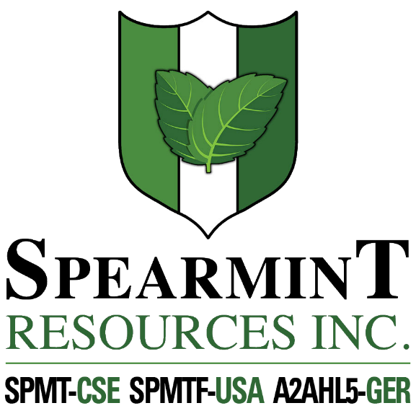

SPEARMINT RESOURCES INC.
1470 - 701 West Georgia St.
Vancouver BC V7Y 1C6

Spearmint Engages Harrison Land Services for Clayton Valley Lithium Project Drill Program

September 4, 2020 - Spearmint Resources Inc. (CSE: SPMT) (OTC Pink: SPMTF) (FSE: A2AHL5) (the “Company”) wishes to announce that Harrison Land Services (HLS) has been engaged to carry out a drill program on its Clayton Valley Lithium Project. This next phase of drilling will be a multi-hole drill program to test the known claystone hosted lithium mineralization within Spearmint’s McGee lithium project. Spearmint has two lithium projects in Nevada consisting of the McGee property (Clay) and the Elon property (Brine) which cover an aggregate area of 1,160 acres. Previous drilling on the McGee project intersected lithium as high as 1,670 ppm Li (announced April 17, 2018).
James Nelson, President of Spearmint, stated "We are pleased to have retained Harrison who have many years of knowledge and experience drilling in the Clayton Valley. Our initial drill program was successful, and we are optimistic that a second series of drill holes could help define our project. This project lies within a known lithium formation which we share with Cypress Development Corp. (CYP.v) who recently announced (August 11, 2020) a measured resource estimate which was increased to 574.1 million tonnes averaging 1,081 ppm Li or 3.3 million tonnes lithium carbonate equivalent (LCE) (see map). Lithium and battery metals in general have been enjoying positive market sentiment recently as electric vehicle sales have taken off, therefore we are eagerly looking forward to commencing operations on one of our flagship properties. Including this planned drill program, Spearmint has multiple projects about to commence including properties in Newfoundland and Quebec and we expect September to be a very active month”
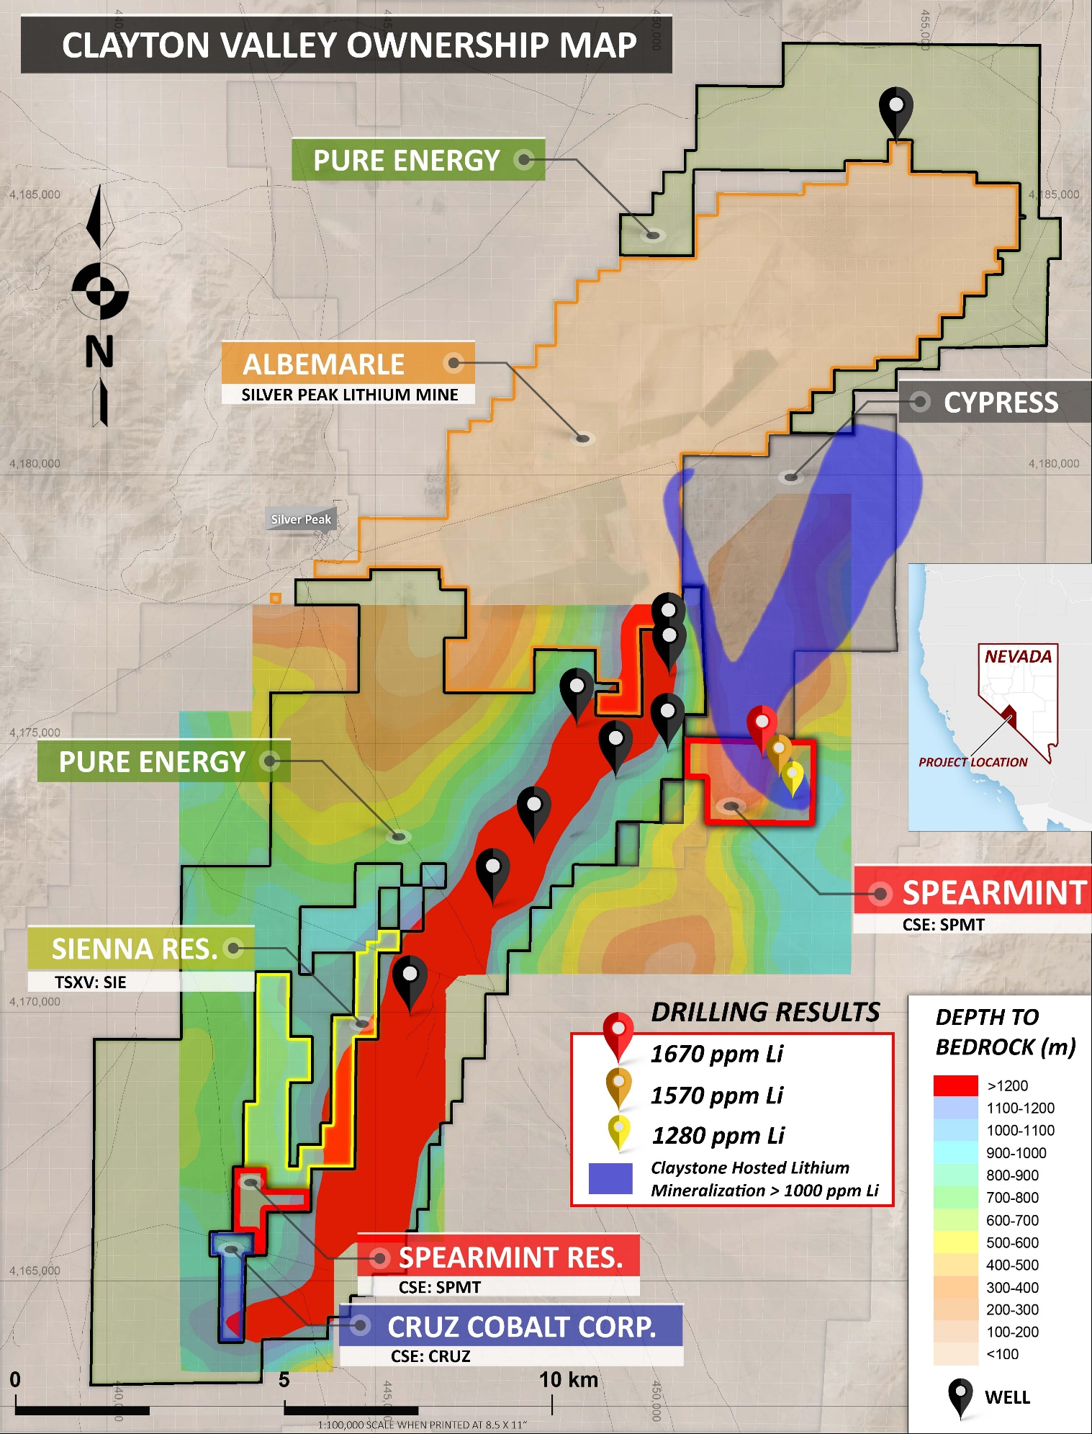

Management cautions that past results or discoveries on properties in proximity to Spearmint may not necessarily be indicative to the presence of mineralization on the Company’s properties. Mr. Greg Thomson, P.Geo., a director of Spearmint and a Qualified Person as defined by National Instrument 43-101 has reviewed and approved the scientific and technical disclosure contained within this news release.

Spearmint is also pleased to announce the appointment of Ms. Twila Jensen as an independent Director to the Company. Ms. Jensen is a director of numerous public companies with over 20 years in the capital markets. Spearmint will also grant two million incentive stock options to directors and officers of the company at an exercise price of .085 cents per share. The options are exercisable for a period of one year pursuant to its rolling stock option plan.

About Spearmint Resources
Spearmint’s current projects include the ‘Goose’ Gold project consisting of 185 acres directly bordering New Found Gold Corp. (NFG.v) as well as the 'Clayton Valley Lithium Prospects' in Nevada comprising of two claim blocks totaling 1,160 acres bordering Pure Energy Minerals (PE.v) & Cypress Development Corp. (CYP.v) where Spearmint's drill results have intersected Lithium values as high as 1670 ppm Li; the ‘Escape Lake North’ PGM Project in Ontario consisting of ~4,000 contiguous acres directly bordering Clean Air Metals Inc. (AIR.v); the Case Lake South Cesium Project in Ontario consisting of ~7,300 acres directly bordering Power Metals Corp.’s (PWM.v) Case Lake Cesium Property; the River Valley East Platinum-Palladium Prospect in Ontario consisting of approximately 4,700 contiguous acres directly bordering New Age Metals (NAM:CSE) flagship River Valley Platinum Group Metals (PGM) project; the Carscallen West Gold Project in Ontario consisting of a ~2500 contiguous acres in the direct vicinity to Melkior Resources Inc. (MKR.v); the Perron-East Gold Prospects consisting of 5 mineral claim blocks covering 11,608 acres located in the Abitibi greenstone belt of northwestern Quebec in the direct vicinity of Amex Exploration Inc.’s (AMX.v) Perron property and past-producing Normetal mine; and the ‘Chibougamau Vanadium Prospect’ comprising of 15,493 contiguous acres directly bordering the vanadium deposit of BlackRock Metal’s (private) Ilmenite vanadium project.
Spearmint's current projects also include a portfolio of prospects in the Golden Triangle of British Columbia; the ‘Golden Triangle Gold Prospects’ comprising of five separate claims blocks totaling 8,265 acres bordering GT Gold Corp (GTT.v), the 6,805 acre ‘NEBA' Gold-Copper Prospects bordering Aben Resources Ltd (ABN.v), and the ‘EL North’ Nickel-Copper Prospect is a contiguous land package of 1,053 acres in the Eskay Creek Camp bordering Garibaldi Resources Corp (GGI.v), as well as the recent acquisition of the 4,980 acre ‘Prickle’ property bordering Brixton Metals Corp. (BBB.V).
Spearmint's other projects in British Columbia include the 'Safari' Copper-Gold Prospect consisting of 9,007 contiguous acres located in the northern Quesnel Trough in North-Central BC, and the ‘Hammernose’ Gold Prospect consisting of 8,685 acres directly bordering Westhaven Gold Corp.’s (WHN.v) Shovelnose Property in the Spences Bridge Gold Belt located in Southern British Columbia, Canada.
If you would like to be added to Spearmint's news distribution list, please send your email address to info@spearmintresources.ca

Contact Information
Tel: 1604646-6903
www.spearmintresources.ca
"James Nelson"
President
Spearmint Resources Inc.

The CSE has not reviewed and does not accept responsibility for the adequacy or accuracy of the content of this release.

