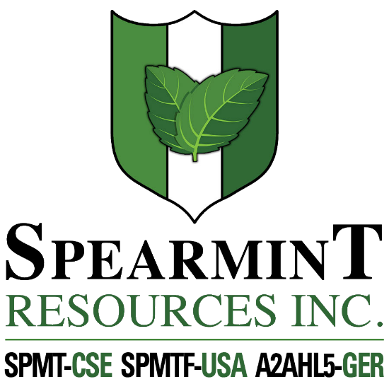

SPEARMINT RESOURCES INC.
1470 - 701 West Georgia St.
Vancouver BC V7Y 1C6

Spearmint Increases Acreage of the Hammernose Prospect in BC After Encountering Positive Gold and Copper Indicators

July 23, 2019 - Spearmint Resources Inc. (CSE: SPMT) (OTC Pink: SPMTF) (FSE: A2AHL5) (the “Company”) is pleased to announce that after receiving positive gold and copper indicators from a recently completed work program announced in a news release on July 18, 2019, the Company has decided to immediately increase the size of the Hammernose gold prospect which now totals 5,910 acres directly bordering the strategic alliance between Westhaven Resources Inc. (WHN.v) and Sable Resource Ltd. in the Spences Bridge gold belt (SBGB) located in Southern British Columbia, Canada.

James Nelson, President of Spearmint stated, “In light of receiving positive data from our sampling program on our Hammernose Prospect in BC, we immediately wanted to expand our land position in this exciting gold and copper district. With gold prices showing multi-year strength, and the increased market attention and focus on gold throughout several districts in BC, Spearmint is well positioned to capitalize on a very active summer work season ahead.”

Recent exploration success by Westhaven Ventures Inc. (WHN.v) on their Shovelnose property, located south of the Hammernose property has sparked ongoing exploration interest in this general area. The northern boundary of the Shovelnose property is located 1.5 kilometres south of the southern boundary of the Hammernose tenure, with the main exploration focus by Westhaven being carried out on the “South Zone” The South Zone, is located approximately 7.4 kilometers south of the southern boundary of the Hammernose property.

Westhaven completed 3,031 metres (m) of diamond drilling in eight holes this past winter at Shovelnose. That program continued to return bonanza gold grades, including the best hole ever drilled on the property (SN19-01: 12.66m of 39.31 g/t gold and 133.11 g/t Ag) and confirmed the potential for mineralization in the south fault block with the successful intersection of a gold mineralized vein zone in SN19-07.

About Spearmint Resources

Spearmint's current projects include a portfolio of prospects in the Golden Triangle of British Columbia; the ‘Golden Triangle Gold Prospects’ comprising of six claims consisting of 9,157 acres bordering GT Gold Corp (GTT.v), the 920 acre 'NEBA West' & 6,803 acre ‘NEBA' Gold-Copper Prospects bordering Aben Resources Ltd (ABN.v), the 'Henry' Gold-Copper Prospect comprised of two contiguous claim blocks totaling 4,912 acres in the direct vicinity of Golden Ridge Resources Ltd. (GLDN.v), and the 17,593 acre ‘EL North’ Nickel-Copper Prospect consisting of six contiguous claims in the Eskay Creek Camp bordering Garibaldi Resources Corp (GGI.v) as well as the recent acquisition, the 4,980 acre ‘Prickle’ property bordering Brixton Metals Corp. (BBB.V).
Spearmint's other projects in British Columbia include the ‘Gold Mountain Prospects’ comprising of three separate claim blocks totaling 1,245 acres bordering Barkerville Gold Mines (BGM.v), the 'Safari’ Copper-Gold Prospect consisting of 9,007 contiguous acres located in the northern Quesnel Trough in north-central BC directly bordering Serengeti Resources Inc. (SIR.v). and the ‘Hammernose’ Gold Prospect consisting of 5,910 acres directly bordering the strategic alliance between Westhaven Ventures Inc. (WHN.v) & Sable Resources Ltd. in the Spences Bridge Gold Belt located in Southern BC, Canada. These claims were acquired via MTOnline.
Spearmint’s current projects also include the ‘Chibougamau Vanadium Prospects’ comprising of 17,142 contiguous acres bordering the vanadium deposit of BlackRock Metal’s (private) Ilmenite vanadium project and Vanadium One Energy Corp. (VONE.v) and Spearmint’s 'Clayton Valley Lithium Prospects' in Nevada comprising of two claim blocks totaling 1,160 acres bordering Pure Energy Minerals (PE.v) & Cypress Development Corp. (CYP.v) where Spearmint’s drill results have intersected Lithium values as high as 1,670 ppm Li.
If you would like to be added to Spearmint's news distribution list, please send your email address to
info@spearmintresources.ca.
Contact Information
Tel: 1604646-6903
www.spearmintresources.ca

"James Nelson"
President
Spearmint Resources Inc.

The CSE has not reviewed and does not accept responsibility for the adequacy or accuracy of the content of this release.

