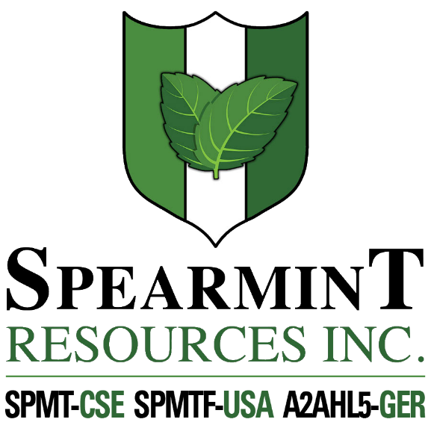

SPEARMINT RESOURCES INC.
1470 - 701 West Georgia St.
Vancouver BC V7Y 1C6

Spearmint Commences Operations on Hammernose Gold Project in the Spences Bridge Gold Belt of British Columbia

July 14, 2020 - Spearmint Resources Inc. (CSE: SPMT) (OTC Pink: SPMTF) (FSE: A2AHL5) (the “Company”) is pleased to announce that it has commenced a work program on the ‘Hammernose’ Gold Project consisting of 8,685 acres directly bordering Westhaven Gold Corp.’s (WHN.v) Shovelnose Property in the Spences Bridge Gold Belt (SBGB) located in Southern British Columbia, Canada. Rio Minerals Limited has been engaged to commence work immediately on the “Hammernose Gold Project.” On July 9, 2020, Westhaven announced drill results that returned 34.00 metres (m) of 1.21 g/t gold (Au) and 3.68 g/t silver (Ag), including: 1.00m of 15.70 g/t Au and 77.50 g/t Ag within 200m of surface at Shovelnose. Management cautions that past results or discoveries on properties in proximity to Spearmint may not necessarily be indicative to the presence of mineralization on the Company’s properties.

James Nelson, President of Spearmint, stated "We are extremely excited to get started on phase two of the work program on our Hammernose project where we had positive gold and copper indicators on last year’s program. We were able to outline several areas of anomalous stream sediments and these targets will be our main focus with the goal of defining the highest priority drill targets. We will also spotlight the newly acquired acreage directly bordering Westhaven with strategic sampling and ground truthing. We have witnessed an uptrend in gold and copper trading near multi-year highs and we’re excited to start work on multiple projects in our portfolio in the coming weeks and months.”

Spearmint Resources Inc. also previously announced (June 19, 2020) that the Company is formulating plans for lithium in Nevada. Spearmint has two separate claim blocks in Nevada that are prospective for lithium known as the Elon property (Brine) and the McGee property (Clay) which cover an aggregate area of 1,160 acres. Exploration drilling had been completed (announced April 17, 2018) on its Clayton Valley Lithium Projects (McGee property) and has intersected lithium as high as 1,670 ppm Li.

Mr. Greg Thomson, P.Geo., a director of Spearmint and a Qualified Person as defined by National Instrument 43-101 has reviewed and approved the scientific and technical disclosure contained within this news release.

About Spearmint Resources
Spearmint’s current projects include the 'Clayton Valley Lithium Prospects' in Nevada comprising of two claim blocks totaling 1,160 acres bordering Pure Energy Minerals (PE.v) & Cypress Development Corp. (CYP.v) where Spearmint's drill results have intersected Lithium values as high as 1670 ppm Li; the ‘Escape Lake North’ PGM Project in Ontario consisting of ~4,000 contiguous acres directly bordering Clean Air Metals Inc. (AIR.v); the Case Lake South Cesium Prospect in Ontario consisting of ~5,000 contiguous acres directly bordering Power Metals Corp.’s (PWM.v) Case Lake Cesium Property; the River Valley East Platinum-Palladium Prospect in Ontario consisting of approximately 4,700 contiguous acres directly bordering New Age Metals (NAM:CSE) flagship River Valley Platinum Group Metals (PGM) project; the Carscallen West Gold Project in Ontario consisting of a ~2500 contiguous acres in the direct vicinity to Melkior Resources Inc. (MKR.v); the Perron-East Gold Prospects consisting of 5 mineral claim blocks covering ~10,910 acres located in the Abitibi greenstone belt of northwestern Quebec in the direct vicinity of Amex Exploration Inc.’s (AMX.v) Perron property and past-producing Normetal mine; and the ‘Chibougamau Vanadium Prospect’ comprising of 15,493 contiguous acres directly bordering the vanadium deposit of BlackRock Metal’s (private) Ilmenite vanadium project.
Spearmint's current projects also include a portfolio of prospects in the Golden Triangle of British Columbia; the ‘Golden Triangle Gold Prospects’ comprising of five separate claims blocks totaling 8,265 acres bordering GT Gold Corp (GTT.v), the 6,805 acre ‘NEBA' Gold-Copper Prospects bordering Aben Resources Ltd (ABN.v), and the ‘EL North’ Nickel-Copper Prospect is a contiguous land package of 1,053 acres in the Eskay Creek Camp bordering Garibaldi Resources Corp (GGI.v), as well as the recent acquisition of the 4,980 acre ‘Prickle’ property bordering Brixton Metals Corp. (BBB.V).
Spearmint's other projects in British Columbia include the 'Safari' Copper-Gold Prospect consisting of 9,007 contiguous acres located in the northern Quesnel Trough in North-Central BC, and the ‘Hammernose’ Gold Prospect consisting of 8,685 acres directly bordering Westhaven Gold Corp.’s (WHN.v) Shovelnose Property in the Spences Bridge Gold Belt located in Southern British Columbia, Canada.
If you would like to be added to Spearmint's news distribution list, please send your email address to info@spearmintresources.ca

Contact Information
Tel: 1604646-6903
www.spearmintresources.ca
"James Nelson"
President
Spearmint Resources Inc.

The CSE has not reviewed and does not accept responsibility for the adequacy or accuracy of the content of this release.

