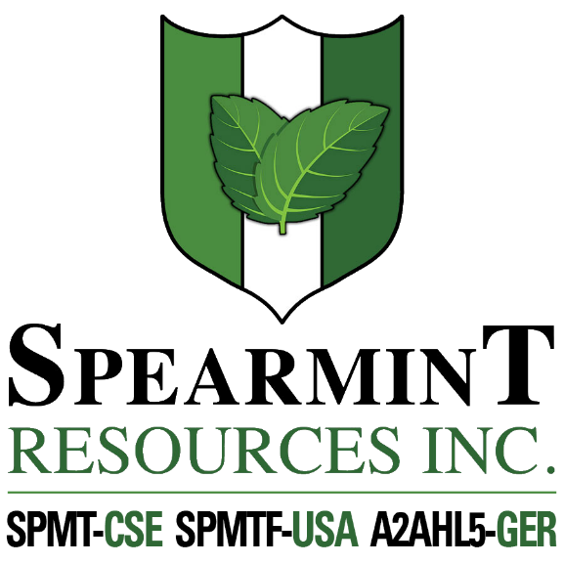

SPEARMINT RESOURCES INC.
1470 - 701 West Georgia St.
Vancouver BC V7Y 1C6

Spearmint Increases Acreage of Hammernose Gold Project in the Spences Bridge Gold Belt of BC

July 10, 2020 - Spearmint Resources Inc. (CSE: SPMT) (OTC Pink: SPMTF) (FSE: A2AHL5) (the “Company”) is pleased to announce that it has increased its acreage on the ‘Hammernose’ Gold Project which now consists of 8,685 acres directly bordering Westhaven Resources Inc.’s (WHN.v) Shovelnose Gold Property, in the Spences Bridge Gold Belt (SBGB) located in Southern British Columbia, Canada. The Hammernose Gold Project is situated off a major highway, in close proximity to power, rail, large producing mines, and within commuting distance from the city of Merritt. Yesterday, on July 9, 2020, Westhaven announced drill results that returned 34.00 metres (m) of 1.21 g/t gold (Au) and 3.68 g/t silver (Ag), including: 1.00m of 15.70 g/t Au and 77.50 g/t Ag within 200m of surface at Shovelnose. Management cautions that past results or discoveries on properties in proximity to Spearmint may not necessarily be indicative to the presence of mineralization on the Company’s properties.

James Nelson, President of Spearmint, stated “We are very pleased to be able to significantly increase our landholdings directly bordering the discovery made by Westhaven Resources Inc. With the recent appreciation in the price of gold and a reenergized junior mining sector, management is optimistic regarding 2020 and plan to be active throughout the rest of the summer.”

Spearmint Resources Inc. also previously announced (June 19, 2020) that the Company is formulating plans for lithium in Nevada. Spearmint has two separate claim blocks in Nevada that are prospective for lithium known as the Elon property (Brine) and the McGee property (Clay) which cover an aggregate area of 1,160 acres. Exploration drilling had been completed (announced April 17, 2018) on its Clayton Valley Lithium Projects (McGee property) and has intersected lithium as high as 1,670 ppm Li
Mr. Greg Thomson, P.Geo., a director of Spearmint and a Qualified Person as defined by National Instrument 43-101 has reviewed and approved the scientific and technical disclosure contained within this news release. This new acreage was acquired via Mtonline.

About Spearmint Resources
Spearmint’s current projects include the 'Clayton Valley Lithium Prospects' in Nevada comprising of two claim blocks totaling 1,160 acres bordering Pure Energy Minerals (PE.v) & Cypress Development Corp. (CYP.v) where Spearmint's drill results have intersected Lithium values as high as 1670 ppm Li; the ‘Escape Lake North’ PGM Project in Ontario consisting of ~4,000 contiguous acres directly bordering Clean Air Metals Inc. (AIR.v); the Case Lake South Cesium Prospect in Ontario consisting of ~5,000 contiguous acres directly bordering Power Metals Corp.’s (PWM.v) Case Lake Cesium Property; the River Valley East Platinum-Palladium Prospect in Ontario consisting of approximately 4,700 contiguous acres directly bordering New Age Metals (NAM:CSE) flagship River Valley Platinum Group Metals (PGM) project; the Carscallen West Gold Project in Ontario consisting of a ~2500 contiguous acres in the direct vicinity to Melkior Resources Inc. (MKR.v); the Perron-East Gold Prospects consisting of 5 mineral claim blocks covering ~10,910 acres located in the Abitibi greenstone belt of northwestern Quebec in the direct vicinity of Amex Exploration Inc.’s (AMX.v) Perron property and past-producing Normetal mine; and the ‘Chibougamau Vanadium Prospect’ comprising of 15,493 contiguous acres directly bordering the vanadium deposit of BlackRock Metal’s (private) Ilmenite vanadium project.
Spearmint's current projects also include a portfolio of prospects in the Golden Triangle of British Columbia; the ‘Golden Triangle Gold Prospects’ comprising of five separate claims blocks totaling 8,265 acres bordering GT Gold Corp (GTT.v), the 6,805 acre ‘NEBA' Gold-Copper Prospects bordering Aben Resources Ltd (ABN.v), and the ‘EL North’ Nickel-Copper Prospect is a contiguous land package of 1,053 acres in the Eskay Creek Camp bordering Garibaldi Resources Corp (GGI.v), as well as the recent acquisition of the 4,980 acre ‘Prickle’ property bordering Brixton Metals Corp. (BBB.V).
Spearmint's other projects in British Columbia include the 'Safari' Copper-Gold Prospect consisting of 9,007 contiguous acres located in the northern Quesnel Trough in North-Central BC, and the ‘Hammernose’ Gold Prospect consisting of 8,685 acres directly bordering Westhaven Resources Inc.’s (WHN.v) Shovelnose Gold Property in the Spences Bridge gold belt located in Southern British Columbia, Canada.
If you would like to be added to Spearmint's news distribution list, please send your email address to info@spearmintresources.ca

Contact Information
Tel: 1604646-6903
www.spearmintresources.ca
"James Nelson"
President
Spearmint Resources Inc.

The CSE has not reviewed and does not accept responsibility for the adequacy or accuracy of the content of this release.

