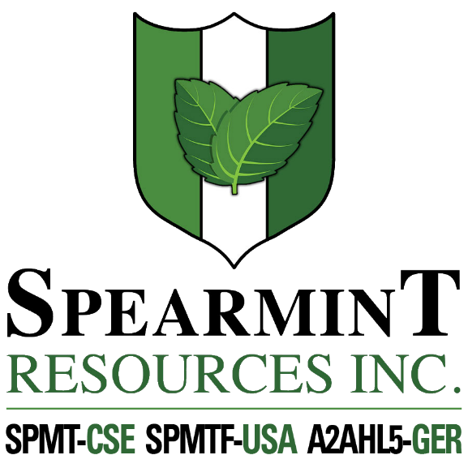

SPEARMINT RESOURCES INC.
1470 - 701 West Georgia St.
Vancouver BC V7Y 1C6

Spearmint Looking to Recommence Operations on its Clayton Valley Lithium Prospects in Nevada

January 30, 2020 - Spearmint Resources Inc. (CSE: SPMT) (OTC Pink: SPMTF) (FSE: A2AHL5) (the “Company”) is pleased to announce the company is planning to start up operations on its Clayton Valley Lithium Prospect in Nevada. Plans are now being formulated by management. Spearmint has two separate claim blocks in Nevada that are prospective for lithium known as the Elon property and the McGee property which cover an aggregate area of 800 acres.

Spearmint Resources Inc. announced that exploration drilling had been completed (announced April 17, 2018) on its Clayton Valley Lithium Prospect and has intersected lithium as high as 1,670 ppm Li. The three holes drilled into the clay formation all intersected lithium. Hole 1 had a range of 1670-396 ppm Li over 270 feet averaging 835 ppm Li, including 35 feet averaging 1,140 ppm Li. Hole 2 had a range of 1570-250 ppm Li averaging 642 ppm Li over 220 feet including 20 feet of 925 ppm Li. Hole 3 had a range of 1280-429 ppm Li averaging 772 ppm Li over 195 feet including 998 ppm Li over 20 feet.

James Nelson, President of Spearmint, stated "There is a distinct positive feeling surrounding lithium and especially lithium in Nevada recently. On January 29, 2020 Noram Ventures Inc. (NRM-tsx.v) announced successful drill results including 56.4 metres with an average of 1,230 parts per million lithium on their project that borders Spearmint. Spearmint intersected a range of 1670-396 ppm Li over 270 feet averaging 835 ppm Li, including 35 feet averaging 1,140 ppm Li. Also recently announced was news that Schlumberger Technology Corporation has begun the initial steps to advance its option to test and develop Pure Energy Mineral’s Clayton Valley Project (announced November 26, 2019). When a major company like Schlumberger is looking at the property right beside Spearmint, and judging by how Noram shares doubled yesterday on their lithium drill results, it is clear that lithium in Nevada is gaining attention again. We are looking forward to getting back into Nevada shortly. We also just announced the acquisition of the River Valley East Platinum-Palladium Prospect in Ontario that we are also formulating plans on. Clearly 2020 will be very active for Spearmint in terms of work programs at a time when the general sentiment towards junior mining companies has turned positive.”

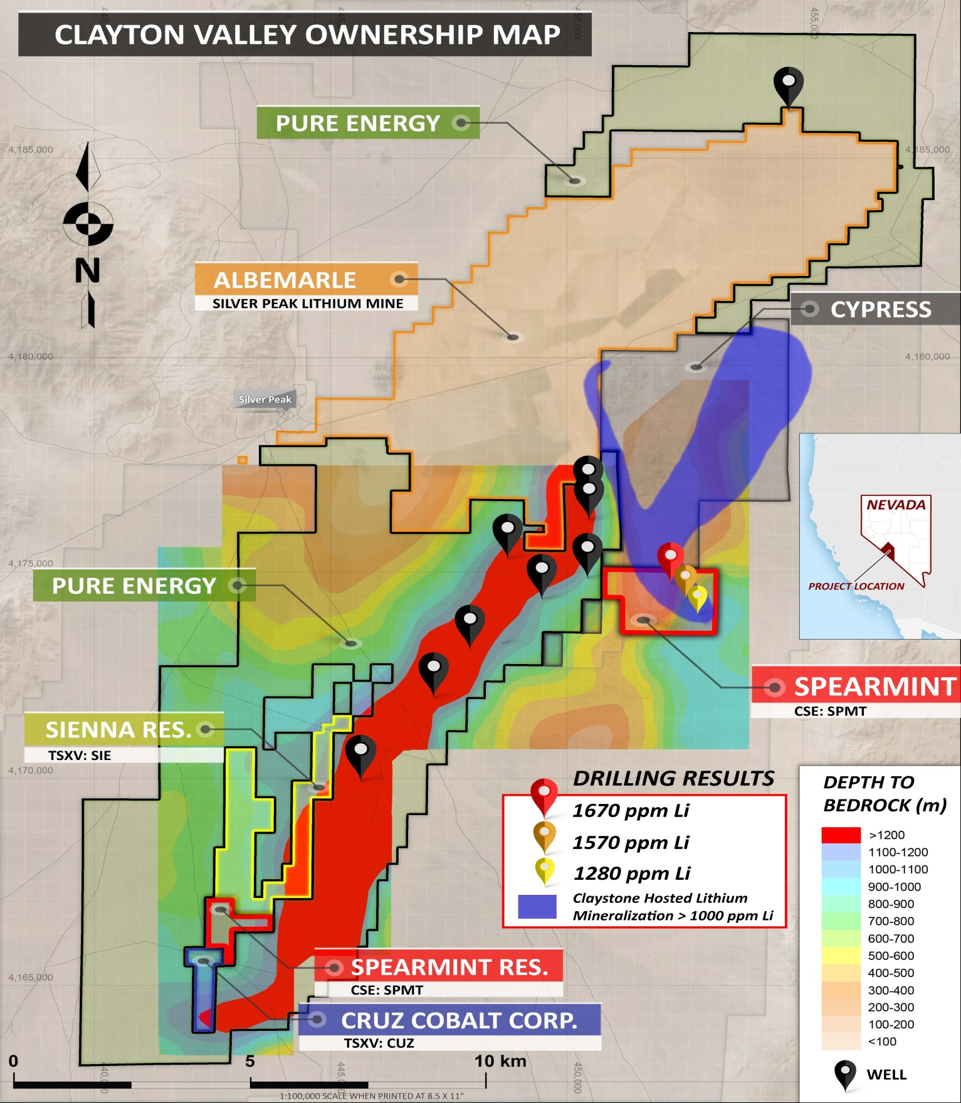

Spearmint recently (January 27, 2020) announced that it has acquired the River Valley East Platinum-Palladium Prospect in Ontario consisting of approximately 4,700 contiguous acres. These new claims are directly bordering New Age Metals (NAM:CSE) flagship River Valley Platinum Group Metals’ (PGM) project which hosts a magmatic contact-hosted platinum-palladium-gold PGE Deposit located in northeastern Ontario, approximately 60 km northeast of Sudbury. According to a New Age Metals’ news release dated August 08, 2019, their PEA highlights a Life of Mine (LOM) of 14 years, with 6 million tonnes annually of potential process plant feed at an average grade of 0.88 gram per tonne (g/t) palladium equivalent (PdEq) and process recovery rate of 80 per cent, resulting in an annual average payable PdEq production of 119,000 ounces.

About Spearmint Resources
Spearmint’s current projects include the River Valley East Platinum-Palladium Prospect in Ontario consisting of approximately 4,700 contiguous acres directly bordering New Age Metals' (NAM:CSE) flagship River Valley Platinum Group Metals (PGM) project, the Perron-East Gold Prospects consisting of 4 mineral claim blocks covering approximately 1,957 acres located in the Abitibi greenstone belt of northwestern Quebec in the direct vicinity of Amex Exploration Inc.’s (AMX.v) Perron property and past-producing Normetal mine, the ‘Chibougamau Vanadium Prospect’ comprising of 17,142 contiguous acres directly bordering the vanadium deposit of BlackRock Metal’s (private) Ilmenite vanadium project, and Spearmint’s 'Clayton Valley Lithium Prospects' in Nevada comprising of two claim blocks totalling 800 acres bordering Pure Energy Minerals (PE.v) & Cypress Development Corp. (CYP.v) where Spearmint's drill results have intersected Lithium values as high as 1670ppmLi.
Spearmint's current projects also include a portfolio of prospects in the Golden Triangle of British Columbia; the ‘Golden Triangle Gold Prospects’ comprising of five separate claims blocks totalling 8,265 acres bordering GT Gold Corp (GTT.v), the 6,805 acre ‘NEBA' Gold-Copper Prospects bordering Aben Resources Ltd (ABN.v), and the ‘EL North’ Nickel-Copper Prospect is a contiguous land package of 1,053 acres in the Eskay Creek Camp bordering Garibaldi Resources Corp (GGI.v), as well as the recent acquisition of the 4,980 acre ‘Prickle’ property bordering Brixton Metals Corp. (BBB.V).
Spearmint's other projects in British Columbia include the 'Safari' Copper-Gold Prospect consisting of 9,007 contiguous acres located in the northern Quesnel Trough in North-Central BC directly bordering Serengeti Resources Inc. (SIR.v), and the ‘Hammernose’ Gold Prospect consisting of 5,910 acres directly bordering the strategic alliance between Westhaven Resources Inc. (WHN.v) & Sable Resource Ltd. (SAE.v) in the Spences Bridge gold belt located in Southern British Columbia, Canada.
The technical contents of this release were approved by Greg Thomson, PGeo, a qualified person as defined by National Instrument 43-101. Management cautions that past results or discoveries on properties in proximity to Spearmint may not necessarily be indicative to the presence of mineralization on the Company's properties.

If you would like to be added to Spearmint's news distribution list, please send your email address to
info@spearmintresources.ca

Contact Information
Tel: 1604646-6903
www.spearmintresources.ca
"James Nelson"
President
Spearmint Resources Inc.

The CSE has not reviewed and does not accept responsibility for the adequacy or accuracy of the content of this release.

