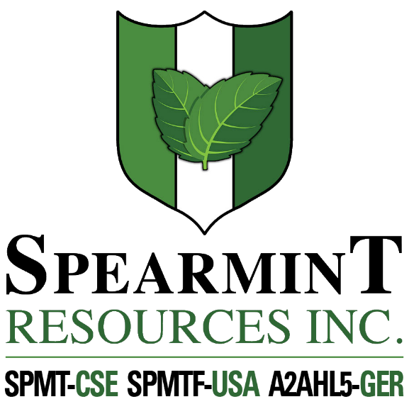

SPEARMINT RESOURCES INC.
1470 - 701 West Georgia St.
Vancouver BC V7Y 1C6

Spearmint Successfully Completes Phase Two of its Work Program on the Hammernose Gold Project in the Spences Bridge Gold Belt of British Columbia

August 4, 2020 - Spearmint Resources Inc. (CSE: SPMT) (OTC Pink: SPMTF) (FSE: A2AHL5) (the “Company”) is pleased to announce that it has successfully completed its second work program on the ‘Hammernose’ Gold Project. Located in the Spences Bridge Gold Belt (SBGB) of Southern British Columbia, the Hammernose consists of 8,685 acres directly bordering Westhaven Gold Corp.’s (WHN.v) Shovelnose Property. All the creeks on the three tenures were sampled and all outcrops and areas of interest were geologically mapped and sampled by Rio Minerals Limited. The samples have been hand-delivered to ActLabs in Kamloops and we should have the results in 4-8 weeks.

On July 9, 2020, Westhaven announced drill results that returned 34.00 metres (m) of 1.21 g/t gold (Au) and 3.68 g/t silver (Ag), including: 1.00m of 15.70 g/t Au and 77.50 g/t Ag within 200m of surface at Shovelnose. Management cautions that past results or discoveries on properties in proximity to Spearmint may not necessarily be indicative to the presence of mineralization on the Company’s properties.

James Nelson, President of Spearmint, stated "We are pleased to have successfully completed our next phase on the Hammernose. This phase will help to define the highest priority drill targets. As we await those results, the Company is well funded to aggressively move forward on multiple other projects that include starting a drill program on our Clayton Valley lithium project, in addition to starting work on our Perron-East gold project in the vicinity of Amex Exploration. Gold prices have recently made all-time highs and most commodities are continuing their uptrends. The weeks ahead are expected to be the most active the Company has experienced to date.”

Spearmint Resources Inc. also previously announced (June 19, 2020) that the Company is formulating plans for lithium in Nevada. Spearmint has two separate claim blocks in Nevada that are prospective for lithium known as the Elon property (Brine) and the McGee property (Clay) which cover an aggregate area of 1,160 acres. Exploration drilling had been completed (announced April 17, 2018) on its Clayton Valley Lithium Projects (McGee property) and has intersected lithium as high as 1,670 ppm Li.

Mr. Greg Thomson, P.Geo., a director of Spearmint and a Qualified Person as defined by National Instrument 43-101 has reviewed and approved the scientific and technical disclosure contained within this news release.

About Spearmint Resources
Spearmint’s current projects include the 'Clayton Valley Lithium Prospects' in Nevada comprising of two claim blocks totaling 1,160 acres bordering Pure Energy Minerals (PE.v) & Cypress Development Corp. (CYP.v) where Spearmint's drill results have intersected Lithium values as high as 1670 ppm Li; the ‘Escape Lake North’ PGM Project in Ontario consisting of ~4,000 contiguous acres directly bordering Clean Air Metals Inc. (AIR.v); the Case Lake South Cesium Prospect in Ontario consisting of ~5,000 contiguous acres directly bordering Power Metals Corp.’s (PWM.v) Case Lake Cesium Property; the River Valley East Platinum-Palladium Prospect in Ontario consisting of approximately 4,700 contiguous acres directly bordering New Age Metals (NAM:CSE) flagship River Valley Platinum Group Metals (PGM) project; the Carscallen West Gold Project in Ontario consisting of a ~2500 contiguous acres in the direct vicinity to Melkior Resources Inc. (MKR.v); the Perron-East Gold Prospects consisting of 5 mineral claim blocks covering 11,608 acres located in the Abitibi greenstone belt of northwestern Quebec in the direct vicinity of Amex Exploration Inc.’s (AMX.v) Perron property and past-producing Normetal mine; and the ‘Chibougamau Vanadium Prospect’ comprising of 15,493 contiguous acres directly bordering the vanadium deposit of BlackRock Metal’s (private) Ilmenite vanadium project.
Spearmint's current projects also include a portfolio of prospects in the Golden Triangle of British Columbia; the ‘Golden Triangle Gold Prospects’ comprising of five separate claims blocks totaling 8,265 acres bordering GT Gold Corp (GTT.v), the 6,805 acre ‘NEBA' Gold-Copper Prospects bordering Aben Resources Ltd (ABN.v), and the ‘EL North’ Nickel-Copper Prospect is a contiguous land package of 1,053 acres in the Eskay Creek Camp bordering Garibaldi Resources Corp (GGI.v), as well as the recent acquisition of the 4,980 acre ‘Prickle’ property bordering Brixton Metals Corp. (BBB.V).
Spearmint's other projects in British Columbia include the 'Safari' Copper-Gold Prospect consisting of 9,007 contiguous acres located in the northern Quesnel Trough in North-Central BC, and the ‘Hammernose’ Gold Prospect consisting of 8,685 acres directly bordering Westhaven Gold Corp.’s (WHN.v) Shovelnose Property in the Spences Bridge Gold Belt located in Southern British Columbia, Canada.
If you would like to be added to Spearmint's news distribution list, please send your email address to info@spearmintresources.ca

Contact Information
Tel: 1604646-6903
www.spearmintresources.ca
"James Nelson"
President
Spearmint Resources Inc.

The CSE has not reviewed and does not accept responsibility for the adequacy or accuracy of the content of this release.

