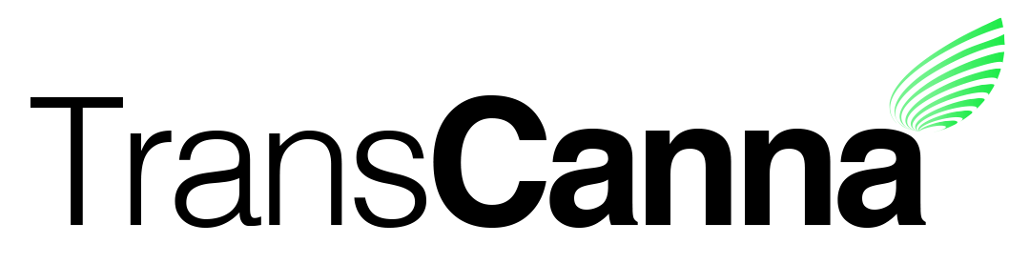
Suite 902, 1030 West Georgia Street
Vancouver, B.C. V6E 3M5

TransCanna Closes Acquisition of SolDaze
Canadian Securities Exchange: TCAN
Borse Frankfurt: TH8
Vancouver, BC, September 19th, 2019 - TransCanna Holdings Inc. (CSE: TCAN, XETR: TH8) (“TransCanna” or the “Company”) is pleased to announce that it has closed its previously announced acquisition of all of the outstanding equity interest in Tres Ojos Naturals LLC, doing business as SolDaze, a limited liability company based in Santa Cruz, California.
TransCanna paid to the vendors a purchase price comprised of an aggregate cash payment of US$200,000 (including a previously paid deposit of US$50,000) and the issuance of 810,000 common shares in the capital of the Company (the "Closing Share Consideration") at a deemed price of $1.14 per share. The Company and the vendors entered into a voluntary pooling agreement in respect of the Closing Share Consideration, which provides for a release of such shares over a two-year period, subject to acceleration in the event that the sales of SolDaze products meet specific revenue targets. The number of shares released may also be reduced in the event that certain revenue targets are not met by the dates specified. An additional cash payment in the amount of US$150,000 will be paid on November 15, 2019 to satisfy the remaining cash portion of the purchase price.
About TransCanna Holdings Inc.
TransCanna Holdings Inc. is a Canadian based company providing branding, transportation and distribution services, through its wholly-owned California subsidiaries, to a range of industries including the cannabis marketplace.

For further information, please visit the Company’s website at www.transcanna.com or email the Company at info@transcanna.com.

On behalf of the Board of Directors
Steve Giblin
President
604-609-6199

Neither the Canadian Securities Exchange nor its Regulation Services Provider (as that term is defined in the policies of the Canadian Securities Exchange) accepts responsibility for the adequacy or accuracy of this release.

