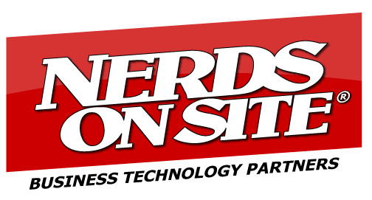

For Immediate Release

NERDS ON SITE TARGETS M&A OPPORTUNITIES IN USA AND CANADA
STRATEGY TO ACCELERATE GROWTH THROUGH CENTRALIZED MANAGED SERVICES UNIT

TORONTO, May 15th, 2019 - Nerds On Site Inc. (“NERDS” or the "Company") (CSE: NERD) (FSE: 3NS.F) (QTCQB: NOSUF), a mobile IT solutions company servicing the SME marketplace, announces its intention to grow its Centralized Managed Service business through mergers and acquisitions in North America.

“NERDS is in an ideal position to scale its best practices in the lucrative Centralized Managed Services business through strategic and targeted mergers and acquisitions,” said Mr. Charles Regan, Nerds On Site CEO. “We have a proven and systematic approach for success, our key identifier and attraction attributes checklist will guide decision making and focus energy on the right targets at the right time within our attribution range.”

Managed Services Providers M & A Strategy Highlights:

- Approximately, 40,000 Managed Services Providers (MSP’s) of various maturity and service offerings exist in North America
- NERDS proven checklist has identified 3000 approximate operations that qualify within the Company’s attribute range
- To accelerate growth with NERDS best practices, target operations ideally have between $1.5M - $2.5M annual contract revenue
- Strategic plan calls for 1 Canadian and 3 USA acquisitions in the initial M & A phase, with more to follow in subsequent phases
“In terms of timing, we are in discussions with the first company we have identified, and it is anticipated that that this first deal will be executed by calendar year-end,” added Mr. Regan.

For further information please contact:

Mr. Charles Regan, CEO of Nerds on Site
Please visit www.investors.nerdsonsite.com
Call 1-877-778-2335, or email IR@nerdsonsite.com.

About Nerds On Site:
Nerds on Site, a company founded in 1995, specializes in providing cost effective, leading edge solutions to Small and Medium sized Enterprise (SME), serving as the complete SME IT solution specialists. Nerds on Site was established in London, Ontario with current annual revenues of approximately $10,000,000 with normalized net earnings of about $100,000.00. The company services over 12,000 clients per year with a superb 96.5% customer satisfaction rating. NOS’s business model is based on Nerds sub contracts in Canada and a Franchise model for USA expansion.

Neither the Canadian Securities Exchange nor its Regulation Services Provider (as that term is defined in the policies of the Canadian Securities Exchange) accepts responsibility for the adequacy or accuracy of this release.
Forward Looking Statements - Certain information set forth in this material may contain forward-looking statements that involve substantial known and unknown risks and uncertainties. All statements other than statements of historical fact are forward-looking statements, including, without limitation, statements regarding future financial position, business strategy, use of proceeds, corporate vision, proposed acquisitions, partnerships, joint-ventures and strategic alliances and co-operations, budgets, cost and plans and objectives of or involving the Company. Such forward-looking information reflects management's current beliefs and is based on information currently available to management. Often, but not always, forward-looking statements can be identified by the use of words such as "plans", "expects", "is expected", "budget", "scheduled", "estimates", "forecasts", "predicts", "intends", "targets", "aims", "anticipates" or "believes" or variations (including negative variations) of such words and phrases or may be identified by statements to the effect that certain actions "may", "could", "should", "would", "might" or "will" be taken, occur or be achieved. A number of known and unknown risks, uncertainties and other factors may cause the actual results or performance to materially differ from any future results or performance expressed or implied by the forward-looking information. These forward-looking statements are subject to numerous risks and uncertainties, certain of which are beyond the control of the Company including, but not limited to, the impact of general economic conditions, industry conditions and dependence upon regulatory approvals. Readers are cautioned that the assumptions used in the preparation of such information, although considered reasonable at the time of preparation, may prove to be imprecise and, as such, undue reliance should not be placed on forward-looking statements. The Company does not assume any obligation to update or revise its forward-looking statements, whether as a result of new information, future events, or otherwise, except as required by securities laws.

