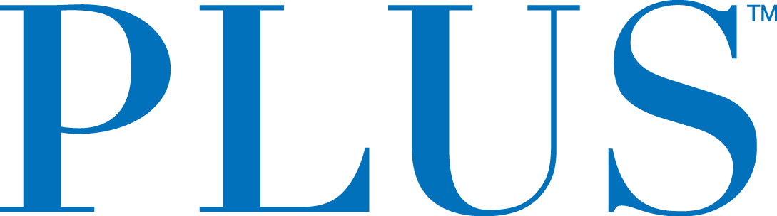

PLUS Announces Participation in Newly Created National Cannabis Roundtable, with John Boehner as Honorary Chairman

A National Campaign to Reform Federal Cannabis Laws
February 8, 2019, San Mateo, CA — Plus Products Inc. (CSE: PLUS) (OTCQB:PLPRF) (the “Company” or “PLUS™”) is pleased to announce its participation in the newly formed National Cannabis Roundtable (“NCR”), a campaign aimed at reforming federal cannabis laws. The NCR will focus on advocating for a rational legal framework for cannabis reform in the United States. Former Speaker of the House, John Boehner, will serve as Honorary Chairman.
“As the cannabis industry grows and matures, it’s vital that we work together for a common-sense legal framework for cannabis policy,” Speaker Boehner said today. As membership grows, he says, NCR will be comprised of growers, processors, retailers, wellness centers, investors, entrepreneurs, and publicly traded companies. With strategic guidance from Speaker Boehner, NCR’s public policy team, which includes The Liaison Group, Squire Patton Boggs and HDMK Public Affairs, will advocate for a multi-faceted reform agenda:

• Remove federal restrictions that prohibit medical research involving cannabis. Encourage the development of solutions that will improve the lives of veterans and patients and combat the opioid epidemic in the United States.
• Allow companies operating legally in the cannabis industry to utilize traditional institutions for transactions and access to financial markets.
• Correct flaws in the US tax code that serve as barriers to legal commerce in the cannabis industry and prohibit the development of solutions that can improve Americans’ lives.
• Build support for, and secure enactment of, federal legislation allowing states to set and enforce their own laws governing cannabis.

“As the Cannabis industry matures, leading companies have a responsibility to help keep the public safe and well informed,” said Jake Heimark, CEO of PLUS. “Our mission at PLUS is to make cannabis safe and approachable and we are excited to help further that mission by being an inaugural participant in the National Cannabis Roundtable.”

“As the top edible company in the largest state, we look forward to helping shape the national dialog around cannabis consumption and make sure the cannabis industry takes a responsible role in keeping consumers safe,” said Jennifer Tung, PLUS’ Chief Risk Officer.”

Visit www.nationalcannabisroundtable.org to learn more.

About Plus Products
The Company is a branded products manufacturer based in California. Its products consist of cannabis-infused edibles, which it sells to both the regulated medicinal and adult-use recreational markets. PLUS is currently one of the fastest-growing edible brands in California with several top-selling products.

All products under the PLUS brand are made with high-quality ingredients and produced in the Company’s dedicated 12,000-foot, food-safe cannabis manufacturing facility in Adelanto, California, staffed with chemists and food scientists.
The Company’s mission is to make cannabis safe and approachable — that starts with manufacturing high-quality products delivering consistent experiences.
For further information contact:
Investors:
Jessica Bornn
Director of Investor Relations
ir@plusproducts.com
Tel +1 650.223.5478
The CSE does not accept responsibility for the adequacy or accuracy of this release.
Forward-Looking Statements
This news release contains statements and information that, to the extent that they are not historical fact, constitute "forward-looking information" within the meaning of applicable securities legislation. Forward-looking information is based on the reasonable assumptions, estimates, analysis and opinions of management made in light of its experience and its perception of trends, current conditions and expected developments, as well as other factors that management believes to be relevant and reasonable in the circumstances at the date that such statements are made, but which may prove to be incorrect.
Forward-looking information involves known and unknown risks, uncertainties and other factors that may cause the actual results, performance or achievements of the Company to differ materially from any future results, performance or achievements expressed or implied by the forward-looking information. Accordingly, readers should not place undue reliance on any such forward-looking information. Further, any forward-looking statement speaks only as of the date on which such statement is made. New factors emerge from time to time, and it is not possible for the Company's management to predict all of such factors and to assess in advance the impact of each such factor on the Company's business or the extent to which any factor, or combination of factors, may cause actual results to differ materially from those contained in any forward-looking statements. The Company does not undertake any obligation to update any forward-looking information to reflect information, events, results, circumstances or otherwise after the date hereof or to reflect the occurrence of unanticipated events, except as required by law including securities laws.

