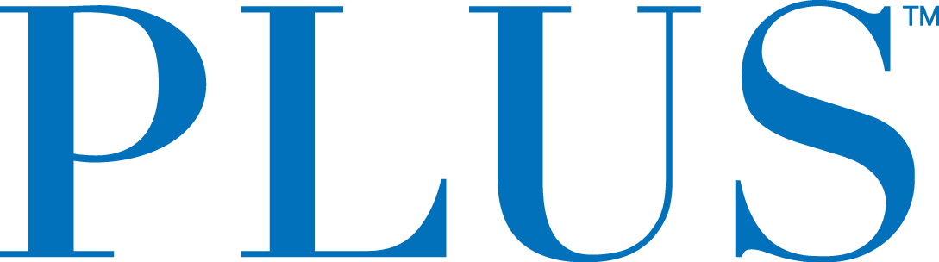

PLUS™ Unveils New Classic Mints
New Low-Dose Edible from the Brand Consumers Trust To
Find Their Just Right

San Mateo, CA – April 18, 2018 – Continuing to demonstrate its passion for providing low-dose cannabis edibles that consumers love, Plus Products Inc. (CSE: PLUS) (OTCQB: PLPRF) (the “Company” or “PLUS”) today announced a new line of mints and the launch of the first flavor, Classic Mint.

The microdosing movement is not slowing down, and more people are implementing cannabis into their healthy lifestyle. Mints are the perfect mechanism for delivering low-dose cannabis for those who may not want something quite as sweet or potent as a higher milligram gummy.

“Mints are a logical extension to the PLUS product family as more customers seek out unique taste experiences and low-dose products they trust,” said Jake Heimark, CEO and Co-founder. “We are excited about continuing to give customers the best experiences and will continue to be the leader in low-dose infused products in THC.”

Refreshing and delicious, PLUS Classic Mint flavored tablets contain 2.5 mg THC and less than 0.1 mg CBD each There are 40 mints per tin.

“We can’t wait to get PLUS Mints on our shelves, as we have a huge demand for microdosed products,” said Nate Haas, owner, Moe Greens. “Everything that comes out of the PLUS house is superb, high quality and we trust the brand enough to continue to sell it to our customers.”

Availability
PLUS Classic Mints are available at a limited number of licensed retailers across the state of California and will be launched market wide at the Hall of Flowers cannabis trade show on April 30th.

About PLUS
PLUS Products creates safe and delicious cannabis food products. PLUS’s mission is to make cannabis safe and approachable - that starts with high-quality products that deliver consistent experiences. PLUS gummy and mint products are manufactured at PLUS’s own factory in Adelanto, CA, where dosage is tested twice internally and then tested twice again by an independent lab. PLUS is headquartered in San Mateo, CA with 60 employees.

For further information contact:
Investors:
Jessica Bornn
Director of Investor Relations
ir@plusproducts.com
Tel +1 650.223.5478

Media:
Heidi Groshelle
Ingrid Marketing
Tel +1 415.307.1380
pr@plusproducts.com

The CSE does not accept responsibility for the adequacy or accuracy of this release.

Forward-Looking Statements

This news release contains statements and information that, to the extent that they are not historical fact, constitute "forward-looking information" within the meaning of applicable securities legislation. Forward-looking information is based on the reasonable assumptions, estimates, analysis and opinions of management made in light of its experience and its perception of trends, current conditions and expected developments, as well as other factors that management believes to be relevant and reasonable in the circumstances at the date that such statements are made, but which may prove to be incorrect.

Forward-looking information involves known and unknown risks, uncertainties and other factors that may cause the actual results, performance or achievements of the Company to differ materially from any future results, performance or achievements expressed or implied by the forward-looking information. Accordingly, readers should not place undue reliance on any such forward-looking information. Further, any forward-looking statement speaks only as of the date on which such statement is made. New factors emerge from time to time, and it is not possible for the Company's management to predict all of such factors and to assess in advance the impact of each such factor on the Company's business or the extent to which any factor, or combination of factors, may cause actual results to differ materially from those contained in any forward-looking statements. The Company does not undertake any obligation to update any forward-looking information to reflect information, events, results, circumstances or otherwise after the date hereof or to reflect the occurrence of unanticipated events, except as required by law including securities laws.

