Corp.

PRESS RELEASE

Calgary, Alberta – February 3, 2021.

For Immediate Release - Medxtractor Corp. ("MXT") updates the SHAMAN psychedelics artificial intelligence project.

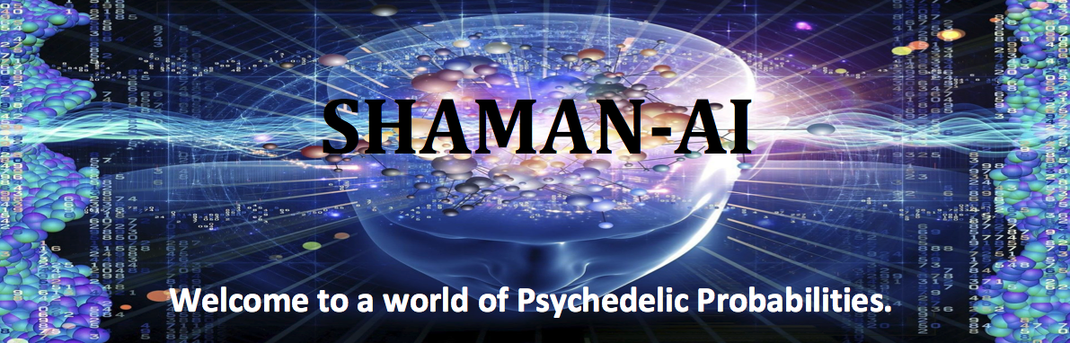

Medxtractor Corp. (the "Company") reports that SHAMAN's core machine learning process has recently been successfully tested. The focus has now progressed to algorithm development related to scoring incoming records prior to their addition to the Reference Database ("RD"). The RD is a proprietary component of the SHAMAN project and requires significant processing to ensure high correlation probability.

Jim Durward, President, states: "Concurrent with this algorithm development, the web interface and data collection protocols are being specified and associated budgets calculated. To date, our rapid development pace has kept us ahead of schedule and under budget. While this is all positive, investors are cautioned that the overall SHAMAN system is not yet fully functional and requires significant further development, including assembly of the Reference Database.
ABOUT MEDXTRACTOR CORP:

The Corporation is a Calgary-based company that generates technologically-based solutions. With installations all over the world, its patented craft-scale bio-extractors are used to extract compounds from a variety of botanical materials. The SHAMAN division is focusing on applying machine learning to predict potential benefits associated with the use of psychedelic drugs within the mental health misdiagnosis problem.

FOR FURTHER INFORMATION, PLEASE CONTACT:

MEDXTRACTOR CORP.
James M. Durward, President and CEO
Telephone: (403) 689-3901
Email: jimd@medxtractor.com
Website: www.medxtractor.com or www.shaman-ai.com

This news release does not constitute an offer to sell or a solicitation of an offer to sell any of the securities in the United States. The securities have not been and will not be registered under the United States Securities Act of 1933, as amended (the "U.S. Securities Act") or any state securities laws and may not be offered or sold within the United States or to U.S. Persons unless registered under the U.S. Securities Act and applicable state securities laws or an exemption from such registration is available. The information in this news release includes certain information and statements about management's view of future events, expectations, plans and prospects that constitute forward looking statements. These statements are based upon assumptions that are subject to significant risks and uncertainties. Because of these risks and uncertainties and as a result of a variety of factors, the actual results, expectations, achievements or performance may differ materially from those anticipated and indicated by these forward looking statements. Any number of factors could cause actual results to differ materially from these forward-looking statements as well as future results. Although the Corporation believes that the expectations reflected in forward looking statements are reasonable, it can give no assurances that the expectations of any forward-looking statements will prove to be correct. Except as required by law, the Corporation disclaims any intention and assumes no obligation to update or revise any forward looking statements to reflect actual results, whether as a result of new information, future events, changes in assumptions, changes in factors affecting such forward looking statements or otherwise.

Neither the Canadian Securities Exchange nor its Regulation Services Provider (as that term is defined in the policies of the Canadian Securities Exchange) accepts responsibility for the adequacy or accuracy of this release.

