Mariner Options the Dog Bay Gold Properties in Central Newfoundland

Edmonton, August 20th, 2020 – Mariner Resources Corp., (“Mariner” or the “Company”) (CSE: RNR) is pleased to announce that it has entered into an option agreement to acquire 100% interest in the Dog Bay Gold properties (the “properties”) consisting of 485 mineral claims totaling 121.25 km² located on the Port Albert Peninsula, Dog Bay, Newfoundland.

Property Highlights
- Located within the Exploits Subzone in prospective siliciclastic sediments and along the northern extent of the Dog Bay Line and Appleton Linear Fault zones, which are associated with gold mineralization in the area.
- Shallow historical drilling on the property consisted of only 1,559m and returned values of up to 3.35m at 10.22 g/t Au, targeting surficial channel sampling intercepts of up to 48.22 g/t Au over 0.80m, 15.25 g/t Au over 3.00m and 9.41 g/t Au over 4.25m (Crosshair Exploration and Mining Corp., 2002-2005).
- Recent prospecting by property Vendors has indicated up to 4 km of undrilled potential strike length, highlighted by assays of up to 233 g/t Au in subcrop and soil samples up to 624 ppb Au.
- New structural model focusing on structurally hosted, epizonal orogenic gold provides a pathway to discovery for new gold deposits on the properties.
- The exploration completed by the Vendors of the Dog Bay properties has delivered results pegging the project as what Mariner considers to be an “advanced early stage prospect” with trenching and targets that are considered “drill ready”.
- Mariner will work to verify existing data and expand on these known gold showings to develop a clear exploration plan immediately.
CEO John Williamson comments, "Mariner continues to build its land position within the Exploits Subzone, extending to the north on the valued Appleton Fault and Dog Bay Line. The acquisition of the Dog Bay properties locks in additional key ground in the Exploits Subzone. We look forward to working with the Vendors, Eddie and Roland Quinlan, as we move to active exploration on our Exploits Subzone projects."

The option agreement covers 8 discrete mineral prospects together consisting of 485 claims, encompassing a total land area of 121.25 km², straddling the northern extent of both the Dog Bay Line and Appleton Fault Zones. The properties can be accessed by travelling north on highway 340 from Notre Dame Junction, where further access is gained by traveling inland on a network of well-maintained forest service roads. The properties are also situated between 20 and 60 km northeast of the late 2019 New Found Gold Corp. gold discovery, which returned a diamond drill hole with 92.86 g/t Au over 19.0 meters near surface (see New Found Gold Corp. news dated January 28, 2020), and is underlain by the same fault zones and package of siliciclastic rocks as the discovery host, as mapped by the Newfoundland and Labrador Geologic Survey.

Mariner believes that the Exploits Subzone, which runs 200 km from Dog Bay southwest to Bay d'Espoir has been neglected since the last major exploration campaigns in the 1980's. The last 40 years have seen incremental advancements in the understanding of gold mineralization in the camp. The sum of this knowledge is now coming together in discrete and effective exploration models that the Company believes will drive major discovery. Mariner intends to leverage this shift in understanding and become one of the most extensive explorers in the Exploits Subzone.

The team at Mariner, with significant local experience and knowledge, have studied the entirety of the Exploits Subzone and picked individual land packages for staking or joint venture where there is an opportunity for world class discoveries and mine development.

Property Geology
The properties are situated within the Exploits Subzone and encompass (from east to west) the Newfoundland Geological Survey mapped Main Point Formation, Indian Islands Group, Duder Group, and Badger Group. Lithological units and age ranges are consistent across the formation and groups and includes Ordovician to Silurian, marine and non-marine siliciclastic sediments, striking in a general NE-SW direction. Within the Duder Group, a unit of melange was mapped, striking parallel to the overall stratigraphy.
Structurally, the properties straddle the northern extent of the NE-SW trending Dog Bay Line and Appleton Linear fault zones. The Dog Bay Line is a significant suture formed by the closing of the Iapetus Ocean and has implications of deep-seated mantle tapping potential. The Appleton Linear is interpreted to be a sub-parallel, secondary structure to the Dog Bay Line, formed by the aforementioned major tectonic thrusting. The Appleton Linear was highlighted by New Found Gold Corp. to host significant mineralization (NFGC, 2020) and has been interpreted to continue onto the acquired properties along strike to the northeast.
Major structural domains coupled with brittle siliciclastic sedimentary rocks, which are covered by the properties, increase the opportunity for epizonal, orogenic gold mineralization to occur. Historic drilling on the property is limited and constrained to 20 shallow (maximum length of 115m) diamond drilled holes totaling 1,559m. Results were positive with intercepts up to 10.22 g/t Au over 3.35m. The drill holes followed up on channel sampling within trenches that returned assays up to 48.22 g/t Au over 0.80m and including 15.25 g/t over 3.00m and 9.41 g/t Au over 4.25m (Crosshair Exploration and Mining Corp., 2002-2005). Recent prospecting and soil sampling in the area, following up on work done by Noranda in the late 1980’s, led to discovery of a 233 g/t Au in quartz veined sediment subcrop as well as soils up to 624 ppb Au, indicating up to 4km of untested potential strike length of gold mineralization trending in the NE-SW directing displayed by the regional structures. Samples have also returned anomalous arsenic and antimony, which are indicative of epizonal, orogenic style mineralization.

Area Map of the Dog Bay Properties
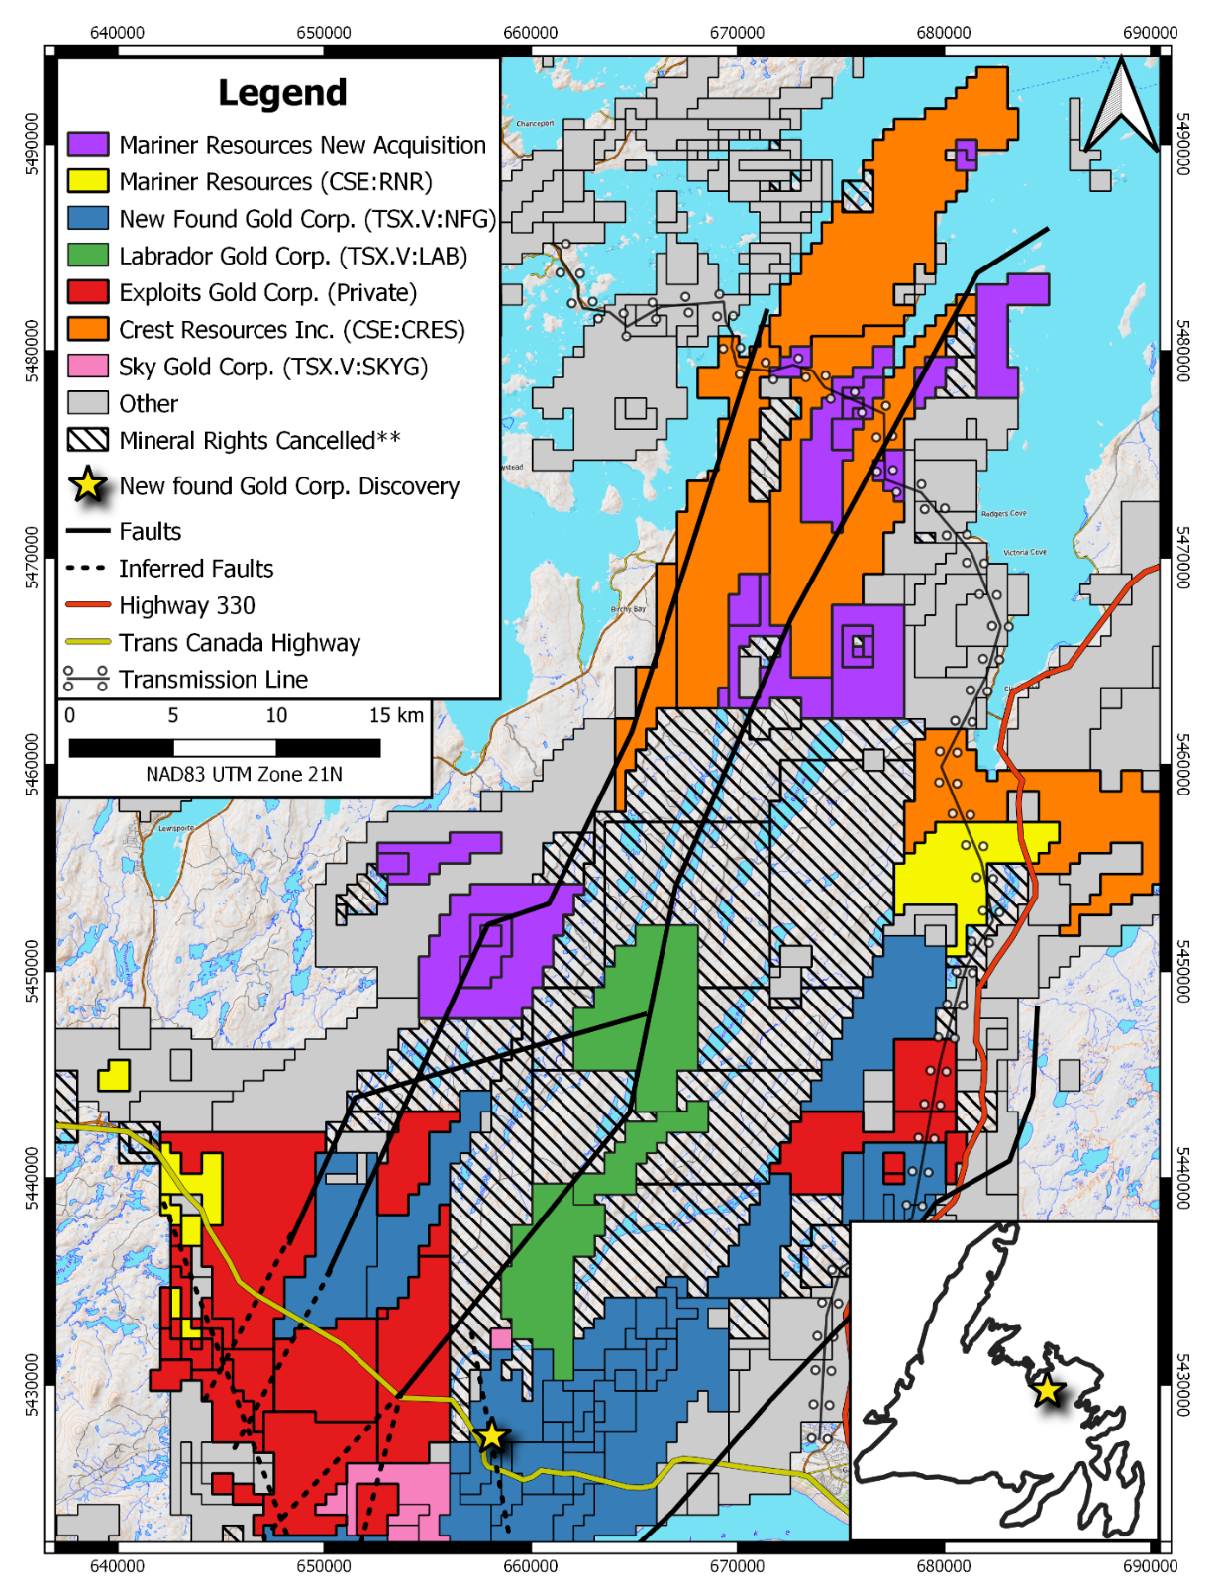

Transaction Outlined
Under the terms of the agreement, the company may acquire a 100-per-cent interest in the property by paying an aggregate of $250,000 cash and issuing 3,500,000 common shares and $560,000 in either cash or common shares as follows:

- $30,000 & 1,000,000 common shares upon signing the purchase agreement; and
- $40,000 & 400,000 common shares on first anniversary; and
- $50,000 & 500,000 common shares on second anniversary; and
- $60,000 & 600,000 common shares on third anniversary; and
- $70,000 & 1,000,000 common shares on fourth anniversary; and
- $10,000 in cash or common shares for the fifth to tenth anniversary; and
- $50,000 in cash or common shares for eleventh to twentieth anniversary.

The vendors shall retain a 2.0-per-cent net smelter return royalty (NSR) on the property, of which the company shall have the right to purchase half (1.0 per cent) for $4-million.

NI 43-101 Disclosure
Ian Herbranson, P.Geo, is a consultant for the company, shareholder and qualified person as defined by National Instrument 43-101. Mr. Herbranson supervised the preparation of the technical information in this news release.

About Mariner Resources Corp.
Mariner Resources Corp. is a Canadian mineral exploration company focused on the acquisition and development of mineral projects in Newfoundland, Canada. The company currently holds the Middle Ridge, True Grit, Great Bend, Mt. Peyton North & Shirley Lake, Gazeebow and Dog Bay projects, which cumulatively cover an area of 1,168.75 km². All four projects lay within the Exploits Subzone and Gander River Ultramafic Belt (GRUB) of the Dunnage Zone, which contain the majority of Newfoundland's gold mineral occurrences and exploration efforts, including New Found Gold's 2019 discovery of 92.86 g/t Au over 19.0 meters near surface. The Exploits Subzone and GRUB regions have been the focus of major staking and financing throughout 2020, with increased exploration activities forecasted in the area moving into 2021.

.

ON BEHALF OF THE BOARD
/s/ "John Williamson"
Chief Executive Officer

For further information, please contact:
Justin Bourassa, Director and CFO
justinb@metalsgroup.com
Tel: (780) 701-3216

This news release may contain certain “forward looking statements”. Forward-looking statements involve known and unknown risks, uncertainties, assumptions and other factors that may cause the actual results, performance or achievements of the Company to be materially different from any future results, performance or achievements expressed or implied by the forward-looking statements. Any forward-looking statement speaks only as of the date of this news release and, except as may be required by applicable securities laws, the Company disclaims any intent or obligation to update any forward-looking statement, whether as a result of new information, future events or results or otherwise.

