Mariner Acquires the Shirley Lake and Mt. Peyton North Gold Properties in Central Newfoundland, Canada

Edmonton, August 7th, 2020 – Mariner Resources Corp. (“Mariner” or the “Company”) (CSE: RNR) is pleased to announce that it has entered into an option agreement to acquire 100% undivided interest in the Shirley Lake and Mt. Peyton North gold properties (the “properties”) in central Newfoundland Canada.

The properties together consist of 51 mineral claims and encompass a land area of 12.75 km². The properties are located along the northwest trending Mt. Peyton structural lineament within the Mt. Peyton Intrusive Suite and are accessible by traveling west on the Trans Canada Highway for 15 km from Glenwood where the Mt. Peyton North property is transected by the highway, the Shirley Lake property is accessible from there by a network of ATV trails.

Property Highlights
- Rock samples on the property from angular quartz arsenopyrite breccia bearing float boulders retuned values of up to 44.0 g/t Au.
- Base metal bearing quartz vein float from the eastern shore of Shirley Lake Assayed 25.0 g/t Au.
- Altered gabbro float from the southern shore of Shirley Lake assayed 1.88 g/t Au.
- Shirley lake hosts a Highly elevated lake sediment sample of 1,010 ppm As.
- A IP/Resistivity survey conducted in 2005 outlined a zone of high resistivity that trends in an east-west direction, coincident with the magnetic high. The geophysical survey provides evidence that the source of the highly altered, auriferous gabbro boulders may be on the property.
- The Company is compiling historic data and has applied for sampling and trenching permits to test historical defined conductors where we see the opportunity to quickly advance to drill testing.
Mariner believes that the Exploits Subzone, which runs 200 km from Dog Bay southwest to Bay d’Espoir has been neglected since the last major exploration campaigns in the 1980’s. The last 40 years have seen incremental advancements in the understanding of gold mineralization in the camp. The sum of this knowledge is now coming together in discrete and effective exploration models the Company believes will drive major discovery. Mariner intends to leverage this shift in understanding and to become one of the largest claim holders in the Exploits Subzone.

The team at Mariner, with significant local experience and knowledge, have studied the entirety of the Exploits Subzone and picked individual land packages for staking or joint venture were there is an opportunity for world class discoveries and mine development. The Company expects the viability of this strategy will become more evident as we continue to pursue project negotiations and unveil more assets in the Exploits Subzone.

President John William comments, “The Mount Peyton Linear is one of the most distinct structures crossing the Exploits Subzone which are known focuses of mineralization in the Gander District. The grade and consistency of gold assays, and anomalous magnetic data from Shirly Lake is indicative of the great potential of this area.”

A Map of the Mt. Peyton North & Shirley Lake Properties
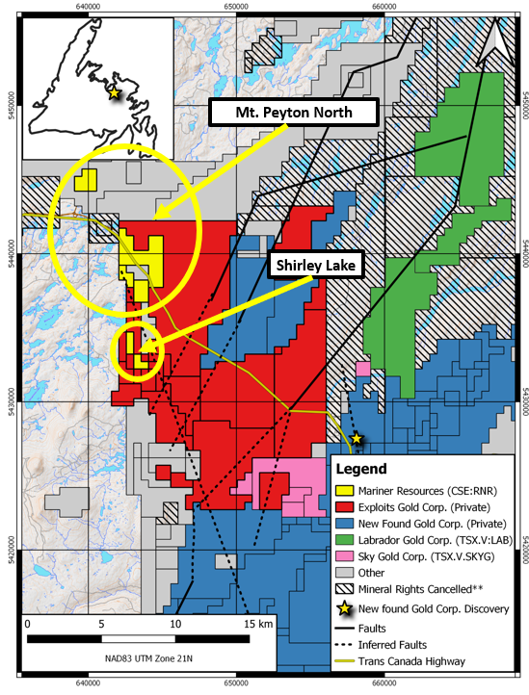

Shirley Lake and Mt. Peyton Property Geology
The properties are located within the Exploits Subzone of the Dunnage zone, which is dominantly underlain by Newfoundland Geological Survey mapped Silurian to Devonian Mt. Peyton Intrusive Suite rocks, and lesser Late Ordovician to Silurian siliciclastic sediments of the Badger and Botwood groups localized to the northern extent of the properties. The Mount Peyton Suite is predominantly gabbro, crosscut by granitic, aplitic, and tonalitic dykes.

The Shirley Lake property was originally explored by Noranda who were brought to the area as a result of a 1,010 ppm Arsenic anomaly in lake sediments (Davenport et al, 1988). Prospecting activities have discovered numerous auriferous, sulphide-bearing boulders (Lewis, 2001), which has brought even more focus to the area. There are three predominant rock types hosting mineralization in the area. Boulders consisting of altered gabbro with arsenopyrite ± chalcopyrite-galena-pyrite-sphalerite, quartz vein float and silica-sericite altered plutonic rocks. Base-metal bearing quartz-vein float on the eastern shore of Shirley Lake have assayed 25.1 g/t Au and altered gabbro float on the southern shore of Shirley Lake assayed 1.89 g/t Au (Evans, 2001b). An area of altered gabbro (biotite-sericite) breccia float assayed up to 44.0 g/t Au at the northwest end of Shirley Lake (Evans, 2001b). Exposures 1.5 km north of Shirley Lake near the “SS Zone” consist of medium-grained gabbro, locally biotitic, cut by several 30 cm-scale miarolitic felsic dykes. In 2005 a magnetic survey was conducted and indicated a weak magnetic relief between the northwest and southeast part of the property, which may reflect a compositional change within the intrusive (Rubicon Minerals, 2005). In 2005 a Pole-Dipole IP/Resistivity survey was also conducted, outlining a zone of high resistivity that trends in an east-west direction, coincident with the magnetic high. The geophysical surveys provide evidence that the source of the highly altered, auriferous gabbro boulders may be on the property as they lay within the magnetic and resistive signatures.

Follow-up work in the form of bedrock trenching is recommended in order to properly delineate the mineralization in the Shirley Lake area.

Transaction Outlined
Under the terms of the agreement, the Company may acquire a 100-per-cent interest in the property by issuing an aggregate of $2,000 cash 575,000 common shares as follows:

Mount Peyton North
- $ 2,000 upon signing; and
- 200,000 common shares upon signing
Shirley Lake Property
- 300,000 common shares upon signing; and
- 2,500 shares for each anniversary of years 6th to 20th
The vendors of each property shall retain a 2.0-per-cent net smelter return royalty (NSR) on the property, of which the Company shall have the right to purchase half (1.0 per cent) for $750,000.

NI 43-101 Disclosure
Ian Herbranson, P.Geo, is a consultant for the Company, shareholder and qualified person as defined by National Instrument 43-101. Mr. Herbranson supervised the preparation of the technical information in this news release.

About Mariner Resources Corp.
Mariner Resources Corp. is a Canadian mineral exploration Company focused on the acquisition and development of mineral projects in Newfoundland, Canada. The Company currently holds the Middle Ridge, True Grit, and Great Bend projects, which cumulatively cover an area of 941km². All three projects lay within the Exploits Subzone and Gander River Ultramafic Belt (GRUB) of the Dunnage Zone, which contain the majority of Newfoundland's gold mineral occurrences and exploration efforts, including New Found Gold's 2019 discovery of 92.86 g/t Au over 19.0 meters near surface. The Exploits Subzone and GRUB regions have been the focus of major staking and financing throughout 2020, with increased exploration activities forecasted in the area moving into 2021.
.

ON BEHALF OF THE BOARD
/s/ "John Williamson"
Chief Executive Officer

For further information, please contact:
Justin Bourassa, Director and CFO
justinb@metalsgroup.com
Tel: (780) 701-3216

This news release may contain certain “forward looking statements”. Forward-looking statements involve known and unknown risks, uncertainties, assumptions and other factors that may cause the actual results, performance or achievements of the Company to be materially different from any future results, performance or achievements expressed or implied by the forward-looking statements. Any forward-looking statement speaks only as of the date of this news release and, except as may be required by applicable securities laws, the Company disclaims any intent or obligation to update any forward-looking statement, whether as a result of new information, future events or results or otherwise.

