Mariner Acquires Exploits Gold Corp., Becomes Largest Landholder in Newfoundland and Announces $3.5 Million Private Placement
NOT FOR DISTRIBUTION TO UNITED STATES NEWS WIRE SERVICES OR FOR DISSEMINATION IN THE UNITED STATES
Vancouver, B.C. - September 2, 2020 - Mariner Resources Corp. (“Mariner” or the “Company”) (CSE: RNR) is pleased to announce that it has entered into an agreement to acquire a 100% interest in Exploits Gold Corp., a private company focused on gold exploration in the prolific Exploits Subzone of central Newfoundland and Labrador.
Exploits Gold Corp. holds a strategic land position, with its core mineral land holdings predating the 2019 New Found Gold Corp. discovery. The two projects are known as the Mt. Peyton and Jonathan’s Pond gold projects. The Mt. Peyton and Jonathans Pond properties are located two and twenty-five kilometers west and northeast respectively of New Found Gold’s Queensway Discovery. Both projects are easily assessable via the Trans Canada Highway and together consist of 939 mineral claims encompassing a land area totalling 234.75 km² in the Exploits Subzone Camp.
Acquisition Highlights
- The addition of Exploits Gold Corp.’s key holdings now makes Mariner the largest land tenure holder in Newfoundland with 1,760 km² of gold exploration ground.
- The Jonathan’s Pond project hosts visible gold bearing quartz veins up to 3m wide, with a current strike length of 450m, open in all directions with grab samples from outcrop of up to 28.82 g/t Au.
- The Mt. Peyton project is situated on a 15 km strike length airborne magnetic anomaly, coincident with the anomalous float grab samples of up to 25.8 g/t Au and elevated lake sediment samples of 1010 ppm As.
- Both projects contain high priority exploration targets and are fully permitted for mechanical trenching, geochemical sampling, and geophysical surveys.
- Mariner has mobilized an experienced local geologic field team. The team will start trenching at the Jonathan’s Pond project in the attempt to extend new surficial exposure of gold mineralization on the claims. A second exploration team is focused on the Dog Bay gold showings, described in a previous news release (see August 20, 2020 new release).
CEO of Mariner Michael Collins comments, "This transaction marks Mariner’s pivotal point in its efforts to become the premier explorer in the Exploits Subzone camp. Exploits Gold Corp.’s land holdings and key management personnel are second to none. This acquisition consolidates major prospective historical showings, which have never been drilled. The consolidated land package is ideal for the structurally hosted, epizonal orogenic gold model. New government geophysics and fragmented exploration data compiled into one data model show us a better pathway to a gold discovery in the Exploits Subzone."
President of Exploits Nick Rodway comments, “As a Newfoundlander, I am extremely fortunate to have been able to play an instrumental role in this transaction. For management, this transaction marks eight months of hard work and strategic planning, but for some shareholders this marks something far more significant. The property vendors of the two projects that Exploits held were a result of over 25 years of hard field work. I would like to thank all property Vendors and shareholders of Exploits for believing in our vision and helping us every step of the way. I am excited to move forward with Mariner in our mission to make a world class discovery in the Exploits Subzone “
In recognition of the Company’s clear focus on the Exploits Subzone in Newfoundland, the Company has applied to change its name to Exploits Discovery Corp. and to change its stock trading symbol on the Canadian Securities Exchange to “NFLD”. The Company also appoints Michael Collins as the President, Chief Executive Officer and a director of the Company and David Groves, PhD to the Advisory Board.
Pictures from Exploits Gold Corp’s Land Holdings
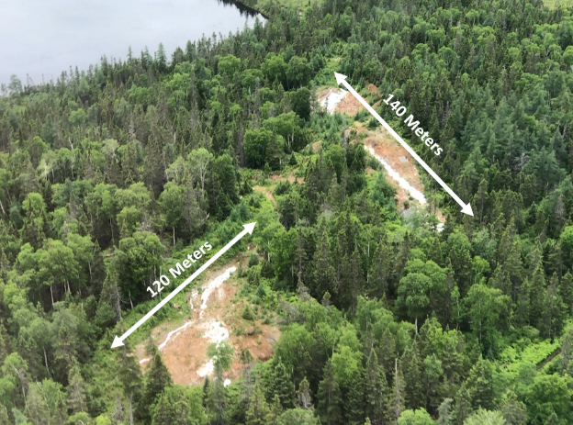
Figure 1: Ariel view of exposed quartz veining at the Jonathan’s Pond project (2020) (Looking southwest).
*White arrows represent strike length of veins at surface. Veins are open in strike length.
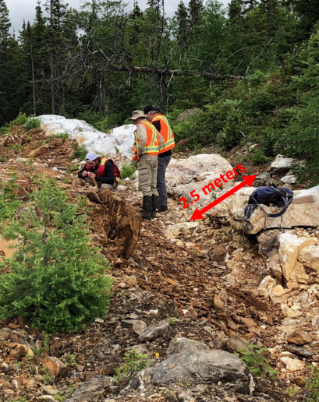
Figure 2: Exploits local field team analysing exposed quartz veining at the Jonathan’s Pond project (2020) (looking south).

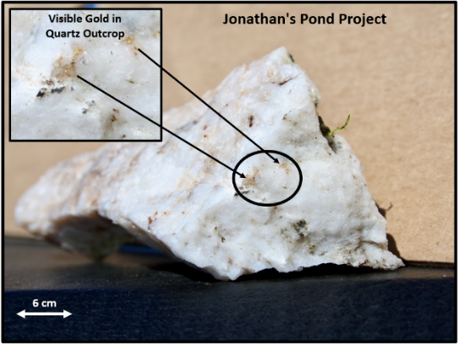
Figure 3: Visible gold from exposed quartz vein outcrop from the Jonathan's Pond Gold project (2020).
*Rock Sample returned 28.8 g/t Au and was analysed at Eastern Analytical using Au (Fire Assay) @ 30g + ICP-34
Mariner believes the Exploits Subzone, which runs 200 km from Dog Bay southwest to Bay d'Espoir, has been neglected since the last major exploration campaigns in the 1980's. Over the last 40 years there have been incremental advancements in the understanding of gold mineralization in the camp. The sum of this knowledge is now coming together in a cohesive and effective exploration model, which the Company believes will drive to a major discovery. Mariner intends to leverage this shift in understanding and become one of the most extensive explorers in the Exploits Subzone.
Mariner’s team with significant local expertise have studied the entirety of the Exploits Subzone and picked individual land packages for staking or joint venture. Mariner’s team believes there is an opportunity for world class discoveries and mine development in the Exploits Subzone.
The acquisition of Exploits Gold Corp. is yet another demonstration of this strategy, as we continue to pursue project negotiations and unveil and explore more assets in the Exploits Subzone.

Area Map Mariner & Exploits Gold Land Holdings
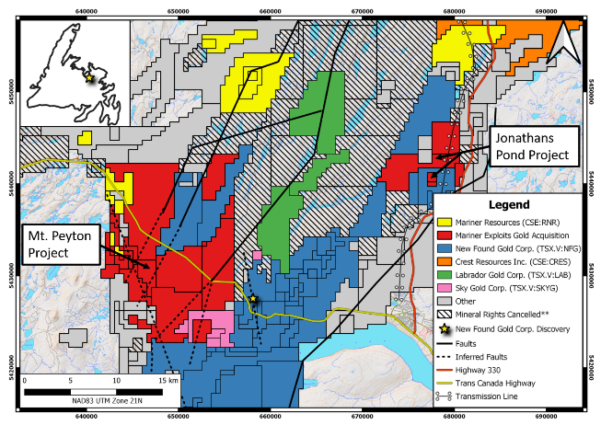
Exploits Subzone District Map
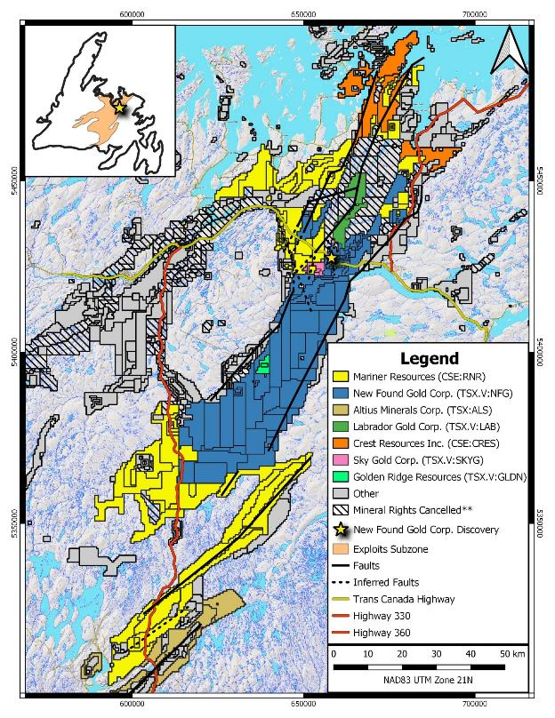
Jonathans Pond Project Geology
The Jonathans Pond project is situated around the Gander River Ultramafic Belt (GRUB) fault zone, a regional scale trans-compressional thrust fault marked by a discontinuous belt of ophiolitic rocks that forms the easternmost boundary of the Exploits Subzone (O’Neil and Blackwood, 1989). The fault zone was created by extensive, crustal scale thrusting during the closing of the Iapetus Ocean, signifying a potential deep seated, mantle tapping conduit for gold bearing fluid to migrate up and into proximal secondary and tertiary structures on the property.
The property geology was mapped by the Newfoundland Geological Survey as being Late Cambrian to Middle Ordovician ophiolites associated with the GRUB on the eastern half of the property, and Ordovician siliciclastic marine rocks of the Davidsville Group in the Exploits Subzone to the west. The contact between the two groups trending north-northeast through the center of the property, which is highlighted by airborne magnetics (Fugro, 2003).
A major structural domain coupled with contrasting brittle siliciclastic sedimentary rocks and ductile mafic to ultramafic plutonic rocks of an ophiolite sequence on the property create an increased opportunity for structurally hosted, epizonal, orogenic gold mineralization to occur.
Jonathans Pond Property History
Historical trenching by local prospectors in 2004 has uncovered northeast trending visible gold bearing quartz veins up to 3m wide. Work by Exploits Gold Corp.’s geologists have expanded the strike length of this quartz veining system to over 450m to date and remains open along trend. Grab samples from outcrop taken by Exploits Gold Corp. in 2020 within the trench assayed up to 27.96 g/t Au. Additional outcropping quartz veins, striking parallel to the aforementioned veining 1.2 km away on the claims, returned assays of up to 28.82 g/t Au. The company is focused on identifying and quantifying additional gold mineralization in the hanging wall and footwall of this gold bearing structure.
From 2003 to 2005, Rubicon conducted a sparse soil sampling and grab sample program. Results displayed anomalous gold and arsenic in soils that trace the veins and provides evidence for multiple vein sets, with potential to continue in strike for greater than an additional 350m. Additionally, Rubicon assayed a float grab sample that returned 50 g/t Au, and three trenches exposed quartz veins in altered gabbro which returned grab sample values of up to 2.8 g/t Au.

Mt. Peyton Project Geology
The Mt. Peyton Project is located within the Exploits Subzone of the Dunnage zone, which is dominantly underlain by Newfoundland Geological Survey mapped Silurian to Devonian Mt. Peyton Intrusive Suite rocks. Ordovician to Silurian siliciclastic marine and non marine sedimentary rocks of the Davidsville Group, Ten Mile Lake Formation, Botwood Group, and Badger Group contact the intrusive suite along the eastern and northern portions of the project boundary. The Mt. Peyton Suite is predominantly gabbro, crosscut by granitic, aplitic, and tonalitic dykes.
The property straddles a significant regional structure of the Dunnage Zone known as the Dog Bay Line. This structure is spatially associated with significant gold mineralization in the region and is underlain by the Silurian siliciclastic sediments of the Exploits Subzone. The Mt. Peyton Intrusive Suite, which covers the western half of the property, is a large Siluro-Devonian batholith and potential heat source that has intruded the Botwood, Indian Islands and Davidsville sedimentary groups.
Mt. Peyton Property History
Exploits Gold’s Mt. Peyton property is situated contiguous with one of Mariners previously acquired properties (the Shirley Lake property). There is a long history of early stage exploration on the property and surrounding area.
During the summer of 2020 Exploits Gold Corp.’s Qualified Person visited the property taking three samples on historically known anomalies, which yielded values of up to 4.10 g/t Au. The property hosts limited bedrock exposure and the sampling represents only a small portion of the interpreted 15 km long Mt. Peyton Linear.
A more detailed property history begins in 1988 when the Department of Energy and Mines of Newfoundland released results from a regional lake sediment geochemical survey. The survey featured a highly anomalous sample with arsenic values of up to 1010 ppm on the Shirley Lake portion of the Mt. Peyton property. This led to an increase of industry focus in the area.
From 1988 to 1991, Noranda, as a result of the 1988 Government Lake sediment sample release, initiated a reconnaissance prospecting and regional till and lake/stream sampling program in the Mt. Peyton area. Initial discoveries of auriferous frost-heaved bedrock showings were made, with assays of up to 25.8 g/t Au, 15.7 g/t Au and 7.6 oz/ton Ag (Tallman, 1990). Detailed exploration (geophysics, trenching and diamond drilling) in 1990 led to the discovery of the Hurricane prospect (drilling of 2m near surface of 6.0 g/t Au, grab samples of 15.6 g/t and 7.6 Oz/t Ag) and Corsair prospect (drilling of 1m near surface of 3.6 g/t Au), along with the initial recognition of the Peyton Trend. Other showings discovered at this time include the Apache/Comanche (1.3 g/t Au in outcrop grab sample) and Sabre showings (2.1 g/t Au, 47.0 Oz/t Ag in outcrop grab sample) (Tallman, 1991).
From 2002-2003, Rubicon Minerals completed a limited prospecting and reconnaissance soil sampling program, as well as an IP/resistivity and magnetic/VLF-EM survey over the Shirley lake area. As a result, grab sampling returned values of 17.0 g/t and 18.9 g/t Au from angular float boulders. The “SS” showing was located 2.5 km north of Shirley Lake returning values of 1.0 g/t Au and 1.26 g/t Au. The IP/resistivity survey outlined a prominent east-west conductor and the magnetic/VLF-EM survey identified an area of higher relief in the northwestern portion of the property (MacVeigh, 2005). These geophysical signatures were overlain by angular gold bearing float samples and provides potential evidence that the bedrock source is proximal. These targets remain untested by drilling.
The only drilling done on the Mt. Peyton property area to date was in the southernmost area (Hurricane and Corsair prospects). The Mt. Peyton property hosts one of the highest recorded lake sediment samples on the island and consists of 15 km of undrilled exploration targets to be followed up on.
Transaction Outlined
Under the terms of the agreement, the Company will acquire a 100-per-cent interest in Exploits Gold Corp. by issuing an aggregate of 18,810,752 common shares. The shares will have a hold period of 1/3 at 6 months, 1/3 at 12 months and 1/3 at 18 months. An additional 600,000 stock options in Exploits Gold Corp. will also convert into stock options in the Company with a strike price of $0.15.
Crest Resources Inc. (“Crest”), a major shareholder of the Company, also holds 47.84% of Exploits Gold Corp. and will receive 5,000,000 shares of the Company in the transaction. Following the proposed transactions, Crest will own and control 13,602,500 common shares of the Company representing 25.5% of the then issued and outstanding common shares based on an estimated total of 53,294,052 common shares outstanding. Crest together with its joint actors will own and control 14,630,000 common shares representing 27.5% of the pro-forma issued and outstanding common shares. Michael Collins is the President, CEO and a director of both Crest and Exploits Gold Corp. and will receive 175,000 common shares in the transaction to bring his total ownership to 595,000 common shares of the Company.
Private Placement
The Company proposes to undertake a non-brokered private placement concurrently with the Exploits Gold Corp. transaction to raise gross proceeds of up to $3,500,000 (the “Offering”) through the issuance of up to 10,000,000 units at a price of $0.35 per unit (each, a “Unit”). Each Unit consists of one common share and one half of one share purchase warrant, with each whole warrant exercisable into one further common share at a price of $0.75 for a term of one year.
The proceeds raised from the Offering will be used by the Company to conduct further exploration work on its properties in Newfoundland, project acquisition, and for general working capital.
Board of Directors/Advisory Board Appointments
The Company is pleased to appoint Michael Collins as President and Chief Executive Officer of the Company and to the Board of Directors. Mr. Collins has an exceptional skill set in project development and analysis which is supported by a wide industry network. Through his work as a geologist and running a mining engineering office in Vancouver, he has developed an understanding of numerous mineral camps and deposit types around the world. His experience steps beyond mineral deposits with a breadth of experience in the feasibility process and the pitfalls of project construction and optimization. With over 14 years as an officer and director of public companies, Mr. Collins understands the intricacies of building corporate structure, marketing and value accretion. Mr. Collins graduated with a BSc. Honours from Dalhousie University in 1996 and is an accredited P.Geo. with EGBC. With this transaction, John Williamson will step down from his position as CEO but will remain on the board of directors. The Company thanks Mr. Williamson for his hard work in progressing the Company to this stage of development and looks forward to his continued involvement in the Company as a director.
David Groves, PhD has been appointed to the Advisory Board where the Company will be able to tap his unique insights into the exploration discovery process. Born in Brighton, England, Dr. Groves was educated at Hobart High School and University of Tasmania, completing a PhD on the giant Mt. Bischoff tin deposit under the mentorship of Mike Solomon. After a period with the Geological Survey of Tasmania, Dr. Grove was appointed Lecturer in Economic Geology at the University of Western Australia (UWA) in 1972. In 1987, he was awarded a Personal Chair at UWA and formed the Centre for Strategic Mineral Deposits, which morphed into the Centre for Global Metallogeny with him as Director, and which became the Centre for Exploration Targeting after his retirement as Emeritus Professor. He had a very successful academic career in terms of approximately 500 highly-cited published papers and book chapters, many keynote and invited lectures, and mentorship of many outstanding postgraduates, being awarded 13 medals and prizes, including the SEG Silver and Penrose Gold Medals and the SGA-Newmont Gold Medal, and being inducted into the Australian Academy of Sciences as a Fellow. He has been President of GSA, SEG and SGA during his career and represented Australia on UNESCO committees.
Since his retirement from UWA, Dr. Groves has continued to write papers and mentor staff and students at the China University of Geosciences in Beijing (CUGB), as well as consult to industry in Africa, Asia, Australia and North America, being involved in discovery of two gold deposits during greenfield exploration in Tanzania and Ethiopia. In 2018, he was made an Australian Geoscience Champion by the Australian Geoscience Council. In 2020 he was made Distinguished Lecturer for 2020 and recognized as one of the 125 Faces of Geoscience by the Australasian Institute of Mining and Metallurgy.
NI 43-101 Disclosure
Ian Herbranson, P.Geo, is a consultant for the Company, shareholder and qualified person as defined by National Instrument 43-101. Mr. Herbranson supervised the preparation of the technical information in this news release.
About Mariner Resources Corp.
Mariner Resources Corp. is a Canadian mineral exploration company focused on the acquisition and development of mineral projects in Newfoundland, Canada. On the close of this transaction the Company will hold the Middle Ridge, True Grit, Great Bend, Mt. Peyton, Jonathans Pond, and Gazeebow projects, which cumulatively cover an area of 1,760 km². All projects within Mariner’s portfolio lie within the Exploits Subzone and Gander River Ultramafic Belt (GRUB) of the Dunnage Zone, which contain the majority of Newfoundland's gold mineral occurrences and exploration efforts, including New Found Gold's 2019 discovery of 92.86 g/t Au over 19.0 meters near surface. The Exploits Subzone and GRUB regions have been the focus of major staking and financing throughout 2020, with increased exploration activities forecasted in the area moving into 2021.
FOR FURTHER INFORMATION CONTACT:

Michael Collins
President and CEO
Mariner Resources Corp.
Telephone: 604-681-3170

Neither the Canadian Securities Exchange nor its Regulation Service Provider (as the term is defined in the policies of the Canadian Securities Exchange) accepts responsibility for the adequacy of accuracy of this news release.

Forward-Looking Statements
This news release contains certain forward-looking statements, which relate to future events or future performance and reflect management’s current expectations and assumptions. Such forward-looking statements reflect management’s current beliefs and are based on assumptions made by and information currently available to the Company. Readers are cautioned that these forward-looking statements are neither promises nor guarantees, and are subject to risks and uncertainties that may cause future results to differ materially from those expected including, but not limited to, market conditions, availability of financing, actual results of the Company’s exploration and other activities, environmental risks, future metal prices, operating risks, accidents, labor issues, delays in obtaining governmental approvals and permits, and other risks in the mining industry. All the forward-looking statements made in this news release are qualified by these cautionary statements and those in our continuous disclosure filings available on SEDAR at www.sedar.com. These forward-looking statements are made as of the date hereof and the Company does not assume any obligation to update or revise them to reflect new events or circumstances save as required by applicable law.
THIS NEWS RELEASE, REQUIRED BY APPLICABLE CANADIAN LAWS, IS NOT FOR DISTRIBUTION TO U.S. NEWS SERVICES OR FOR DISSEMINATION IN THE UNITED STATES, AND DOES NOT CONSTITUTE AN OFFER TO SELL SECURITIES AND THE COMPANY IS NOT SOLICITING AN OFFER TO BUY THE SECURITIES DESCRIBED HEREIN. THESE SECURITIES HAVE NOT BEEN REGISTERED UNDER THE UNITED STATES SECURITIES ACT OF 1933, AS AMENDED, OR ANY STATE SECURITIES LAWS, AND MAY NOT BE OFFERED OR SOLD IN THE UNITED STATES OR TO U.S. PERSONS UNLESS REGISTERED OR EXEMPT THEREFROM.

