880-580 Hornby Street

Vancouver B.C. V6C 3B6

604-803-5838

info @ newtechminerals.ca



NTM: CSE

**New Tech intersects 216 g/t silver over 10.67 metres within a 19.81 metre interval of 135 g/t silver in inaugural drill program at La Escondida Project, Sonora, Mexico**

**March 8th,2022, Vancouver, British Columbia** - **New Tech Minerals Corp. NTM-CSE** (**“New Tech** or the **“Company”**)is pleased to announceresults from an inaugural drill program recently completed on its La Escondida Silver-Gold project located in Sonora, Mexico (the "**La Escondida Project**").

The drill program consisted of 16 reverse circulation (RC) holes, totaling 1,780 metres, and was designed to investigate areas where previous rock-chip sampling returned high silver and elevated gold values along portions of the exposed strike lengths of two prominent veins. Twelve holes intersected significant precious metals mineralization with seven holes reporting narrow intervals with high grade silver assays generally within wider mineralization as shown in the table below.

**Significant Results**

|  |  |  |  |  |  |
| --- | --- | --- | --- | --- | --- |
| Hole | From_m | To_m | Interval_m | Au_g/t | Ag_g/t |
| 21ESC002RC | 35.05 | 45.72 | 10.67 | 0.09 | 35.8 |
| includes | 36.58 | 39.62 | 3.05 | 0.08 | 78.9 |
|  |  |  |  |  |  |
| 21ESC005RC | 54.86 | 64.01 | 9.14 | 0.08 | 60.1 |
| includes | 60.96 | 64.01 | 3.05 | 0.13 | 92.0 |
|  |  |  |  |  |  |
| 21ESC008RC | 45.72 | 57.91 | 12.19 | 0.12 | 34.3 |
| includes | 48.77 | 50.29 | 1.52 | 0.12 | 79.6 |
|  |  |  |  |  |  |
| 21ESC011RC | 123.44 | 143.26 | 19.81 | 0.09 | 135.3 |
| includes | 131.06 | 141.73 | 10.67 | 0.08 | 216.4 |
|  | 140.21 | 141.73 | 1.52 | 0.15 | 1210.0 |
|  |  |  |  |  |  |
| 21ESC012RC | 0.00 | 6.10 | 6.10 | 0.26 | 40.9 |
| includes | 1.52 | 3.05 | 1.52 | 0.60 | 95.8 |
|  |  |  |  |  |  |
| 21ESC013RC | 91.44 | 92.96 | 1.52 | 0.11 | 220.0 |
|  |  |  |  |  |  |
| 21ESC015RC | 18.29 | 30.48 | 12.19 | 0.17 | 54.5 |
| includes | 18.29 | 19.81 | 1.52 | 0.39 | 254.0 |
| and | 28.96 | 30.48 | 3.05 | 0.40 | 86.7 |

Jonathan George, President & CEO of the Company, commented, “This first ever drill program at the La Escondida Project has revealed what appears to be a very robust mineralized system and, of particular significance, is that the easternmost and deepest hole, 21ESC11RC, intersected the widest and highest grade mineralized zone encountered in the program, suggesting excellent potential along strike and at depth. Extensive follow-up exploration, including diamond drilling, is being planned to further evaluate the numerous mineralized zones which remain open in all directions.”

**QA/QC**

Assays were completed by ALS Global with sample preparation in Hermosillo, Sonora, and analyses by 30 gram fire assay and atomic absorption for gold and an ICP package with 4 acid digestion for other elements in Vancouver, Canada. Samples consisted of approximately 50% of material returned from 5-foot (1.52 meter) intervals. Control samples consisting of Certified Reference materials and blanks were inserted into the sample stream.

**About La Escondida Silver- Gold Project**

The La Escondida Project is comprised of three contiguous concessions, totaling 4,178 hectares, located approximately 140 kilometers northeast of Hermosillo, Sonora, Mexico, and 50 kilometers west of Silvercrest’s near production Las Chispas mine and First Majestic’s Santa Elena mine. New Tech’s wholly owned Mexican subsidiary, NTM Minerales SA de CV, has an option to acquire a 100% interest in the core La Escondida concessions, and has acquired a surrounding 4,000hectare concession both of which are subject to a 2% NSR. A map showing the location of the La Escondida Project is below. For more detailed information please visit our website: [www.newtechminerals.ca](http://www.newtechminerals.ca).

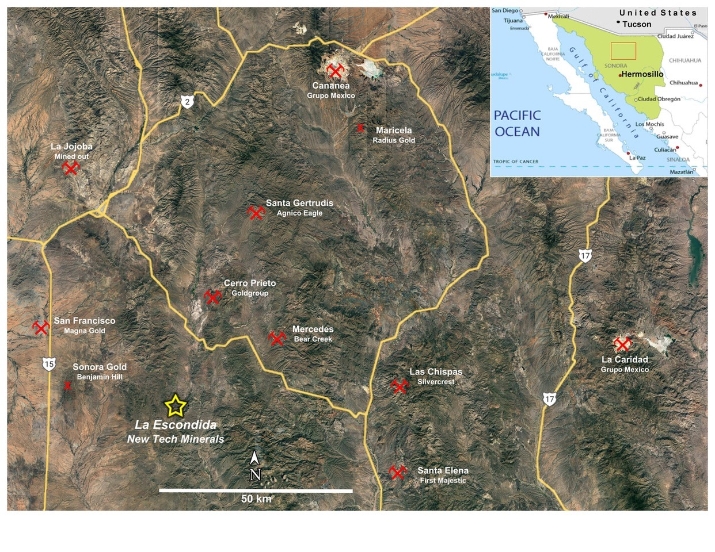

**Qualified Person:**

Dr. Craig Gibson, PhD, CPG is the qualified person as defined by National Instrument 43-101 and has reviewed and approved the technical information in this news release. Mr. Gibson is independent of the Company, as determined in accordance with National Instrument 43-101.

On behalf of the Board of Directors

“Jonathan George”, President & CEO

Neither the OTCQX nor the Canadian Securities Exchange nor its Regulation Services Provider (as that term is defined in the policies of the Canadian Securities Exchange) accepts responsibility for the adequacy or accuracy of this release.

Forward Looking Information

This press release contains forward-looking information (within the meaning of applicable Canadian securities legislation) that involves various risks and uncertainties regarding future events. Such forward-looking information includes statements based on current expectations involving a number of risks and uncertainties and such forward-looking statements are not guarantees of future performance of the Company, and include, without limitation, statements relating to plans for future exploration and the magnitude and quality of the mineralization at the La Escondida Project. There are numerous risks and uncertainties that could cause actual results and the Company's plans and objectives to differ materially from those expressed in the forward-looking information in this news release, including without limitation, the following risks and uncertainties;; (i) risks inherent in the mining industry; (ii) regulatory and environmental risks; (iii) results of exploration activities and development of mineral properties; (i) risks relating to the estimation of mineral resources; (v) stock market volatility and capital market fluctuations; and (vi) general market and industry conditions. Actual results and future events could differ materially from those anticipated in such information. This forward-looking information is based on estimates and opinions of management on the date hereof and is expressly qualified by this notice. Risks and uncertainties about the Company's business are more fully discussed in the Company's disclosure materials filed with the securities regulatory authorities in Canada at www.sedar.com. The Company assumes no obligation to update any forward-looking information or to update the reasons why actual results could differ from such information unless required by applicable law.