Metallica Metals Files NI 43-101 Technical Report and Earns 100% Interest in the Starr Gold-Silver Project

Vancouver, British Columbia – September 6, 2022 – Metallica Metals Corp. (CSE:MM) (OTCQB:MTALF) (FWB:SY7P) (the “Company” or “Metallica Metals”) is pleased to announce that it has filed a NI 43-101 Technical Report on its flagship Starr gold-silver project (“Starr” or the “Project”), located in the Thunder Bay Mining District of Ontario, Canada. It can be found on SEDAR at https://www.sedar.com and has been posted on the Company website at Starr Property NI 43-101. The report focuses on the Company’s recently completed 4,426m diamond drill program, detail of assay results, and suggestions for future exploration. The Company is also pleased to announce it has now obtained a 100% interest in the Starr Project. This is an important milestone for Metallica Metals and signifies the Company’s belief in resource expansion and further Au-Ag discoveries.
Technical Report and Project Highlights:
- 4,426m of diamond drilling completed across the central and eastern portions of the Starr property. An area never previously drilled in the east contained newly discovered mineralization and has been named the Brandi Zone.
- Intercept highlights include 34.9m at 1.11 g/t Au from STR21-001, 25.75m at 1.14 g/t Au from STR21-003 and 14.2m at 4.1 g/t Au from STR21-004
- Mineralization at the main Starr showing is open in all directions. Surface showings on west side of property remain to be drill tested.
Aaron Stone, CEO of Metallica Metals commented, “We are pleased to file the NI 43-101 Technical Report on our flagship Starr gold-silver project. The results from our recently completed drill program confirm the high-grade nature of mineralization contained in the central portion of the property, in addition to demonstrating the great potential for further discoveries on the underworked eastern and western parts of the project. The new discovery at the previously undrilled Brandi Zone is a perfect example of the future prospects for this project. This report has provided us with a fantastic overview of the project and has given us a clear exploration path to follow. Obtaining a 100% interest in the project is another accomplishment for us. The Company is excited by the progression on the property and is committed to expanding the known footprint of mineralization.”
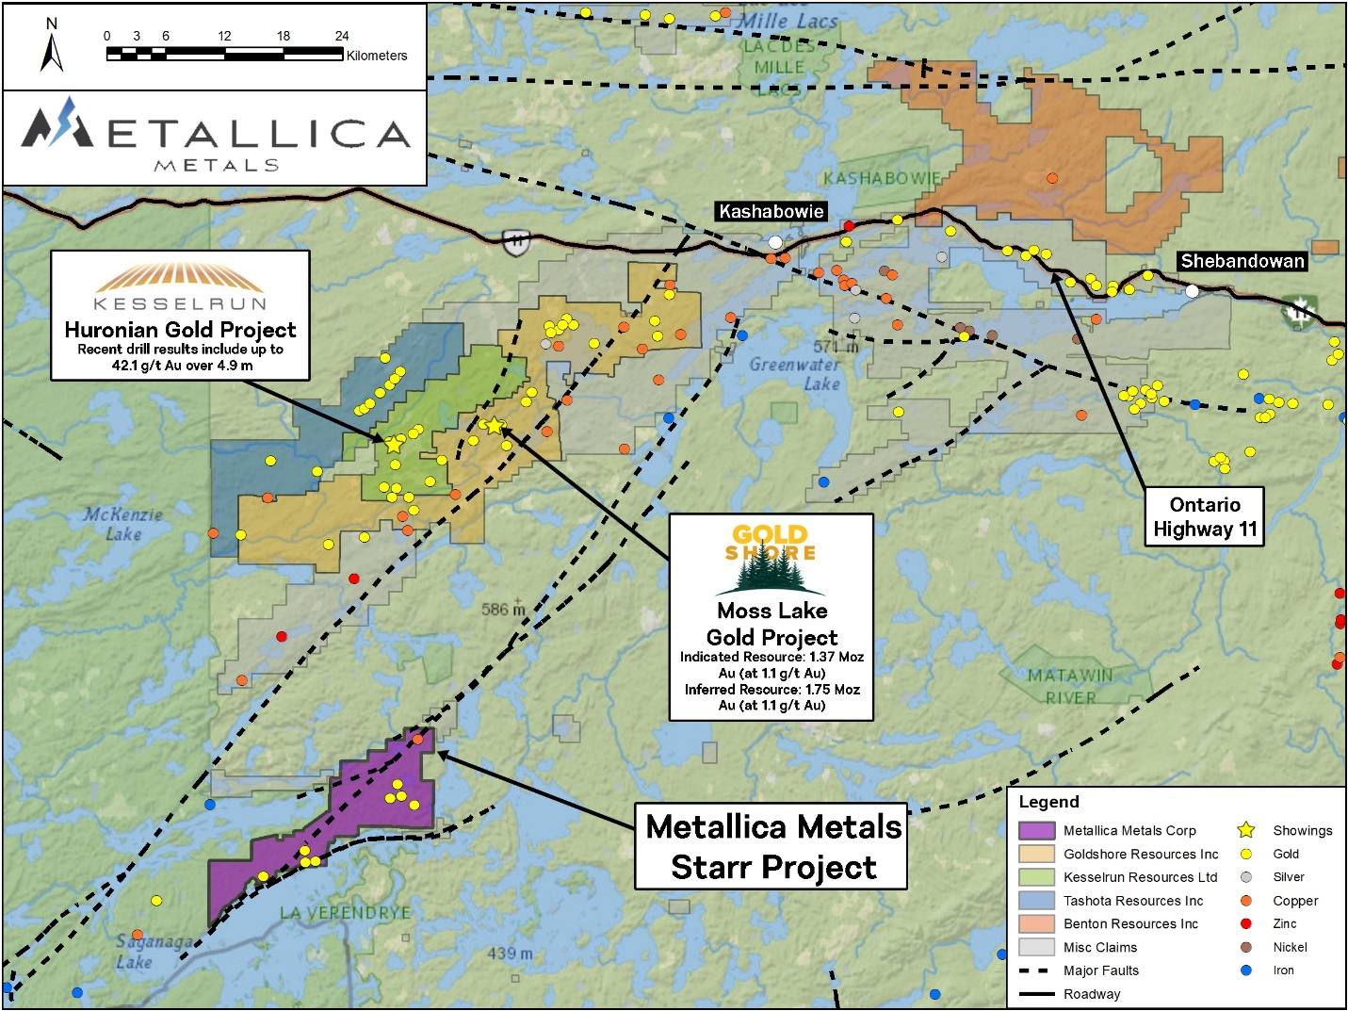
Figure 2: Location of Metallica Metals’ Starr Gold-Silver Project with respect to adjacent properties including the Moss Lake gold deposit (sources: 2013 NI 43-101 Technical Report and PEA for the Moss Lake Project and Kesselrun Resources October 7, 2020 news release – see figure notes below for further details on mineral resource estimate reference)
Figure Notes: The adjacent Moss Lake gold deposit hosts an Indicated Mineral Resource of 39,797,000 tonnes grading 1.1 g/t Au for 1,377,300 contained ounces of gold and an Inferred Mineral Resource of 50,364,000 tonnes grading 1.1 g/t Au for 1,751,600 contained ounces of gold, and is currently under care and maintenance (source: NI 43-101 Technical Report and PEA for the Moss Lake Project with an effective date of May 31, 2013 and filed on SEDAR under Moss Lake Gold Mines Ltd., now Wesdome Gold Mines Ltd.). Readers are cautioned that mineralization and mineral resource estimates on adjacent and/or nearby properties are not necessarily indicative of mineralization on the Starr Project (please refer to additional cautionary statements below).
Completion of acquiring 100% interest of the Starr Project
On November 16, 2020, the Company entered into a share purchase agreement to acquire 2752300 Ontario Inc. whose sole asset was an option agreement with Benton Resources Inc. (“Benton”) to earn up to a 100% interest in the Project.
The Company has made the following payments to Benton to earn the 100% interest in the Project:
- On November 25, 2020, the Company issued 1,380,000 common shares and paid $50,000 cash;
- On July 30, 2021, the Company issued 1,248,177 common shares and paid $50,000 cash; and
- On July 29, 2022, the Company issued 1,082,120 common shares and paid $50,000 cash; and
- On August 31, 2022, the Company issued 2,000,000 common shares and paid $50,000 cash.
The Company has incurred $1,701,429 in qualified expenditures on the Project to satisfy the minimum $800,000 in qualified expenditures required in order to earn a 100% interest in the Project.
The Project remains subject to a net smelter return royalty (the “NSR”) whereby 1.5% of the NSR may purchased on certain claims for payment of $500,000 for each 0.5% on the NSR and 1% of the NSR may be purchased on certain claims for payment of $1,000,000.
Authors and Qualified Person Statement
The NI 43-101 Technical Report was completed by Neil Pettigrew, M.Sc., P.Geo. of Fladgate Exploration. Mr. Pettigrew is an Independent Qualified Person (QP) as defined by National Instrument 43-101. Mr. Pettigrew has read and approved the contents of this news release, as it relates to the Technical Report.
Paul Ténière, M.Sc., P.Geo., President and Director of Metallica Metals, a qualified person as defined by Canadian National Instrument 43-101 standards and has reviewed the technical content of this news release and has approved its dissemination.
Cautionary Statement
This news release also contains scientific and technical information with respect to adjacent or similar mineral properties to the Starr Project, which the Company has no interest in or rights to explore. Readers are cautioned that information regarding mineral resources, geology, and mineralization on adjacent or similar properties is not necessarily indicative of the mineralization on the Company’s properties.
On behalf of the Board of Directors:
METALLICA METALS CORP.
Aaron Stone, P.Geo.
Chief Executive Officer
astone@metallica-metals.com

Head Office:  Suite 810 – 789 West Pender Street  Vancouver, BC V6C 1H2 Canada  Ph: (604) 687-2038 | Toronto Office:  Suite 401 – 217 Queen Street West  Toronto, ON M5V 0R2 Canada
About Metallica Metals Corp.
Metallica Metals Corp. is a Canadian junior mining company listed on the Canadian Securities Exchange (“CSE”) and its common shares trade under the ticker symbol “MM”. The Company is focused on acquiring and exploring gold-silver and platinum group metal (PGM) properties across Canada. The Company is currently exploring and developing its Starr Gold-Silver Project, and Sammy Ridgeline and Richview Pine PGM projects, which are all located adjacent to advanced mining projects in the Thunder Bay Mining District of Ontario.
For more information, please visit the Company’s website at https://metallica-metals.com.
Neither the Canadian Securities Exchange nor its Regulation Services Provider (as that term is defined in the policies of the Canadian Securities Exchange) accepts responsibility for the adequacy or accuracy of this release.

Forward-looking Information Statement

This news release contains certain “forward-looking information” within the meaning of applicable securities law. Forward-looking information is frequently characterized by words such as “plan”, “expect”, “project”, “intend”, “believe”, “anticipate”, “estimate” and other similar words, or statements that certain events or conditions “may” or “will” occur. In particular, forward-looking information in this press release includes, but is not limited to, statements with respect to the Company’s proposed acquisition, exploration program and the expectations for the mining industry. Although we believe that the expectations reflected in the forward-looking information are reasonable, there can be no assurance that such expectations will prove to be correct. We cannot guarantee future results, performance or achievements. Consequently, there is no representation that the actual results achieved will be the same, in whole or in part, as those set out in the forward-looking information. Forward-looking information is based on the opinions and estimates of management at the date the statements are made and are subject to a variety of risks and uncertainties and other factors that could cause actual events or results to differ materially from those anticipated in the forward-looking information. Some of the risks and other factors that could cause the results to differ materially from those expressed in the forward-looking information include, but are not limited to: general economic conditions in Canada and globally; industry conditions, including governmental regulation and environmental regulation; failure to obtain industry partner and other third party consents and approvals, if and when required; the availability of capital on acceptable terms; the need to obtain required approvals from regulatory authorities; stock market volatility; liabilities inherent in water disposal facility operations; competition for, among other things, skilled personnel and supplies; incorrect assessments of the value of acquisitions; geological, technical, processing and transportation problems; changes in tax laws and incentive programs; failure to realize the anticipated benefits of acquisitions and dispositions; and the other factors. Readers are cautioned that this list of risk factors should not be construed as exhaustive. The forward-looking information contained in this news release is expressly qualified by this cautionary statement. We undertake no duty to update any of the forward-looking information to conform such information to actual results or to changes in our expectations except as otherwise required by applicable securities legislation. Readers are cautioned not to place undue reliance on forward-looking information.

