TO: CANADIAN SECURITIES EXCHANGE (“CSE”)
Leviathan Cannabis Group Inc. (“Listed Issuer”) hereby confirms to CSE that on June 15, 2018, the Woodstock Biomed Inc. (“Woodstock”) transaction closed whereby the Listed Issuer acquired all of the common shares of Woodstock and title to the common shares of Woodstock.

Date: 19 June 2018

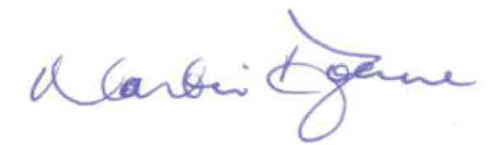
Signed: ______________________________________
Name: Martin J. Doane
Title: Chief Executive Officer
I have authority to bind the company

