Quizam Media Corporation
(the “Company”)

August 20, 2018

Canadian Securities Exchange
220 Bay Street, 9th Floor
Toronto, Ontario M5J 2W4

Dear Sirs/Mesdames:

Re: Confirmation of Receipt of Proceeds
Pursuant to Section 2.7 of Policy 6 of the Canadian Securities Exchange, we advise that the Company has completed the non-brokered private placement of an aggregate 4,200,000 common shares of the Company at $0.06 per common share, for gross proceeds of $252,000 (the “Offering”).
The terms of the Offering are outlined in the Company’s final Form 9 – Notice of Proposed Issuance of Listed Securities dated August 09, 2018.

Yours very truly,

Quizam Media Corporation

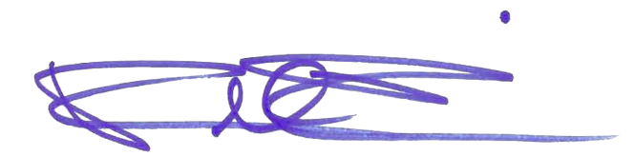
Date: August 20, 2018

Signed:
(Signature)

Russ Rossi
(Print Name)

CEO
(Print Office)

