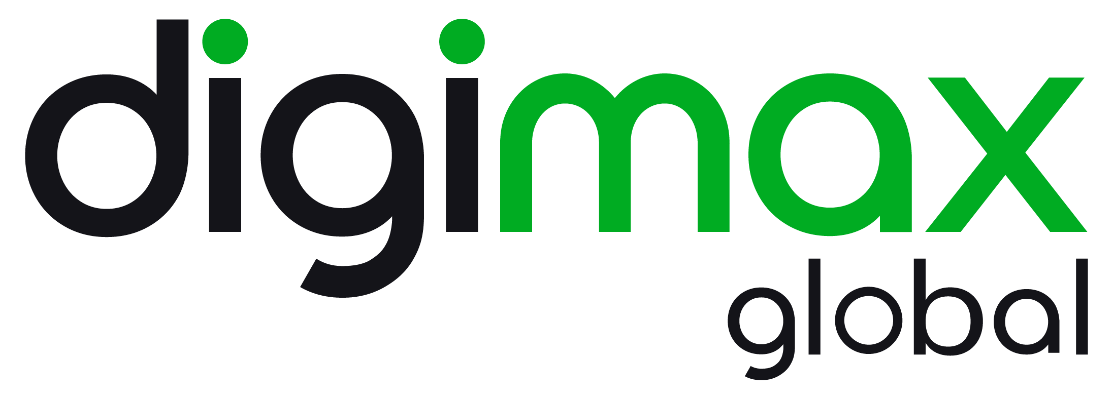

DigiMax Signs Definitive Agreement to Acquire
Spetz Tech Limited

FOR IMMEDIATE RELEASE – June 23, 2022

TORONTO/ACCESSWIRE –DIGIMAX GLOBAL INC. (the “Company” or “DigiMax”) (CSE: DIGI, OTC: DBKSF) is pleased to announce that it has signed a definitive agreement (the “Agreement”) dated June 23, 2022, to acquire all of the issued and outstanding shares of Israel-based Spetz Tech Ltd. (“Spetz”), a technology company which has developed artificial intelligence (“AI”) software to operate a revolutionary and fast-growing mobile application that connects consumers to available, top-rated tradespeople, service providers and professionals in their area immediately or at any schedule time (the “Transaction”).

Spetz’s proprietary mobile application uses AI to determine which service provider best matches the work sought by a given consumer, then immediately establishes a connection between consumer and service provider, usually within 30 seconds to one minute of the consumer request. The Spetz platform allows it to charge a small fee for every job opportunity offered to a service provider through its platform with no costs passed along to the consumer. The proprietary Spetz mobile application has been in operation in Israel for four years, the United Kingdom for two years and in Australia for one year. Spetz is a global online, AI-powered marketplace platform that dynamically connects consumers to nearby rated service providers.

“Spetz’s network of service providers and AI technology are ahead of the curve, and the existing synergies between it’s business and DigiMax are readily apparent,” said Chris Carl, CEO of DigiMax. “The rapid adoption of Spetz’s application in Australia and the UK has shown that Spetz’s model works, and with the support provided by DigiMax, we believe that a similar, if not greater, rate of adoption of Spetz’s application will occur in North America.”

Transaction Rationale
- To date, Spetz has generated over 400,000 service calls, and has connected members of the public to almost 10,000 service providers worldwide;
- Spetz intends to enter the US market in Q3 of 2022 and sees substantial growth potential over three years while maintaining a balance of marketing spending and revenue generation, in addition to anticipated growth in its existing regions;
- The Spetz platform is highly scalable, with more than 400 service categories built into the system to date, an ability to support millions of service calls worldwide, automated onboarding and account management for clients, and seamless integration capabilities for other service industries; and
- Spetz has the potential to become a service coordination tool for any Business to Consumer service across many industries and sectors, including accounting, legal services, healthcare industry and homecare services. This multi-disciplinary, AI-driven, and scalable design differentiates Spetz from its current competitors in the marketplace.

Terms of the Transaction
The Transaction, which is an arm’s length transaction, is subject to customary conditions of closing and is expected to close in the coming weeks. In consideration for all of the issued and outstanding shares of Spetz, DigiMax will issue 250 million securities of the Company (the “Consideration Securities”) to the securityholders of Spetz, which will amount to approximately 47% of the outstanding shares of the Company upon the closing of the Transaction (the “Closing”). The number of Consideration Securities being issued to the securityholders of Spetz is not contingent on the trading price of DigiMax’s common shares on the CSE.

Upon Closing, Yossi Nevo, the current Founder CEO of Spetz, will assume the role of Chief Operating Officer of the Company, and Ofir Friedman, Spetz’s current VP of Marketing & Business Development, will assume the role of Chief Marketing Officer of the Company. In addition to the foregoing, both Messrs. Nevo and Friedman will be appointed to the Company’s board of directors upon Closing.

In connection with the Transaction, the Company and Spetz have agreed to pay a finder’s fee to a certain arm’s length party (the “Finder’s Fee”). The Finder’s Fee is comprised of 4 million common shares of the Company, as well as 4 million ordinary shares of Spetz.

About Spetz

Spetz is an established AI technology company with operations in Israel, the United Kingdom and Australia. Through its mobile application, Spetz’s patent-pending AI technology is able to generate the best-matched home service solution for any given consumer for any given service in under 30 seconds, enabling immediate direct contact between the service provider and consumer. Spetz’s experienced management and advisory team has decades of experience in the service provider industry and artificial intelligence applications.

More information can be seen at:

Website –
https://www.spetz.app
Google App Store – https://play.google.com/store/apps/details?id=com.sinapis.gpage
Trust Pilot - https://www.trustpilot.com/review/spetz.co.uk
Spetz Service Provider Commentary - https://www.youtube.com/watch?v=dJ5-WpyU9tU

About DigiMax

DigiMax is an AI technology Company committed to unlocking the potential of disruptive technologies by providing advanced financial, predictive, and cryptocurrency solutions across various verticals. DigiMax is an official IBM partner, and the Company’s engineering team has extensive experience in Machine Learning, Neural Language Processing, AI, Big Data, and Cryptocurrency technology.

To learn more, visit our website: https://digimaxglobal.com/
Contact: 1-(833)-DIGIMAX (833-344-4629)
Edward Murphy Chris Carl
Chair of Board of Directors President & CEO
416-720-0456 (833) 344-4629 x700
emurphy@digimax-global.com ccarl@digimax-global.com
Cautionary Note Regarding Forward-looking Statements
NEITHER THE CANADIAN SECURITIES EXCHANGE, NOR THEIR REGULATIONS SERVICES PROVIDERS HAVE REVIEWED OR ACCEPT RESPONSIBILITY FOR THE ADEQUACY OR ACCURACY OF THIS RELEASE
Certain information in this press release constitutes forward-looking statements under applicable securities laws. Any statements that are contained in this news release that are not statements of historical fact may be deemed to be forward-looking statements and are based on expectations, estimates and projections as at the date of this press release. Forward-looking statements are often identified by terms such as "may", "should", "anticipate", "expect", "potential", "believe", "intend" or negatives of these terms and similar expressions. In this press release, forward-looking statements relate, among other things, to: the ability of the Company and Spetz to complete the Transaction on the terms outlined above, [the ability of the Company to attain final approval of the Transaction by the Israeli Tax Authority, the CSE and satisfy the remaining closing conditions], DigiMax’s continued growth and profitability and ability to continue to provide solutions across various verticals, the anticipated synergies between Spetz and the Company, the expectation that Spetz’s application will be adopted by the North American market and the anticipated rate of adoption. Forward-looking statements are necessarily based upon a number of estimates and assumptions that, while considered reasonable, are subject to known and unknown risks, uncertainties, and other factors that may cause the actual results and future events to differ materially from those expressed or implied by such forward-looking statements.
Forward-looking statements are based on certain assumptions. While the Company considers these assumptions to be reasonable based on information currently available, they are inherently subject to significant business, economic and competitive uncertainties and contingencies and they may prove to be incorrect.
Forward-looking statements also necessarily involve known and unknown risks, including without limitation, risks associated with general economic conditions, including the COVID-19 pandemic, a lack of interest in Spetz’s application in the North American market, ability to complete favorable acquisitions, income tax and regulatory matters in Canada and Israel.
Readers are cautioned that the foregoing is not exhaustive. Readers are further cautioned not to place undue reliance on forward-looking statements as there can be no assurance that the plans, intentions or expectations upon which they are placed will occur. Such information, although considered reasonable by management at the time of preparation, may prove to be incorrect and actual results may differ from those anticipated. Forward-looking statements are not guarantees of future performance. The purpose of forward-looking information is to provide the reader with a description of management's expectations, and such forward-looking information may not be appropriate for any other purpose. Except as required by law, the Company disclaims any obligation to update or revise any forward-looking statements, whether as a result of new information, events or otherwise. Forward-looking statements contained in this news release are speak as to the date hereof, and are expressly qualified by this cautionary statement.
Neither the CSE nor its Regulation Services Provider (as that term is defined in the policies of the CSE) accepts responsibility for the adequacy or accuracy of this press release. There can be no assurance that such statements will prove to be accurate, as actual results and future events could differ materially from those anticipated in such statements. Accordingly, readers should not place undue reliance on the forward-looking statements and information contained in this press release. Except as required by law, DigiMax assumes no obligation to update the forward-looking statements of beliefs, opinions, projections, or other factors, should they change.

