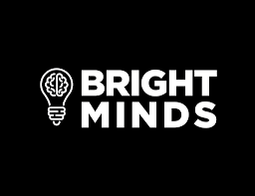

For Immediate Release

Bright Minds Biosciences to Present at the H.C. Wainwright Virtual Conference
Psychedelics in Psychiatry and Beyond

Vancouver, BC – June 11, 2021 – Bright Minds Biosciences (“Bright Minds,” “BMB” or the “Company”) (CSE:DRUG) (OTCQB:BMBIF), a biotechnology company focused on developing novel transformative treatments for neuropsychiatry disorders, epilepsy and pain, today announced that Ian McDonald, Chief Executive Officer, and Dr. Gideon Shapiro Ph.D, Vice President of Discovery, will be presenting at the H.C. Wainwright Virtual Conference Psychedelics in Psychiatry and Beyond, as follows:

Date: Thursday, June 17, 2021
Time: On demand, beginning at 7:00AM ET
Webcast: https://journey.ct.events/view/bb74a476-165a-434c-9dae-e21e74792148
The presentation will be webcast beginning at the aforementioned time and available for 7 days thereafter using the link provided above.

About Bright Minds
Bright Minds is focused on developing novel transformative treatments for neuropsychiatry disorders, epilepsy and pain. Bright Minds has a portfolio of next generation serotonin agonists designed to precisely target abnormalities in neurocircuitry that lead to dysfunctional behaviors. The Company is developing targeted therapies with the potential to improve the treatment of mental health and neurological disorders through the use of serotonergic compounds leveraging its world class scientific and drug development expertise to bring forward the next generation of safe and efficacious drugs. Bright Minds drugs extenuate the therapeutic aspects of psychedelic and other serotonergic compounds while minimizing the side effects thereby creating superior drugs to first generation compounds, such as psilocybin.

Investor Contact:
Judy DiClemente
jdiclemente@insitecony.com

